

**Zabbix监控系统搭建手册**

信息技术中心

2016年8月1日

目录

1、安装环境 4

1.1 主机信息 4

1.2 软件信息 4

1.3 关闭防火墙和SELinux 4

2、服务器端安装 4

2.1 安装源 4

2.2 安装Zabbix-Server 4

2.3 安装mysql 7

2.4 创建Zabbix数据库 10

2.5 配置zabbix_server.conf 11

2.6 启动Zabbix-Server 13

2.7 配置php.ini 13

2.8 配置Web界面 13

3、Zabbix-Agent客户端安装 18

3.1 安装 Linux Zabbix-Agent 18

3.5 安装 Windows Zabbix-Agent 20

3.6 Linux SNMP监控方式的配置 21

4、添加host主机到监控平台 22

4.1 登录监控平台，创建主机 22

4.2 添加agent监控 22

4.3 添加模板用于监控条目 22

4.4 监控成功后，Ｚ图标状态显示绿色 22

4.5 监控数据产生，查看监控图表 23

**文档修订记录**

|  |  |  |  |
| --- | --- | --- | --- |
| 日 期 | 版本 | 描述信息 | 作者 |
| 2016-8-1 | 1.0 | 新建 | 石磊 |
| 2016-8-2 | 1.1 | 添加agent安装步骤 | 陈俊彦 |
| 2016-8-3 | 1.2 | 添加host主机添加到监控平台 | 陈俊彦 |
| 2016-10-17 | 1.5 | 整合文档 | 陈俊彦 |

1、安装环境

1.1 主机信息

|  |  |  |  |  |  |
| --- | --- | --- | --- | --- | --- |
| 序号 | 操作系统 | 主机名 | 版本 | IP | 用途 |
| 1 | RHEL | D2-ZABBIX20 | 6.5-x86_64 | 10.163.36.20 | 服务器端 |
| 2 | RHEL | D2-POMS81 | 6.5-x86_64 | 10.163.91.81 | 客户端 |

1.2 软件信息

|  |  |  |
| --- | --- | --- |
| 序号 | 名称 | 版本 |
| 1 | Zabbix | 2.2 |
| 2 | orabbix | 1.2.3 |

1.3 关闭服务器端防火墙和SELinux

[root@D2-ZABBIX20 ~]# /etc/init.d/iptables status

iptables: Firewall is not running.

[root@D2-ZABBIX20 ~]# getenforce

Disabled

2、服务器端安装

2.1 安装源

安装Zabbix官方源和epel源：

[root@D2-ZABBIX20 ~]# rpm -ivh http://repo.zabbix.com/zabbix/2.2/rhel/6/x86_64/zabbix-release-2.2-1.el6.noarch.rpm

Retrieving http://repo.zabbix.com/zabbix/2.2/rhel/6/x86_64/zabbix-release-2.2-1.el6.noarch.rpm

warning: /var/tmp/rpm-tmp.ctwSmf: Header V4 DSA/SHA1 Signature, key ID 79ea5ed4: NOKEY

Preparing... ########################################### [100%]

1:zabbix-release ########################################### [100%]

[root@D2-ZABBIX20 ~]# rpm -ivh http://dl.fedoraproject.org/pub/epel/6/x86_64/epel-release-6-8.noarch.rpm

Retrieving http://dl.fedoraproject.org/pub/epel/6/x86_64/epel-release-6-8.noarch.rpm

warning: /var/tmp/rpm-tmp.d8KUTs: Header V3 RSA/SHA256 Signature, key ID 0608b895: NOKEY

Preparing... ########################################### [100%]

1:epel-release ########################################### [100%]

2.2 安装Zabbix-Server

在http://vault.centos.org/6.5/os/x86_64/Packages/下载 php-bcmath-5.3.3-26.el6.x86_64和php-mbstring-5.3.3-26.el6.x86_64.rpm包并进行安装：

[root@D2-ZABBIX20 ~]# wget http://vault.centos.org/6.5/os/x86_64/Packages/php-bcmath-5.3.3-26.el6.x86_64.rpm

--2016-08-01 12:03:29-- http://vault.centos.org/6.5/os/x86_64/Packages/php-bcmath-5.3.3-26.el6.x86_64.rpm

Resolving vault.centos.org... 108.61.16.227, 2607:ff28:0:28:5054:ff:fe4b:3e8a

Connecting to vault.centos.org|108.61.16.227|:80... connected.

HTTP request sent, awaiting response... 200 OK

Length: 35564 (35K) [application/x-rpm]

Saving to: 鈥減hp-bcmath-5.3.3-26.el6.x86_64.rpm鈥

100%[=====================================================================================================================>] 35,564 6.68K/s in 5.2s

2016-08-01 12:03:40 (6.68 KB/s) - 鈥減hp-bcmath-5.3.3-26.el6.x86_64.rpm鈥saved [35564/35564]

[root@D2-ZABBIX20 ~]# wget http://vault.centos.org/6.5/os/x86_64/Packages/php-mbstring-5.3.3-26.el6.x86_64.rpm

--2016-08-01 12:04:45-- http://vault.centos.org/6.5/os/x86_64/Packages/php-mbstring-5.3.3-26.el6.x86_64.rpm

Resolving vault.centos.org... 108.61.16.227, 2607:ff28:0:28:5054:ff:fe4b:3e8a

Connecting to vault.centos.org|108.61.16.227|:80... connected.

HTTP request sent, awaiting response... 200 OK

Length: 466232 (455K) [application/x-rpm]

Saving to: 鈥減hp-mbstring-5.3.3-26.el6.x86_64.rpm鈥

100%[=====================================================================================================================>] 466,232 6.87K/s in 55s

2016-08-01 12:05:42 (8.29 KB/s) - 鈥減hp-mbstring-5.3.3-26.el6.x86_64.rpm鈥saved [466232/466232]

[root@D2-ZABBIX20 ~]# rpm -ivh php-mbstring-5.3.3-26.el6.x86_64.rpm

warning: php-mbstring-5.3.3-26.el6.x86_64.rpm: Header V3 RSA/SHA1 Signature, key ID c105b9de: NOKEY

error: Failed dependencies:

php-common(x86-64) = 5.3.3-26.el6 is needed by php-mbstring-5.3.3-26.el6.x86_64

[root@D2-ZABBIX20 ~]# yum install php-common

Loaded plugins: product-id, refresh-packagekit, security, subscription-manager

This system is not registered to Red Hat Subscription Management. You can use subscription-manager to register.

Setting up Install Process

Resolving Dependencies

--> Running transaction check

---> Package php-common.x86_64 0:5.3.3-26.el6 will be installed

--> Finished Dependency Resolution

Dependencies Resolved

===============================================================================================================================================================

Package Arch Version Repository Size

===============================================================================================================================================================

Installing:

php-common x86_64 5.3.3-26.el6 local 525 k

Transaction Summary

===============================================================================================================================================================

Install 1 Package(s)

Total download size: 525 k

Installed size: 2.9 M

Is this ok [y/N]: y

Downloading Packages:

php-common-5.3.3-26.el6.x86_64.rpm | 525 kB 00:00

Running rpm_check_debug

Running Transaction Test

Transaction Test Succeeded

Running Transaction

Warning: RPMDB altered outside of yum.

Installing : php-common-5.3.3-26.el6.x86_64 1/1

Verifying : php-common-5.3.3-26.el6.x86_64 1/1

Installed:

php-common.x86_64 0:5.3.3-26.el6

Complete!

[root@D2-ZABBIX20 ~]# rpm -ivh php-mbstring-5.3.3-26.el6.x86_64.rpm

warning: php-mbstring-5.3.3-26.el6.x86_64.rpm: Header V3 RSA/SHA1 Signature, key ID c105b9de: NOKEY

Preparing... ########################################### [100%]

1:php-mbstring ########################################### [100%]

[root@D2-ZABBIX20 ~]# rpm -ivh php-bcmath-5.3.3-26.el6.x86_64.rpm

warning: php-bcmath-5.3.3-26.el6.x86_64.rpm: Header V3 RSA/SHA1 Signature, key ID c105b9de: NOKEY

Preparing... ########################################### [100%]

1:php-bcmath ########################################### [100%]

[root@D2-ZABBIX20 ~]# yum install -y zabbix zabbix-get zabbix-server zabbix-web-mysql zabbix-web zabbix-agent

2.3 安装mysql

[root@D2-ZABBIX20 ~]# yum -y install mysql-server

Loaded plugins: product-id, refresh-packagekit, security, subscription-manager

This system is not registered to Red Hat Subscription Management. You can use subscription-manager to register.

Setting up Install Process

Resolving Dependencies

--> Running transaction check

---> Package mysql-server.x86_64 0:5.1.71-1.el6 will be installed

--> Processing Dependency: mysql = 5.1.71-1.el6 for package: mysql-server-5.1.71-1.el6.x86_64

--> Processing Dependency: perl-DBI for package: mysql-server-5.1.71-1.el6.x86_64

--> Processing Dependency: perl-DBD-MySQL for package: mysql-server-5.1.71-1.el6.x86_64

--> Processing Dependency: perl(DBI) for package: mysql-server-5.1.71-1.el6.x86_64

--> Running transaction check

---> Package mysql.x86_64 0:5.1.71-1.el6 will be installed

---> Package perl-DBD-MySQL.x86_64 0:4.013-3.el6 will be installed

---> Package perl-DBI.x86_64 0:1.609-4.el6 will be installed

--> Finished Dependency Resolution

Dependencies Resolved

=====================================================================================================================================================

Package Arch Version Repository Size

=====================================================================================================================================================

Installing:

mysql-server x86_64 5.1.71-1.el6 local 8.6 M

Installing for dependencies:

mysql x86_64 5.1.71-1.el6 local 893 k

perl-DBD-MySQL x86_64 4.013-3.el6 local 134 k

perl-DBI x86_64 1.609-4.el6 local 707 k

Transaction Summary

=====================================================================================================================================================

Install 4 Package(s)

Total download size: 10 M

Installed size: 29 M

Downloading Packages:

(1/4): mysql-5.1.71-1.el6.x86_64.rpm | 893 kB 00:00

(2/4): mysql-server-5.1.71-1.el6.x86_64.rpm | 8.6 MB 00:00

(3/4): perl-DBD-MySQL-4.013-3.el6.x86_64.rpm | 134 kB 00:00

(4/4): perl-DBI-1.609-4.el6.x86_64.rpm | 707 kB 00:00

-----------------------------------------------------------------------------------------------------------------------------------------------------

Total 26 MB/s | 10 MB 00:00

Running rpm_check_debug

Running Transaction Test

Transaction Test Succeeded

Running Transaction

Installing : perl-DBI-1.609-4.el6.x86_64 1/4

Installing : perl-DBD-MySQL-4.013-3.el6.x86_64 2/4

Installing : mysql-5.1.71-1.el6.x86_64 3/4

Installing : mysql-server-5.1.71-1.el6.x86_64 4/4

Verifying : perl-DBD-MySQL-4.013-3.el6.x86_64 1/4

Verifying : mysql-server-5.1.71-1.el6.x86_64 2/4

Verifying : mysql-5.1.71-1.el6.x86_64 3/4

Verifying : perl-DBI-1.609-4.el6.x86_64 4/4

Installed:

mysql-server.x86_64 0:5.1.71-1.el6

Dependency Installed:

mysql.x86_64 0:5.1.71-1.el6 perl-DBD-MySQL.x86_64 0:4.013-3.el6 perl-DBI.x86_64 0:1.609-4.el6

Complete!

安装完成后修改mysql配置文件：

[root@D2-ZABBIX20 ~]# vim /etc/my.cnf

[mysqld]

datadir=/var/lib/mysql

socket=/var/lib/mysql/mysql.sock

user=mysql

# Disabling symbolic-links is recommended to prevent assorted security risks

symbolic-links=0

character-set-server=utf8

innodb_file_per_table=1

[mysqld_safe]

log-error=/var/log/mysqld.log

pid-file=/var/run/mysqld/mysqld.pid

启动mysql：

[root@D2-ZABBIX20 ~]# chkconfig mysqld on

[root@D2-ZABBIX20 ~]# chkconfig --list mysqld

mysqld 0:off 1:off 2:on 3:on 4:on 5:on 6:off

[root@D2-ZABBIX20 ~]# service mysqld start

Initializing MySQL database: Installing MySQL system tables...

OK

Filling help tables...

OK

To start mysqld at boot time you have to copy

support-files/mysql.server to the right place for your system

PLEASE REMEMBER TO SET A PASSWORD FOR THE MySQL root USER !

To do so, start the server, then issue the following commands:

/usr/bin/mysqladmin -u root password 'new-password'

/usr/bin/mysqladmin -u root -h D2-ZABBIX20 password 'new-password'

Alternatively you can run:

/usr/bin/mysql_secure_installation

which will also give you the option of removing the test

databases and anonymous user created by default. This is

strongly recommended for production servers.

See the manual for more instructions.

You can start the MySQL daemon with:

cd /usr ; /usr/bin/mysqld_safe &

You can test the MySQL daemon with mysql-test-run.pl

cd /usr/mysql-test ; perl mysql-test-run.pl

Please report any problems with the /usr/bin/mysqlbug script!

[ OK ]

Starting mysqld: [ OK ]

[root@D2-ZABBIX20 ~]# ps -ef | grep mysql

root 28995 1 0 13:52 pts/2 00:00:00 /bin/sh /usr/bin/mysqld_safe --datadir=/var/lib/mysql --socket=/var/lib/mysql/mysql.sock --pid-file=/var/run/mysqld/mysqld.pid --basedir=/usr --user=mysql

mysql 29103 28995 0 13:52 pts/2 00:00:00 /usr/libexec/mysqld --basedir=/usr --datadir=/var/lib/mysql --user=mysql --log-error=/var/log/mysqld.log --pid-file=/var/run/mysqld/mysqld.pid --socket=/var/lib/mysql/mysql.sock

root 29122 28863 0 13:53 pts/2 00:00:00 grep mysql

[root@D2-ZABBIX20 ~]# netstat -tunlp | grep 3306

tcp 0 0 0.0.0.0:3306 0.0.0.0:* LISTEN 29103/mysqld

2.4 创建Zabbix数据库

设置mysql的root用户密码：

[root@D2-ZABBIX20 ~]# mysqladmin -uroot password admin

[root@D2-ZABBIX20 ~]# mysql -uroot -padmin

Welcome to the MySQL monitor. Commands end with ; or \g.

Your MySQL connection id is 4

Server version: 5.1.71 Source distribution

Copyright (c) 2000, 2013, Oracle and/or its affiliates. All rights reserved.

Oracle is a registered trademark of Oracle Corporation and/or its

affiliates. Other names may be trademarks of their respective

owners.

Type 'help;' or '\h' for help. Type '\c' to clear the current input statement.

mysql> create database zabbix character set utf8;

Query OK, 1 row affected (0.00 sec)

mysql> grant all privileges on zabbix.* to zabbix@localhost identified by 'zabbix';

Query OK, 0 rows affected (0.00 sec)

mysql> flush privileges;

Query OK, 0 rows affected (0.00 sec)

[root@D2-ZABBIX20 ~]# mysql -uzabbix -pzabbix

Welcome to the MySQL monitor. Commands end with ; or \g.

Your MySQL connection id is 7

Server version: 5.1.71 Source distribution

Copyright (c) 2000, 2013, Oracle and/or its affiliates. All rights reserved.

Oracle is a registered trademark of Oracle Corporation and/or its

affiliates. Other names may be trademarks of their respective

owners.

Type 'help;' or '\h' for help. Type '\c' to clear the current input statement.

mysql> use zabbix

Database changed

mysql> source /usr/share/doc/zabbix-server-mysql-2.2.14/create/schema.sql;

mysql> source /usr/share/doc/zabbix-server-mysql-2.2.14/create/images.sql

mysql> source /usr/share/doc/zabbix-server-mysql-2.2.14/create/data.sql

mysql> show tables;

2.5 配置zabbix_server.conf

修改前：

[root@D2-ZABBIX20 ~]# egrep -v "(^#|^$)" /etc/zabbix/zabbix_server.conf

LogFile=/var/log/zabbix/zabbix_server.log

LogFileSize=0

PidFile=/var/run/zabbix/zabbix_server.pid

DBName=zabbix

DBUser=zabbix

DBSocket=/var/lib/mysql/mysql.sock

SNMPTrapperFile=/var/log/snmptt/snmptt.log

AlertScriptsPath=/usr/lib/zabbix/alertscripts

ExternalScripts=/usr/lib/zabbix/externalscripts

修改后：

[root@D2-ZABBIX20 ~]# egrep -v "(^#|^$)" /etc/zabbix/zabbix_server.conf

LogFile=/var/log/zabbix/zabbix_server.log

LogFileSize=0

PidFile=/var/run/zabbix/zabbix_server.pid

DBHost=localhost

DBName=zabbix

DBUser=zabbix

DBPassword=zabbix

DBSocket=/var/lib/mysql/mysql.sock

DBPort=3306

StartPollers=5

StartIPMIPollers=10

StartPollersUnreachable=10

StartTrappers=10

StartPingers=10

StartDiscoverers=10

VMwareFrequency=60

VMwareCacheSize=8M

SNMPTrapperFile=/var/log/snmptt/snmptt.log

ListenIP=10.163.36.20

MaxHousekeeperDelete=500

CacheSize=256M

StartDBSyncers=40

HistoryCacheSize=128M

TrendCacheSize=128M

HistoryTextCacheSize=128M

ValueCacheSize=128M

Timeout=30

TrapperTimeout=300

UnreachablePeriod=45

UnavailableDelay=60

UnreachableDelay=15

AlertScriptsPath=/etc/zabbix/alertscripts

ExternalScripts=/etc/zabbix/externalscripts

FpingLocation=/usr/sbin/fping

LogSlowQueries=10000

StartProxyPollers=50

ProxyConfigFrequency=3600

根据参数修改情况创建对于目录：

[root@D2-ZABBIX20 ~]# mkdir /etc/zabbix/alertscripts /etc/zabbix/externalscripts

2.6 启动Zabbix-Server

[root@D2-ZABBIX20 ~]# /etc/init.d/zabbix-server start

Starting Zabbix server: [ OK ]

[root@D2-ZABBIX20 ~]# /etc/init.d/httpd start

Starting httpd: httpd: Could not reliably determine the server's fully qualified domain name, using 10.163.36.20 for ServerName

[ OK ]

修改/etc/httpd/conf/httpd.conf

[root@D2-ZABBIX20 ~]# grep ServerName /etc/httpd/conf/httpd.conf | grep 80

ServerName localhost:80

[root@D2-ZABBIX20 ~]# /etc/init.d/httpd restart

Stopping httpd: [ OK ]

Starting httpd: [ OK ]

[root@D2-ZABBIX20 ~]# chkconfig zabbix-server on

[root@D2-ZABBIX20 ~]# chkconfig httpd on

[root@D2-ZABBIX20 ~]# chkconfig --list zabbix-server

zabbix-server 0:off 1:off 2:on 3:on 4:on 5:on 6:off

[root@D2-ZABBIX20 ~]# chkconfig --list httpd

httpd 0:off 1:off 2:on 3:on 4:on 5:on 6:off

2.7 配置php.ini

修改的参数有：

[root@D2-ZABBIX20 ~]# egrep -v "(^;|^$)" /etc/php.ini

max_input_time=300

max_execution_time = 300

max_input_time = 60

memory_limit = 128M

date.timezone = Asia/Shanghai

mbstring.func_overload = 2

重启httpd：

[root@D2-ZABBIX20 ~]# /etc/init.d/httpd restart

Stopping httpd: [ OK ]

Starting httpd: [ OK ]

2.8 配置Web界面

访问<http://10.163.36.20/zabbix/setup.php>，进行配置：

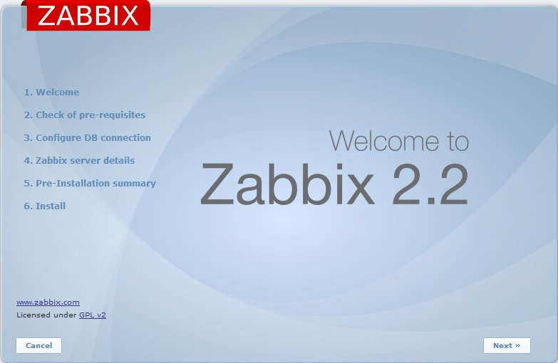

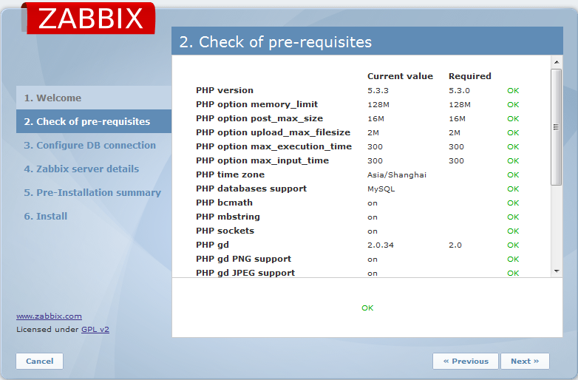

可以看到所有参数设置都满足需求，如果不满足，需要去修改php.ini文件，并重启httpd。

配置数据库连接的各项参数：

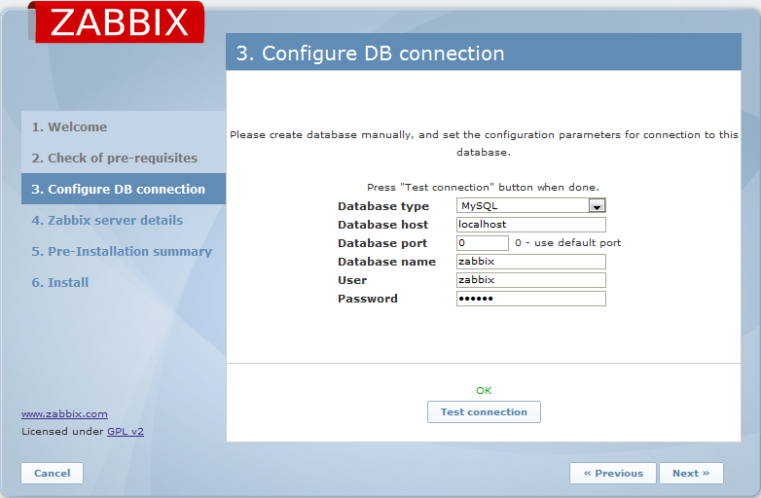

输入用户名和密码后进行测试。Ok后配置zabbix server的地址，端口和名称。

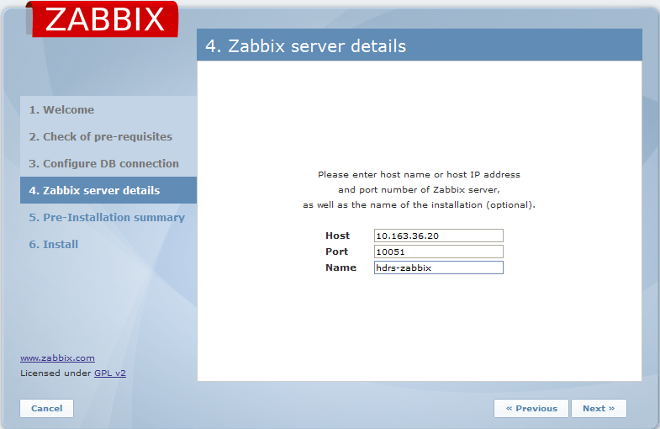

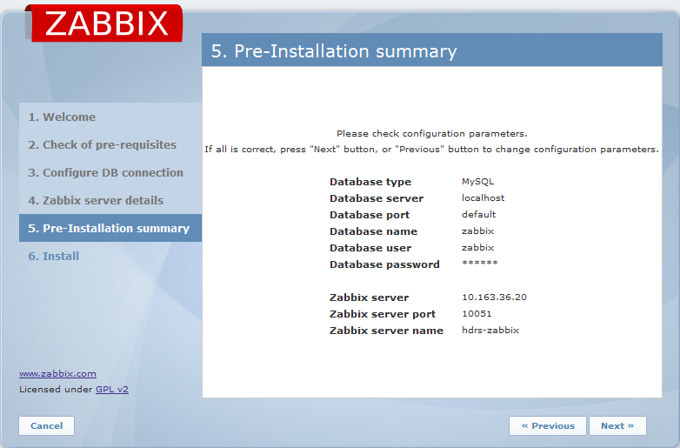

以上配置信息会写入到/etc/zabbix/web/zabbix.conf.php

[root@D2-ZABBIX20 ~]# vim /etc/zabbix/web/zabbix.conf.php

<?php

// Zabbix GUI configuration file

global $DB;

$DB['TYPE'] = 'MYSQL';

$DB['SERVER'] = 'localhost';

$DB['PORT'] = '0';

$DB['DATABASE'] = 'zabbix';

$DB['USER'] = 'zabbix';

$DB['PASSWORD'] = 'zabbix';

// SCHEMA is relevant only for IBM_DB2 database

$DB['SCHEMA'] = '';

$ZBX_SERVER = '10.163.36.20';

$ZBX_SERVER_PORT = '10051';

$ZBX_SERVER_NAME = 'hdrs-zabbix';

$IMAGE_FORMAT_DEFAULT = IMAGE_FORMAT_PNG;

?>

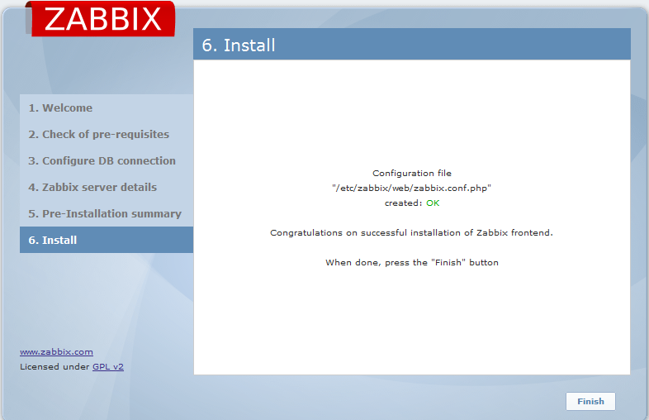

进入登录界面，默认账户是admin，密码是zabbix。

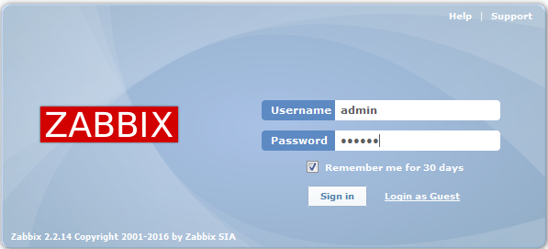

至此完成服务器端的安装。

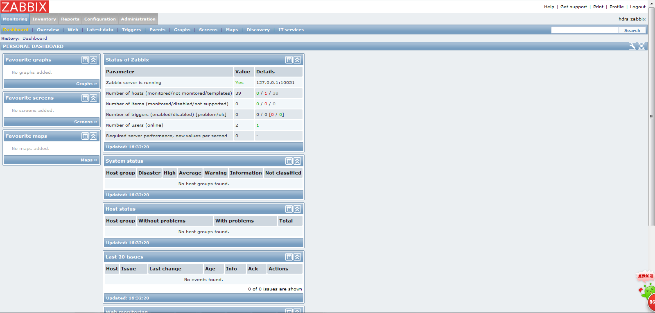

3、Zabbix-Agent客户端安装

3.1 安装 Linux Zabbix-Agent

### 3.1.1 rpm包安装

从Zabbix官网下载RPM安装包zabbix-2.2.14-1.el6.x86_64.rpm 和zabbix-agent-2.2.14-1.el6.x86_64.rpm, 下载地址为

<http://repo.zabbix.com/zabbix/2.2/rhel/6/x86_64/>

Y:\信息技术部\系统架构组\zabbix-agent-2.2.14_x86_64

#### 3.1.1.1　先安装zabbix包，然后安装zabbix-agent即可

*shell # rpm –ivh zabbix-2.2.14-1.el6.x86_64.rpm*

*shell # rpm –ivh zabbix-agent-2.2.14-1.el6.x86_64.rpm*

#### 3.1.1.2　配置文件目录在/etc/zabbix下

修改配置文件中两个地方

Server=192.168.100.239 Zabbix服务器的IP地址

Hostname=Zabbix-Agent01 Zabbix客户端的计算机名字

shell# egrep -v "(^#|^$)" ./zabbix_agentd.conf

PidFile=/var/run/zabbix/zabbix_agentd.pid

LogFile=/var/log/zabbix/zabbix_agentd.log

LogFileSize=0

Server=127.0.0.1,10.163.36.20

ServerActive=10.163.36.20:10051

Hostname=Zabbix-Agent01

Include=/etc/zabbix/zabbix_agentd.d/

#### 3.1.1.3启动服务和配置开机启动

*service zabbix-agent start*

chkconfig zabbix-agent on

### 3.1.2　yum源安装

从Zabbix官网yum 源安装RPM包

*shell # rpm –ivh*[*http://repo.zabbix.com/zabbix/2.2/rhel/6/x86_64/*](http://repo.zabbix.com/zabbix/2.2/rhel/6/x86_64/)*zabbix-agent-2.2.14-1.el6.x86_64.rpm*

*shell # yum install –y zabbix zabbix-agent*

### 3.1.3编译安装

也可以下载Zabbix pre-compiled agents(目前都是３２位的)

<http://www.zabbix.com/downloads/2.2.9/zabbix_agents_2.2.9.linux2_6_23.i386.tar.gz>

#### 3.1.3.1首先修改计算机的主机名字

shell# hostname

Zabbix-Agent01

shell# cat /etc/sysconfig/network

NETWORKING=yes

HOSTNAME=Zabbix-Agent01

#### 3.1.3.2.创建用户

useradd -s /sbin/nologin zabbix

#### 3.1.3.3.下载解压客户端

下载Zabbix pre-compiled agents(目前都是３２位的)

http://www.zabbix.com/downloads/2.2.9/zabbix_agents_2.2.9.linux2_6_23.i386.tar.gz

在2.0后客户端安装的时候，会解压三个文件，sbin conf bin；把解压的三个目录复制到我们创建的zabbix目录下面

shell# tar zxvf zabbix_agents_2.2.9.linux2_6_23.i386.tar.gz

shell# cp -a bin/ sbin/ conf/ /usr/local/zabbix/

#### 3.1.3.4.配置zabbix客户端的端口

在配置文件vim /etc/services中添加如下内容

#####################zabbix agents#############

zabbix-agent 10050/tcp #Zabbix Agent

zabbix-agent 10050/udp #Zabbix Agent

如果客户端防火墙没有关闭，可以添加Zabbix的端口

#### 3.1.3.5.修改zabbix客户端的配置文件

shell# mv /usr/local/zabbix/zabbix_agentd.conf /usr/local/etc

修改配置文件中两个地方

Server=192.168.100.239 Zabbix服务器的IP地址

Hostname=Zabbix-Agent01 Zabbix客户端的计算机名字

shell# egrep -v "(^#|^$)" ./zabbix_agentd.conf

PidFile=/var/run/zabbix/zabbix_agentd.pid

LogFile=/var/log/zabbix/zabbix_agentd.log

LogFileSize=0

Server=127.0.0.1,10.163.36.20

ServerActive=10.163.36.20:10051

Hostname=Zabbix-Agent01

Include=/etc/zabbix/zabbix_agentd.d/

#### 3.1.3.6.设置Zabbix的启动脚本

shell# cp -a /usr/local/zabbix/sbin/zabbix_agentd /etc/init.d/

shell# chmod +x /etc/init.d/zabbix_agentd

shell# echo "/etc/rc.d/init.d/zabbix_agentd" >> /etc/rc.local

shell# /etc/rc.d/init.d/zabbix_agentd start

如果因为系统zabbix的客户端脚本没有状态可以从服务器上拷贝一个过来

[root@Zabbix-Server ~]# scp /etc/rc.d/init.d/zabbix_agentd root@10.163.36.20:/etc/rc.d/init.d/

root@10.163.36.20's password:

zabbix_agentd 100% 2177 2.1KB/s 00:00

[root@Zabbix-Server ~]#

#### 3.1.3.7.查看状态

[root@localhost sbin]# ps -ef | grep zabbix_agentd

zabbix 23167 1 0 23:45 ? 00:00:00 /usr/local/zabbix/sbin/zabbix_agentd

zabbix 23168 23167 0 23:45 ? 00:00:00 /usr/local/zabbix/sbin/zabbix_agentd

zabbix 23169 23167 0 23:45 ? 00:00:00 /usr/local/zabbix/sbin/zabbix_agentd

zabbix 23170 23167 0 23:45 ? 00:00:00 /usr/local/zabbix/sbin/zabbix_agentd

zabbix 23171 23167 0 23:45 ? 00:00:00 /usr/local/zabbix/sbin/zabbix_agentd

zabbix 23172 23167 0 23:45 ? 00:00:00 /usr/local/zabbix/sbin/zabbix_agentd

root 23176 22786 0 23:46 pts/0 00:00:00 grep zabbix_agentd

[root@localhost sbin]#

#### 3.1.3.8.服务器测试键值KEY(从10.163.36.20）

[root@D2-ZABBIX20 init.d]# zabbix_get -s 10.163.36.110 -k system.uname

Linux testagent 2.6.32-431.el6.x86_64 #1 SMP Sun Nov 10 22:19:54 EST 2013 x86_64

[root@D2-ZABBIX20 init.d]#

3.2 安装 Windows Zabbix-Agent

下载Zabbix-Agent windows版本，下载地址为

<http://www.zabbix.com/downloads/2.2.9/zabbix_agents_2.2.9.win.zip>

解压到文件夹*C:\Program Files\zabbix_agents_2.2.9.win.zip*

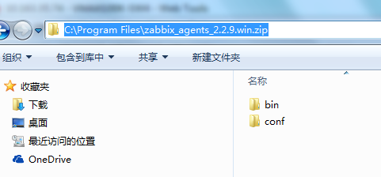

配置文件zabbix_agentd.win.conf的配置内容如下，主要把server(被动模式)和serverActive(主动模式)的zabbix服务器的IP地址添加，以用于的客户端的监控数据收集

并手动创建log文件夹用于日志收集*C:\Program Files\zabbix_agents_2.2.9.win.zip\zabbix_agentd.log*

*Server=10.163.36.20*

*ServerActive=10.163.36.20*

*Hostname=192.168.17.99*

*LogFile=C:\Program Files\zabbix_agents_2.2.9.win.zip\zabbix_agentd.log\zabbix_agentd.log*

注册服务

以管理员身份进入cmd命令行

*cd C:\Program Files\zabbix_agents_2.2.9.win.zip\bin\win64*

*zabbix_agentd.exe --install -c "C:\ProgramFiles\zabbix_agents_2.2.9.win.zip\conf\zabbix_agentd.win.conf"*

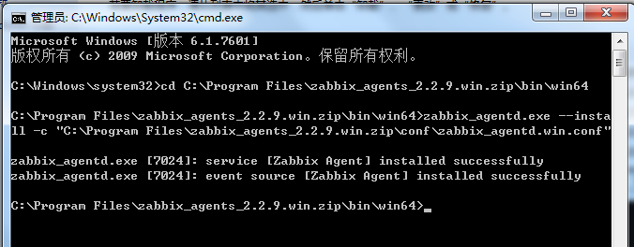

启用服务

启用zabbix agent 服务，并为自动启动

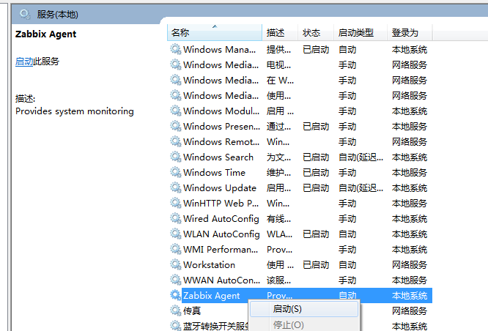

4、添加host主机到监控平台

4.1 登录监控平台，创建主机

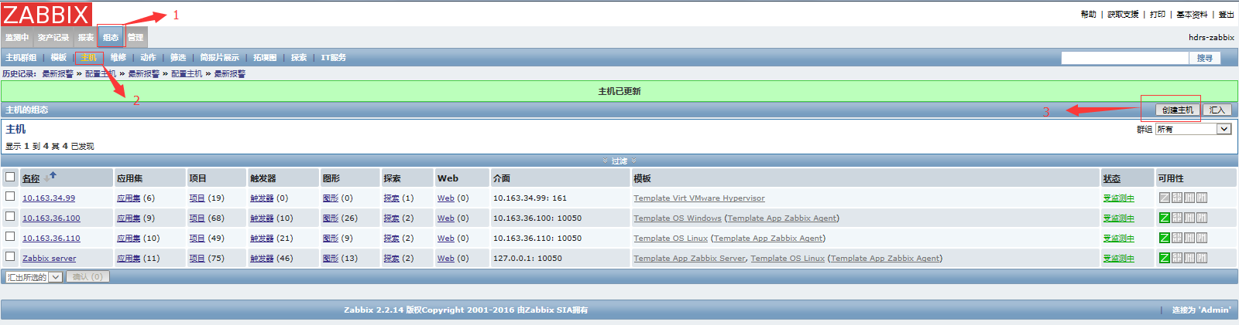

4.2 添加agent监控

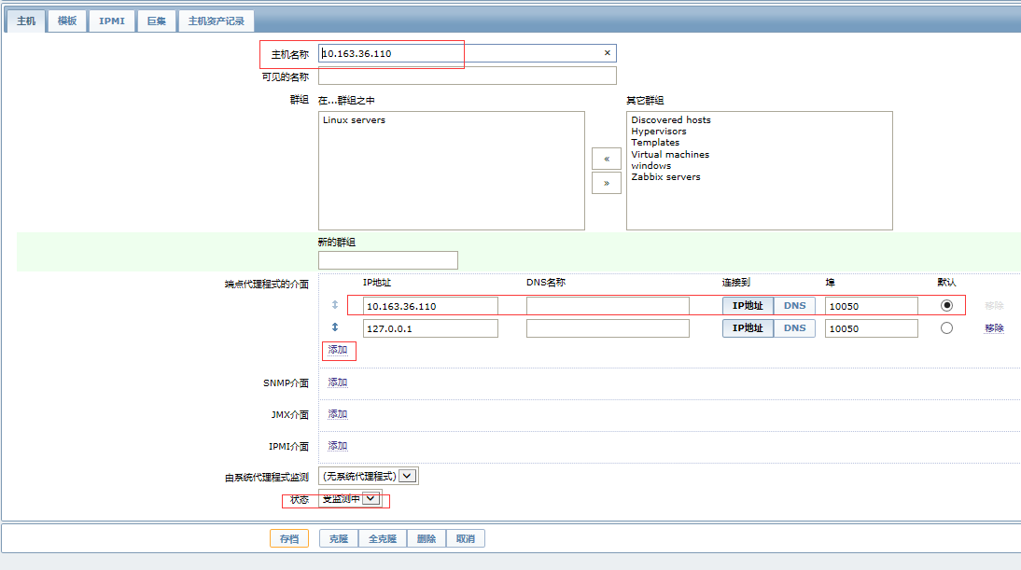

4.3 添加模板用于监控条目

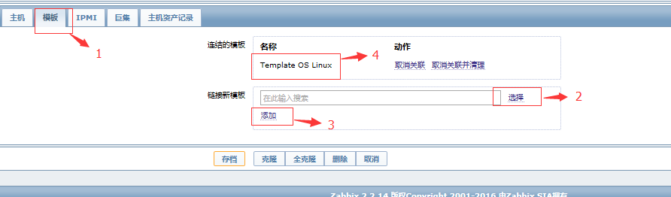

4.4 监控成功后，Ｚ图标状态显示绿色

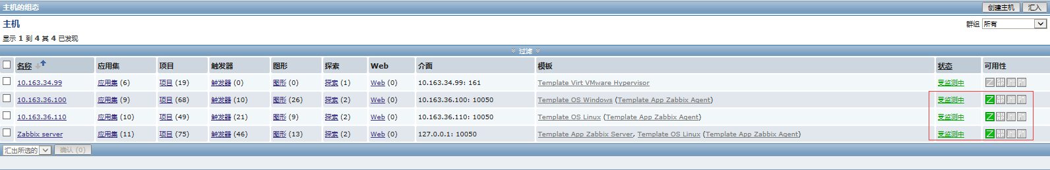

4.5 监控数据产生，查看监控图表

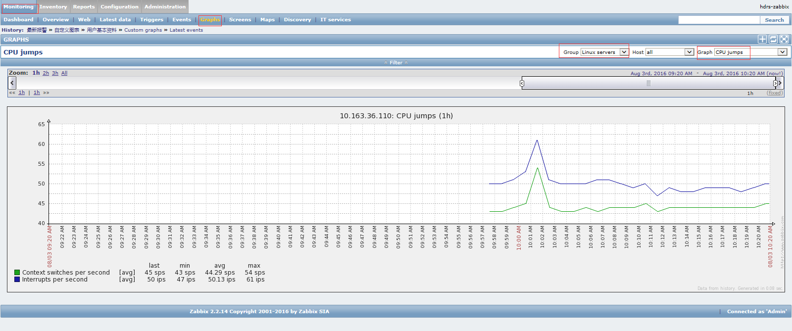

5、Linux系统监控实例

5.1 客户端关闭防火墙和SELinux

[root@D2-POMS81 ~]# /etc/init.d/iptables status

iptables: Firewall is not running.

[root@D2-POMS81 ~]# getenforce

Disabled

5.2 客户端安装Zabbix-Agent

从Zabbix官网下载RPM安装包zabbix-2.2.14-1.el6.x86_64.rpm和zabbix-agent-2.2.14-1.el6.x86_64.rpm, 下载地址为<http://repo.zabbix.com/zabbix/2.2/rhel/6/x86_64/>，上传到客户端进行安装。

[root@D2-POMS81 ~]# rpm -ivh zabbix-2.2.14-1.el6.x86_64.rpm

warning: zabbix-2.2.14-1.el6.x86_64.rpm: Header V4 DSA/SHA1 Signature, key ID 79ea5ed4: NOKEY

Preparing... ########################################### [100%]

1:zabbix ########################################### [100%]

[root@D2-POMS81 ~]# rpm -ivh zabbix-agent-2.2.14-1.el6.x86_64.rpm

warning: zabbix-agent-2.2.14-1.el6.x86_64.rpm: Header V4 DSA/SHA1 Signature, key ID 79ea5ed4: NOKEY

Preparing... ########################################### [100%]

1:zabbix-agent ########################################### [100%]

5.3 客户端配置zabbix-agentd.conf

修改前：

[root@D2-POMS81 ~]# egrep -v "(^#|^$)" /etc/zabbix/zabbix_agentd.conf

PidFile=/var/run/zabbix/zabbix_agentd.pid

LogFile=/var/log/zabbix/zabbix_agentd.log

LogFileSize=0

Server=127.0.0.1

ServerActive=127.0.0.1

Hostname=Zabbix server

Include=/etc/zabbix/zabbix_agentd.d

修改后：

[root@D2-POMS81 ~]# egrep -v "(^#|^$)" /etc/zabbix/zabbix_agentd.conf

PidFile=/var/run/zabbix/zabbix_agentd.pid

LogFile=/var/log/zabbix/zabbix_agentd.log

LogFileSize=0

EnableRemoteCommands=1

Server=10.163.36.20

ServerActive=10.163.36.20:10051

Hostname=10.163.91.81

AllowRoot=1

Include=/etc/zabbix/zabbix_agentd.d/

5.4 客户端启动zabbix-agent

[root@D2-POMS81 ~]# chkconfig --list zabbix-agent

zabbix-agent 0:off 1:off 2:off 3:off 4:off 5:off 6:off

[root@D2-POMS81 ~]# chkconfig zabbix-agent on

[root@D2-POMS81 ~]# chkconfig --list zabbix-agent

zabbix-agent 0:off 1:off 2:on 3:on 4:on 5:on 6:off

[root@D2-POMS81 ~]# cp -a /usr/sbin/zabbix_agentd /etc/init.d/

[root@D2-POMS81 ~]# chmod +x /etc/init.d/zabbix_agentd

[root@D2-POMS81 ~]# /etc/init.d/zabbix-agent start

Starting Zabbix agent: [ OK ]

[root@D2-POMS81 ~]# ps -ef | grep zabbix

root 30657 1 0 15:46 ? 00:00:00 zabbix_agentd -c /etc/zabbix/zabbix_agentd.conf

root 30659 30657 0 15:46 ? 00:00:00 zabbix_agentd: collector [idle 1 sec]

root 30660 30657 0 15:46 ? 00:00:00 zabbix_agentd: listener #1 [waiting for connection]

root 30661 30657 0 15:46 ? 00:00:00 zabbix_agentd: listener #2 [waiting for connection]

root 30662 30657 0 15:46 ? 00:00:00 zabbix_agentd: listener #3 [waiting for connection]

root 30663 30657 0 15:46 ? 00:00:00 zabbix_agentd: active checks #1 [idle 1 sec]

root 34810 38462 0 16:44 pts/0 00:00:00 grep zabbix

5.5 服务器端配置主机和模版

使用zabbix_get命令测试客户端agent是否配置正确：

[root@D2-ZABBIX20 ~]# zabbix_get -s 10.163.91.81 -k system.uname

Linux D2-POMS81 2.6.32-431.el6.x86_64 #1 SMP Sun Nov 10 22:19:54 EST 2013 x86_64

返回正常，说明配置正确。

添加主机创建监控：

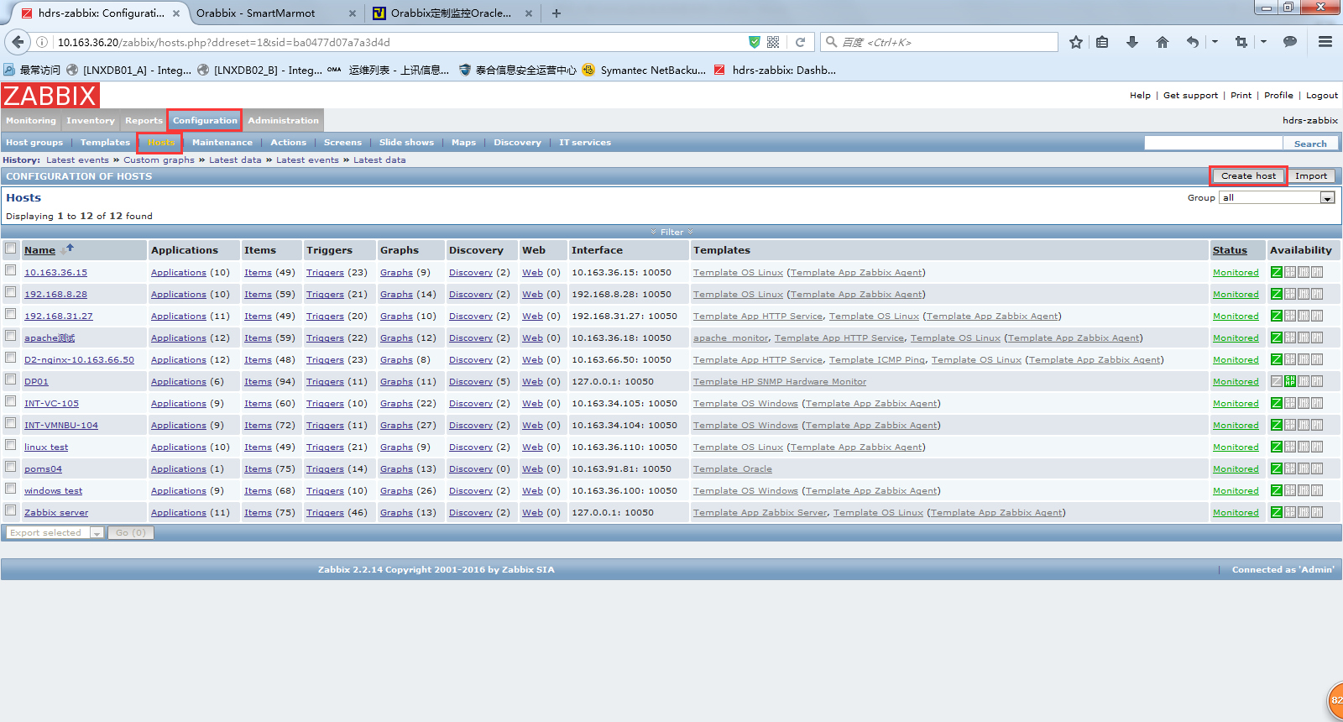

此处的Host name要与前面/etc/zabbix/zabbix_agentd.conf文件中的Hostname一致。

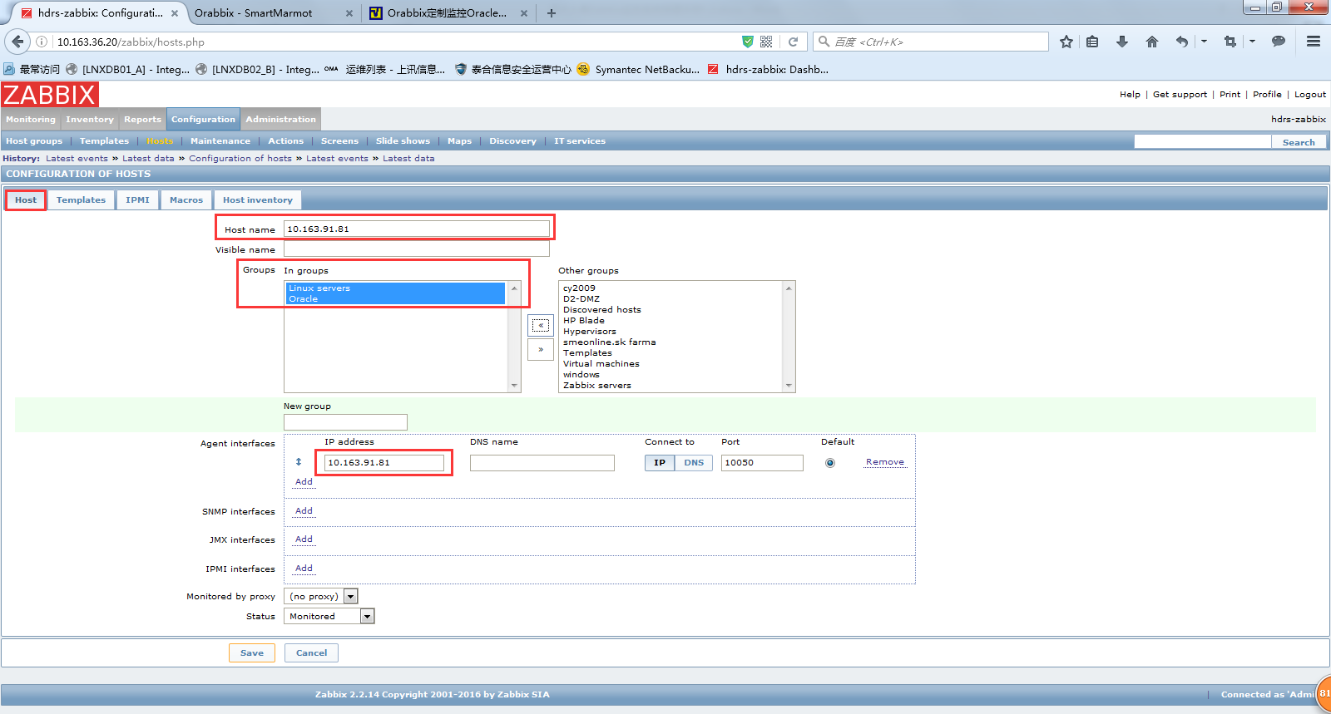

添加模版：

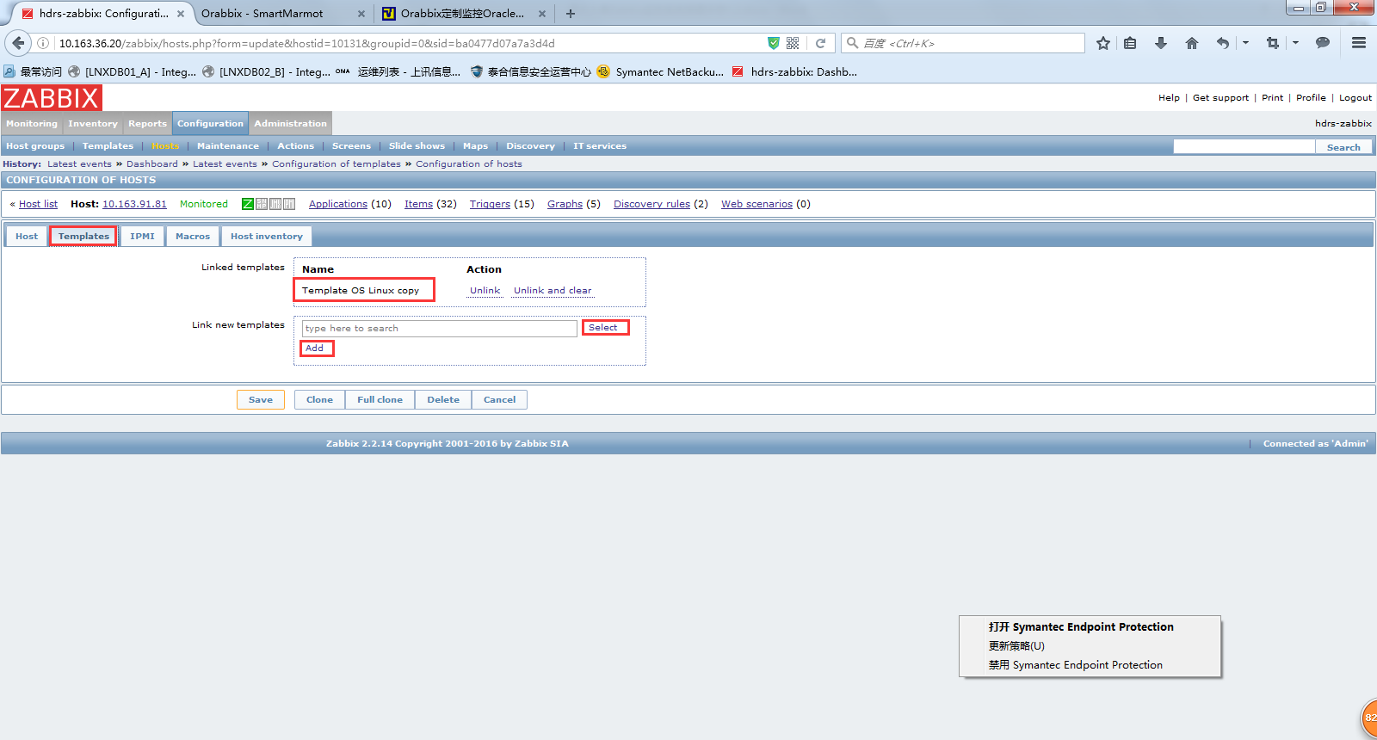

6、Oracle数据库监控实例

6.1 客户端安装orabbix

Zabbix通过在客户端安装orabbix对oracle进行监控，是与zabbix agent同一级别的agent。原理如下图：

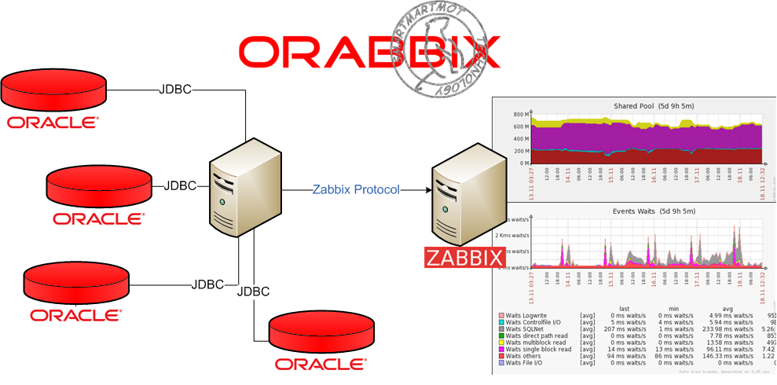

通过orabbix可以监控的内容如下：

|  |
| --- |
| * DB Version (i.e. Validity of package) * Archiving (Archive log production with trend analysis) * Event Waits (Files I/O, single block read, multi-block read, direct path read, SQLNet Messages, Control file I/O, Log Write) * Hit Ratio (Hit Ratio on Triggers, Tables/Procedures, SQL Area, Body) * Logical I/O (Server performance on Logical I/O of: Current Read, Consistent Read, Block Change) * Physical I/O (Redo Writes, Datafile Writes, Datafile Reads) * PGA * SGA (In particular; Fixed Buffer, Java Pool, Large Pool, Log Buffer, Shared Poolm Buffer Cache) * Shared Pool (Pool Dictionary Cache, Pool Free Memory, Library Chache, SQL Area, MISC.) * Pin Hit Ratio (Oracle library cache pin are caused by contention with the library cache, the area used to store SQL executables for re-use) * Sessions / Processes * Sessions (Active Sessions, Inactive Sessions, System Sessions) * DBSize/DBFileSize (DBSize size of database really used space and of Filesize) |

从<http://www.smartmarmot.com/product/orabbix/download/>下载orabbix，目前版本为1.2.3。

安装要求如下：

|  |
| --- |
| To use Orabbix, you will require the following on your Zabbix Server:   * Zabbix 1.8.x Server * Java Runtime Environment 6   Current known successfully tested Oracle host platforms:   * RHEL5.X (CentOS 5.4 & 5.5) * Windows 2003 (with Java SE 1.6) * HP-UX 11.31 * AIX 5.3 |

下面针对10.163.91.81进行安装，操作系统为RHEL6.5，数据库为oracle 11.2.0.4。

1. 先确认jdk，如果没有或者版本不满足，则需要卸载后重新安装。

[root@D2-POMS81 ~]# java -version

java version "1.5.0"

gij (GNU libgcj) version 4.4.7 20120313 (Red Hat 4.4.7-4)

Copyright (C) 2007 Free Software Foundation, Inc.

This is free software; see the source for copying conditions. There is NO

warranty; not even for MERCHANTABILITY or FITNESS FOR A PARTICULAR PURPOSE.

[root@D2-POMS81 ~]# yum remove java

[root@D2-POMS81 ~]# chmod u+x jdk-6u25-linux-x64.bin

[root@D2-POMS81 ~]# ./jdk-6u25-linux-x64.bin

安装完成后添加环境变量：

[root@D2-POMS81 ~]# vim /etc/profile

在最后面添加如下内容 ：

[root@D2-POMS81 ~]# tail -4 /etc/profile

export JAVA_HOME=/root/jdk1.6.0_25

export JAVA_BIN=/root/jdk1.6.0_25/bin

export PATH=$PATH:$JAVA_HOME/bin

export CLASSPATH=.:$JAVA_HOME/lib/dt.jar:$JAVA_HOME/lib/tools.jar

立即生效：

[root@D2-POMS81 ~]# source /etc/profile

[root@D2-POMS81 ~]# java -version

java version "1.6.0_25"

Java(TM) SE Runtime Environment (build 1.6.0_25-b06)

Java HotSpot(TM) 64-Bit Server VM (build 20.0-b11, mixed mode)

（2）安装orabbix

创建目录：

[root@D2-POMS81 ~]# mkdir -p /opt/orabbix

[root@D2-POMS81 ~]# cd /opt/orabbix

解压：

[root@D2-POMS81 orabbix]# unzip /root/orabbix-1.2.3.zip

[root@D2-POMS81 orabbix]# cd ..

授予权限：

[root@D2-POMS81 opt]# chmod -R a+x orabbix/

6.2 客户端配置orabbix

[root@D2-POMS81 opt]# cp /opt/orabbix/conf/config.props.sample　/opt/orabbix/conf/config.props

[root@D2-POMS81 opt]# vim /opt/orabbix/conf/config.props

#comma separed list of Zabbix servers

ZabbixServerList=ZabbixServer1

ZabbixServer1.Address=10.163.36.20

ZabbixServer1.Port=10051

#ZabbixServer2.Address=IP_ADDRESS_OF_ZABBIX_SERVER

#ZabbixServer2.Port=PORT_OF_ZABBIX_SERVER

#pidFile

OrabbixDaemon.PidFile=./logs/orabbix.pid

#frequency of item's refresh

OrabbixDaemon.Sleep=300

#MaxThreadNumber should be >= than the number of your databases

OrabbixDaemon.MaxThreadNumber=100

#put here your databases in a comma separated list

DatabaseList=poms04

#Configuration of Connection pool

#if not specified Orabbis is going to use default values (hardcoded)

#Maximum number of active connection inside pool

DatabaseList.MaxActive=10

#The maximum number of milliseconds that the pool will wait

#(when there are no available connections) for a connection to be returned

#before throwing an exception, or <= 0 to wait indefinitely.

DatabaseList.MaxWait=100

DatabaseList.MaxIdle=1

#define here your connection string for each database

poms04.Url=jdbc:oracle:thin:@10.163.91.81:1521:poms04

poms04.User=zabbix

poms04.Password=zabbix

#Those values are optionals if not specified Orabbix is going to use the general values

poms04.MaxActive=10

poms04.MaxWait=100

poms04.MaxIdle=1

poms04.QueryListFile=./conf/query.props

#DB2.Url=jdbc:oracle:thin:@server2.domain.example.com:<LISTENER_PORT>:DB2

#DB2.User=zabbix

#DB2.Password=zabbix_password

#DB2.QueryListFile=./conf/query.props

#DB3.Url=jdbc:oracle:thin:@server3.domain.example.com:<LISTENER_PORT>:DB3

#DB3.User=zabbix

#DB3.Password=zabbix_password

#DB3.QueryListFile=./conf/query.props

6.3 客户端数据库配置

（1）创建用户

执行以下语句创建数据库用户：

|  |
| --- |
| CREATE USER ZABBIX  IDENTIFIED BY zabbix  DEFAULT TABLESPACE USERS  TEMPORARY TABLESPACE TEMP  PROFILE DEFAULT  ACCOUNT UNLOCK;  GRANT CONNECT TO ZABBIX;  GRANT RESOURCE TO ZABBIX;  ALTER USER ZABBIX DEFAULT ROLE ALL;  GRANT SELECT ANY TABLE TO ZABBIX;  GRANT CREATE SESSION TO ZABBIX;  GRANT SELECT ANY DICTIONARY TO ZABBIX;  GRANT UNLIMITED TABLESPACE TO ZABBIX;  GRANT SELECT ANY DICTIONARY TO ZABBIX; |

（2）放行数据库11g的网络限制

SQL> exec dbms_network_acl_admin.create_acl(acl => 'resolve.xml',description => 'resolve acl', principal =>'ZABBIX', is_grant => true, privilege => 'resolve');

PL/SQL procedure successfully completed.

SQL> exec dbms_network_acl_admin.assign_acl(acl => 'resolve.xml', host =>'*');

PL/SQL procedure successfully completed.

SQL> commit;

Commit complete.

SQL> select utl_inaddr.get_host_name('127.0.0.1') from dual;

UTL_INADDR.GET_HOST_NAME('127.0.0.1')

--------------------------------------------------------------------------------

Localhost

6.4 客户端启动orabbix

配置跟随系统启动：

[root@D2-POMS81 ~]# cp /opt/orabbix/init.d/orabbix /etc/init.d/orabix

[root@D2-POMS81 ~]# cp /opt/orabbix/init.d/orabbix /etc/init.d/orabbix

[root@D2-POMS81 ~]# chkconfig --add orabbix

[root@D2-POMS81 ~]# chkconfig --level 345 orabbix on

[root@D2-POMS81 ~]# cp /opt/orabbix/run.sh /opt/orabbix/run.sh.bak

[root@D2-POMS81 ~]# sed -i 's#java#/root/jdk1.6.0_25/bin/java#g' /opt/orabbix/run.sh

[root@D2-POMS81 ~]# /etc/init.d/orabbix start

Starting Orabbix service:

6.5 服务器端配置主机和模版

从客户端的/opt/orabbix/template目录下下载模版到本地，再进行导入：

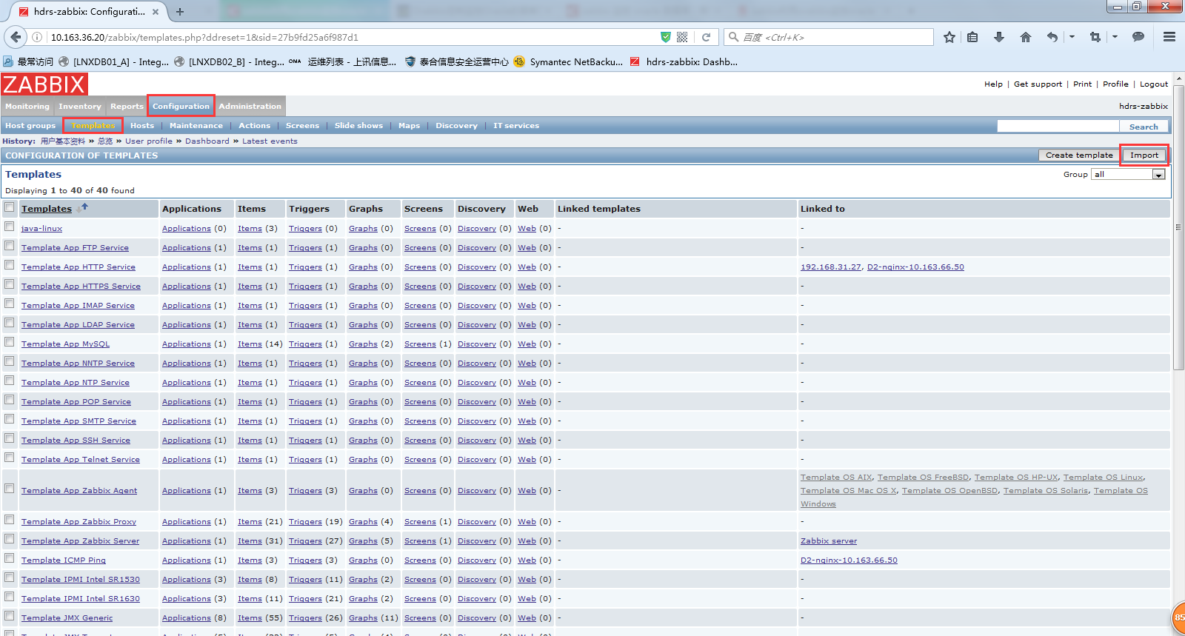

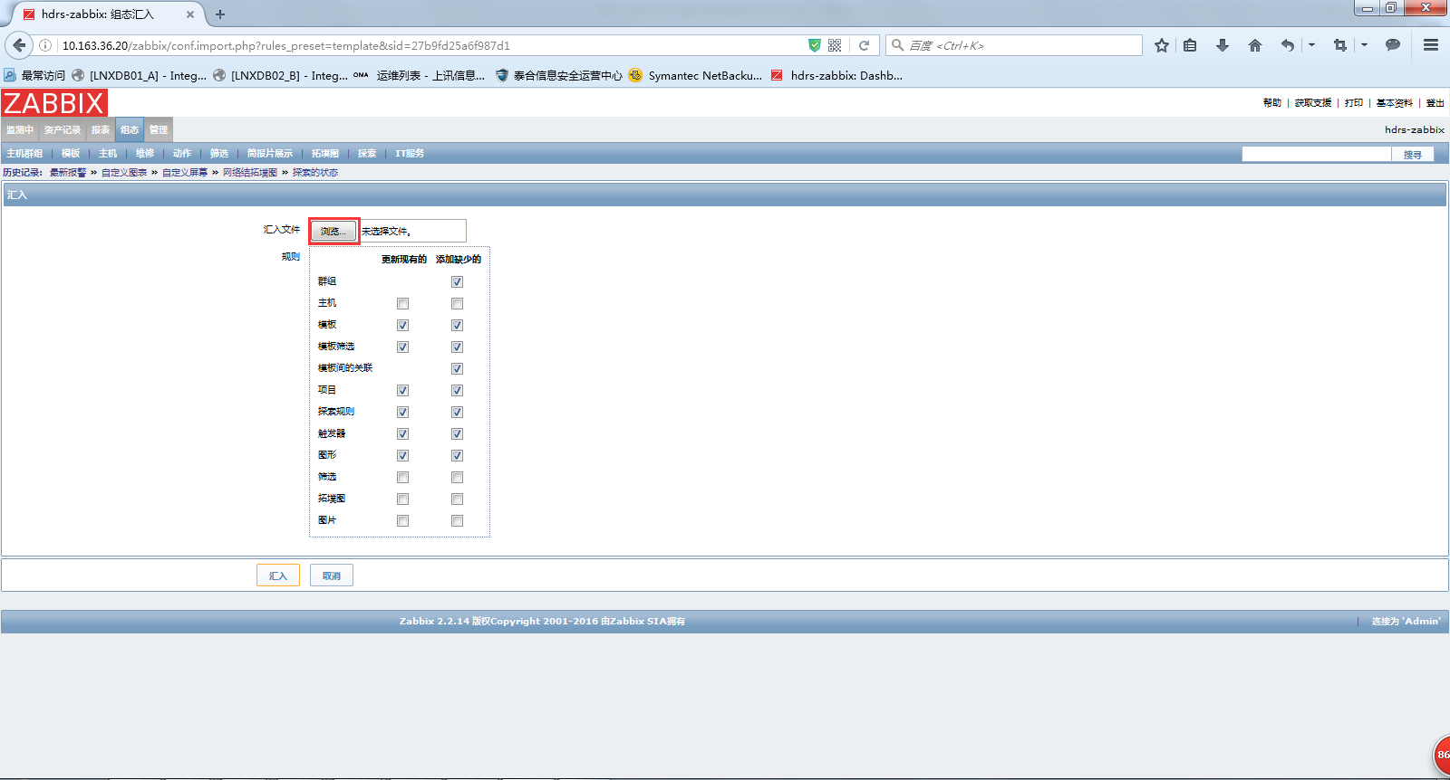

添加主机创建监控：

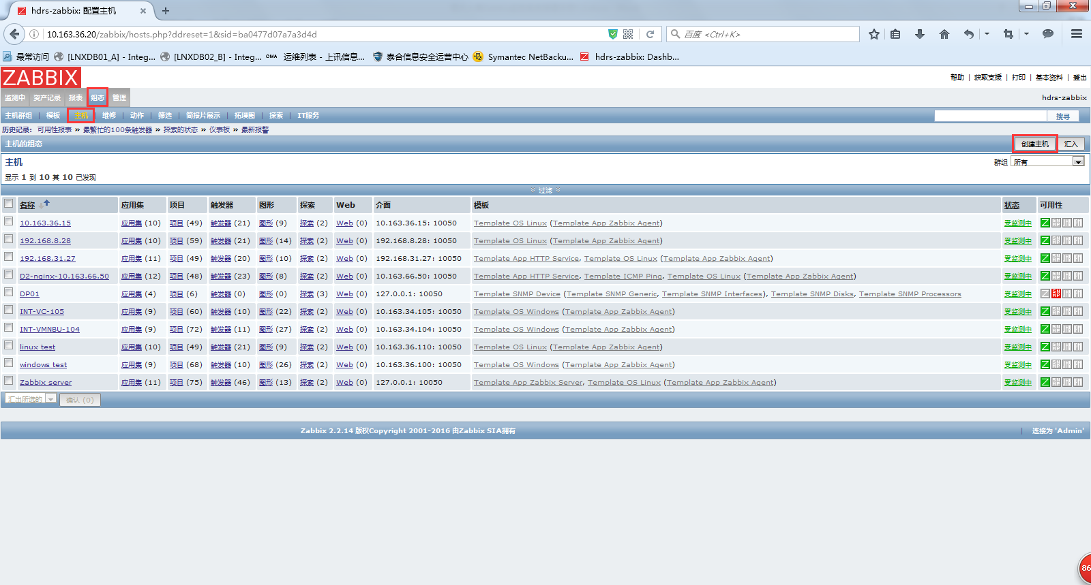

Host name为客户端配置文件中指定的DatabaseList。

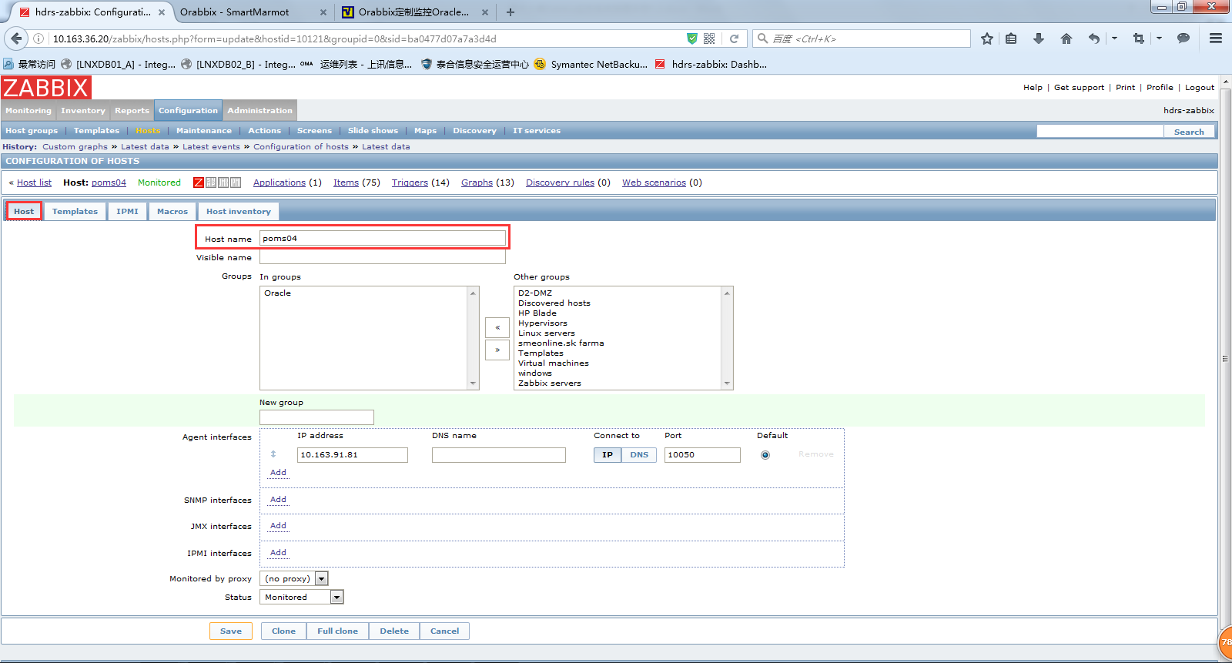

链接模版到该主机：

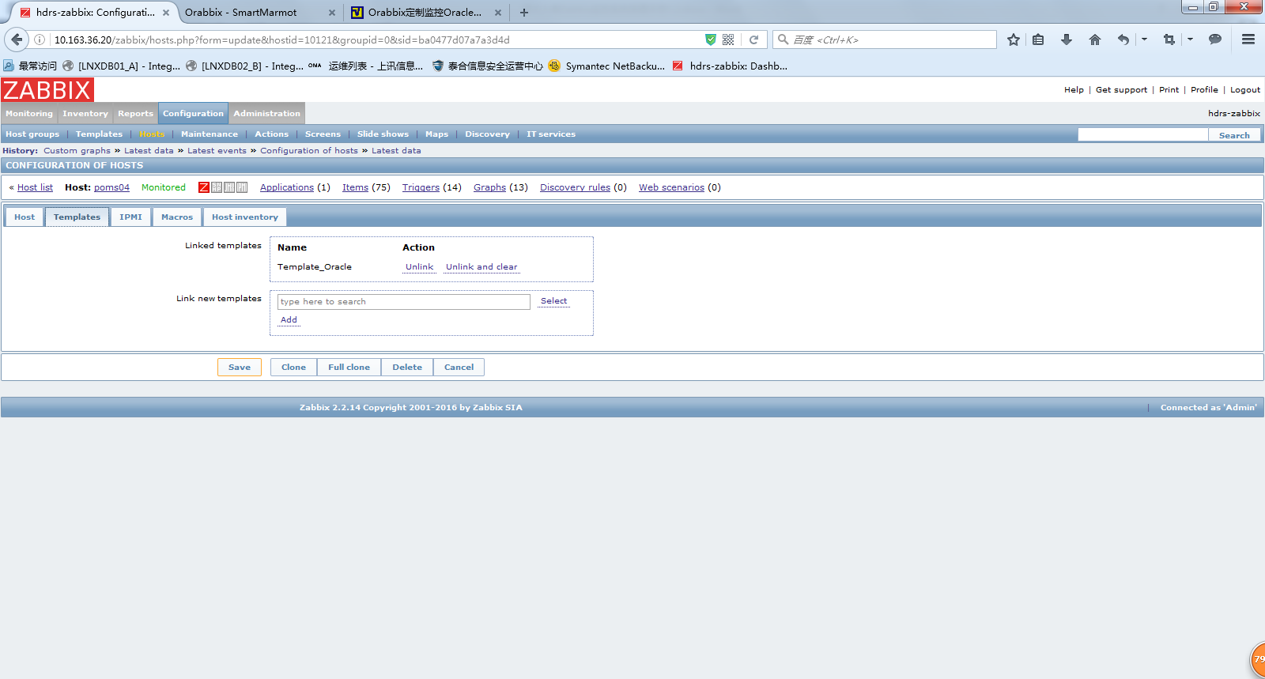

6.6 客户端配置query.props

在文件/opt/orabbix/conf/config.props中指定了QueryListFile参数为./conf/query.props，可以通过配置query.props文件自定义查询获取数据库数据。

例如需要监控数据库的快速恢复区的使用情况，则需要先在参数QueryList中添加监控项：flash_recovery_area_usage，然后指定语句，注意语句结束是不需要分号的，如果sql语句比较长，需要以\结尾。

[root@D2-POMS81 ~]# grep flash_recovery_area_usage.Query /opt/orabbix/conf/query.props

flash_recovery_area_usage.Query=SELECT SUM(PERCENT_SPACE_USED) FROM V$FLASH_RECOVERY_AREA_USAGE

|  |
| --- |
| [root@D2-POMS81 conf]# cat pisit23query.props  DefaultQueryPeriod=2  QueryList=archive,audit,dbblockgets,dbconsistentgets,dbhitratio,dbphysicalread,dbversion,hitratio_body,hitratio_sqlarea,hitratio_table_proc, \  lio_current_read,locks,maxprocs,maxsession,miss_latch,pga_aggregate_target, pga,phio_datafile_reads,phio_datafile_writes,phio_redo_writes,pinhitratio_body,pinhitratio_sqlarea,pinhitratio_table-proc,pinhitratio_trigger, \  pool_dict_cache,pool_free_mem,pool_lib_cache,pool_misc,pool_sql_area,procnum,session_active,session_inactive,session,session_system,sga_buffer_cache, \  sga_fixed,sga_java_pool,sga_large_pool,sga_log_buffer,sga_shared_pool,tbl_space,userconn,waits_controfileio,waits_directpath_read, \  waits_file_io,waits_latch,waits_logwrite,waits_multiblock_read,waits_singleblock_read,hitratio_trigger,lio_block_changes,lio_consistent_read,waits_other,waits_sqlnet,users_locked,uptime,flash_recovery_area_usage,dg_error  #DataGuardPrimaryQueryList=dg_error,dg_sequence_number  DataGuardStandbyQueryList=dg_sequence_number_stby  RmanQueryList=rman_check_status  rman_check_status.Query=select ' DB NAME->'||DB_NAME||'- ROW TYPE->'||ROW_TYPE||'- START TIME->'||to_char(start_time, 'Dy DD-Mon-YYYY HH24:MI:SS') ||'- END TIME->'||to_char(end_time, 'Dy DD-Mon-YYYY HH24:MI:SS')||'- MBYTES PROCESSED->'||MBYTES_PROCESSED||'- OBJECT TYPE->'||OBJECT_TYPE||'- STATUS->'||STATUS||'- OUTPUT DEVICE->'||OUTPUT_DEVICE_TYPE||'- INPUT MB->'||INPUT_BYTES/1048576||'- OUT MB'||OUTPUT_BYTES/1048576 \  FROM rc_rman_status \  WHERE start_time > SYSDATE - 1 \  AND ( STATUS like '%FAILED%' \  OR STATUS like '%ERROR%') \  ORDER BY END_TIME  rman_check_status.NoDataFound=none  uptime.Query=select to_char((sysdate-startup_time)*86400, 'FM99999999999999990') retvalue from v$instance  users_locked.Query=SELECT username||' '|| lock_date ||' '|| account_status FROM dba_users where ACCOUNT_STATUS like 'EXPIRED(GRACE)' or ACCOUNT_STATUS like 'LOCKED(TIMED)'  users_locked.NoDataFound=none  archive.Query=select round(A.LOGS*B.AVG/1024/1024/10) from ( SELECT COUNT (*) LOGS FROM V$LOG_HISTORY WHERE FIRST_TIME >= (sysdate -10/60/24)) A, ( SELECT Avg(BYTES) AVG, Count(1), Max(BYTES) Max_Bytes, Min(BYTES) Min_Bytes FROM v$log) B  archive.RaceConditionQuery=select value from v$parameter where name='log_archive_start'  archive.RaceConditionValue=FALSE  audit.Query=select username "username", \  to_char(timestamp,'DD-MON-YYYY HH24:MI:SS') "time_stamp", \  action_name "statement", \  os_username "os_username", \  userhost "userhost", \  returncode||decode(returncode,'1004','-Wrong Connection','1005','-NULL Password','1017','-Wrong Password','1045','-Insufficient Priviledge','0','-Login Accepted','--') "returncode" \  from sys.dba_audit_session \  where (sysdate - timestamp)*24 < 1 and returncode <> 0 \  order by timestamp  audit.NoDataFound=none  dbblockgets.Query=select to_char(sum(decode(name,'db block gets', value,0))) "block_gets" \  FROM v$sysstat  dbconsistentgets.Query=select to_char(sum(decode(name,'consistent gets', value,0))) "consistent_gets" \  FROM v$sysstat  dbhitratio.Query=select ( \  sum(decode(name,'consistent gets', value,0)) + sum(decode(name,'db block gets', value,0)) - sum(decode(name,'physical reads', value,0))) / (sum(decode(name,'consistent gets', value,0)) + sum(decode(name,'db block gets', value,0)) ) * 100 "hit_ratio" \  FROM v$sysstat  dbphysicalread.Query=select sum(decode(name,'physical reads', value,0)) "phys_reads" FROM v$sysstat  dbversion.Query=select COMP_ID||' '||COMP_NAME||' '||VERSION||' '||STATUS||' <br />' from dba_registry union SELECT ' - SERVERNAME = <b>'||UTL_INADDR.get_host_name ||'</b> - SERVERADDRESS = <b>'||UTL_INADDR.get_host_address||'</b> <br />'from dual union SELECT ' - DB_NAME = <b>'||SYS_CONTEXT ('USERENV', 'DB_NAME') ||'</b> - INSTANCE_NAME = <b>' ||SYS_CONTEXT ('USERENV', 'INSTANCE_NAME')||'</b> <br />' FROM dual  sqlnotindexed.Query=SELECT SUM(DECODE(NAME, 'table scans (long tables)', VALUE, 0))/ (SUM(DECODE(NAME, 'table scans (long tables)', VALUE, 0))+SUM(DECODE(NAME, 'table scans (short tables)', VALUE, 0)))*100 SQL_NOT_INDEXED FROM V$SYSSTAT WHERE 1=1 AND ( NAME IN ('table scans (long tables)','table scans (short tables)') )  hitratio_body.Query=select gethitratio*100 "get_pct" FROM v$librarycache where namespace ='BODY'  hitratio_sqlarea.Query=select gethitratio*100 "get_pct" FROM v$librarycache where namespace ='SQL AREA'  hitratio_trigger.Query=select gethitratio*100 "get_pct" FROM v$librarycache where namespace ='TRIGGER'  hitratio_table_proc.Query=select gethitratio*100 "get_pct" FROM v$librarycache where namespace = 'TABLE/PROCEDURE'  lio_block_changes.Query=SELECT to_char(SUM(DECODE(NAME,'db block changes',VALUE,0))) \  FROM V$SYSSTAT \  WHERE NAME ='db block changes'  lio_consistent_read.Query=SELECT to_char(sum(decode(name,'consistent gets',value,0))) FROM V$SYSSTAT WHERE NAME ='consistent gets'  lio_current_read.Query=SELECT to_char(sum(decode(name,'db block gets',value,0))) FROM V$SYSSTAT WHERE NAME ='db block gets'  locks.Query=SELECT b.session_id AS sid, \  NVL(b.oracle_username, '(oracle)') AS username, \  a.owner AS object_owner, \  a.object_name, \  Decode(b.locked_mode, 0, 'None', \  1, 'Null (NULL)', \  2, 'Row-S (SS)', \  3, 'Row-X (SX)', \  4, 'Share (S)', \  5, 'S/Row-X (SSX)', \  6, 'Exclusive (X)', \  b.locked_mode) locked_mode, \  b.os_user_name \  FROM dba_objects a, \  v$locked_object b \  WHERE a.object_id = b.object_id \  ORDER BY 1, 2, 3, 4  #locks.Query=select sn.USERNAME ||'@'||sn.machine, \  '|SID->' || m.SID, \  '|Serial->'|| sn.SERIAL#, \  '|Lock Type->'||m.TYPE, \  decode(LMODE, \  1, 'Null', \  2, 'Row-S (SS)', \  3, 'Row-X (SX)', \  4, 'Share', \  5, 'S/Row-X (SSX)', \  6, 'Exclusive') lock_type, \  decode(REQUEST, \  0, 'None', \  1, 'Null', \  2, 'Row-S (SS)', \  3, 'Row-X (SX)', \  4, 'Share', \  5, 'S/Row-X (SSX)', \  6, 'Exclusive') lock_requested, \  '|Time (Sec)->'||m.CTIME "Time(sec)", \  '|ID1->'||m.ID1, \  '|ID2->'||m.ID2, \  '|SQL Text->'||t.SQL_TEXT \  from v$session sn, \  v$lock m , \  v$sqltext t \  where t.ADDRESS =sn.SQL_ADDRESS \  and t.HASH_VALUE =sn.SQL_HASH_VALUE \  and ((sn.SID =m.SID and m.REQUEST !=0) \  or (sn.SID =m.SID and m.REQUEST =0 and LMODE !=4 and (ID1, ID2) in \  (select s.ID1, s.ID2 \  from v$lock S \  where REQUEST !=0 \  and s.ctime > 5 \  and s.ID1 =m.ID1 \  and s.ID2 =m.ID2))) \  order by sn.USERNAME, sn.SID, t.PIECE  locks.NoDataFound=none  maxprocs.Query=select value "maxprocs" from v$parameter where name ='processes'  maxsession.Query=select value "maxsess" from v$parameter where name ='sessions'  miss_latch.Query=SELECT SUM(misses) FROM V$LATCH  pga_aggregate_target.Query=select to_char(decode( unit,'bytes', value/1024/1024, value),'999999999.9') value from V$PGASTAT where name in 'aggregate PGA target parameter'  pga.Query=select to_char(decode( unit,'bytes', value/1024/1024, value),'999999999.9') value from V$PGASTAT where name in 'total PGA inuse'  phio_datafile_reads.Query=select to_char(sum(decode(name,'physical reads direct',value,0))) FROM V$SYSSTAT where name ='physical reads direct'  phio_datafile_writes.Query=select to_char(sum(decode(name,'physical writes direct',value,0))) FROM V$SYSSTAT where name ='physical writes direct'  phio_redo_writes.Query=select to_char(sum(decode(name,'redo writes',value,0))) FROM V$SYSSTAT where name ='redo writes'  pinhitratio_body.Query=select pins/(pins+reloads)*100 "pin_hit ratio" FROM v$librarycache where namespace ='BODY'  pinhitratio_sqlarea.Query=select pins/(pins+reloads)*100 "pin_hit ratio" FROM v$librarycache where namespace ='SQL AREA'  pinhitratio_table-proc.Query=select pins/(pins+reloads)*100 "pin_hit ratio" FROM v$librarycache where namespace ='TABLE/PROCEDURE'  pinhitratio_trigger.Query=select pins/(pins+reloads)*100 "pin_hit ratio" FROM v$librarycache where namespace ='TRIGGER'  pool_dict_cache.Query=SELECT TO_CHAR(ROUND(SUM(decode(pool,'shared pool',decode(name,'dictionary cache',(bytes)/(1024*1024),0),0)),2)) pool_dict_cache FROM V$SGASTAT  pool_free_mem.Query=SELECT TO_CHAR(ROUND(SUM(decode(pool,'shared pool',decode(name,'free memory',(bytes)/(1024*1024),0),0)),2)) pool_free_mem FROM V$SGASTAT  pool_lib_cache.Query=SELECT TO_CHAR(ROUND(SUM(decode(pool,'shared pool',decode(name,'library cache',(bytes)/(1024*1024),0),0)),2)) pool_lib_cache FROM V$SGASTAT  pool_misc.Query=SELECT TO_CHAR(ROUND(SUM(decode(pool,'shared pool',decode(name,'library cache',0,'dictionary cache',0,'free memory',0,'sql area', 0,(bytes)/(1024*1024)),0)),2)) pool_misc FROM V$SGASTAT  pool_sql_area.Query=SELECT TO_CHAR(ROUND(SUM(decode(pool,'shared pool',decode(name,'sql area',(bytes)/(1024*1024),0),0)),2)) pool_sql_area FROM V$SGASTAT  procnum.Query=select count(*) "procnum" from v$process  session_active.Query=select count(*) from v$session where TYPE!='BACKGROUND' and status='ACTIVE'  session_inactive.Query=select SUM(Decode(Type, 'BACKGROUND', 0, Decode(Status, 'ACTIVE', 0, 1))) FROM V$SESSION  session.Query=select count(*) from v$session  session_system.Query=select SUM(Decode(Type, 'BACKGROUND', 1, 0)) system_sessions FROM V$SESSION  sga_buffer_cache.Query=SELECT to_char(ROUND(SUM(decode(pool,NULL,decode(name,'db_block_buffers',(bytes)/(1024*1024),'buffer_cache',(bytes)/(1024*1024),0),0)),2)) sga_bufcache FROM V$SGASTAT  sga_fixed.Query=SELECT TO_CHAR(ROUND(SUM(decode(pool,NULL,decode(name,'fixed_sga',(bytes)/(1024*1024),0),0)),2)) sga_fixed FROM V$SGASTAT  sga_java_pool.Query=SELECT to_char(ROUND(SUM(decode(pool,'java pool',(bytes)/(1024*1024),0)),2)) sga_jpool FROM V$SGASTAT  sga_large_pool.Query=SELECT to_char(ROUND(SUM(decode(pool,'large pool',(bytes)/(1024*1024),0)),2)) sga_lpool FROM V$SGASTAT  sga_log_buffer.Query=SELECT TO_CHAR(ROUND(SUM(decode(pool,NULL,decode(name,'log_buffer',(bytes)/(1024*1024),0),0)),2)) sga_lbuffer FROM V$SGASTAT  sga_shared_pool.Query=SELECT TO_CHAR(ROUND(SUM(decode(pool,'shared pool',decode(name,'library cache',0,'dictionary cache',0,'free memory',0,'sql area',0,(bytes)/(1024*1024)),0)),2)) pool_misc FROM V$SGASTAT  tbl_space.Query=SELECT * FROM ( \  select '- Tablespace ->',t.tablespace_name ktablespace, \  '- Type->',substr(t.contents, 1, 1) tipo, \  '- Used(MB)->',trunc((d.tbs_size-nvl(s.free_space, 0))/1024/1024) ktbs_em_uso, \  '- ActualSize(MB)->',trunc(d.tbs_size/1024/1024) ktbs_size, \  '- MaxSize(MB)->',trunc(d.tbs_maxsize/1024/1024) ktbs_maxsize, \  '- FreeSpace(MB)->',trunc(nvl(s.free_space, 0)/1024/1024) kfree_space, \  '- Space->',trunc((d.tbs_maxsize - d.tbs_size + nvl(s.free_space, 0))/1024/1024) kspace, \  '- Perc->',decode(d.tbs_maxsize, 0, 0, trunc((d.tbs_size-nvl(s.free_space, 0))*100/d.tbs_maxsize)) kperc \  from \  ( select SUM(bytes) tbs_size, \  SUM(decode(sign(maxbytes - bytes), -1, bytes, maxbytes)) tbs_maxsize, tablespace_name tablespace \  from ( select nvl(bytes, 0) bytes, nvl(maxbytes, 0) maxbytes, tablespace_name \  from dba_data_files \  union all \  select nvl(bytes, 0) bytes, nvl(maxbytes, 0) maxbytes, tablespace_name \  from dba_temp_files \  ) \  group by tablespace_name \  ) d, \  ( select SUM(bytes) free_space, \  tablespace_name tablespace \  from dba_free_space \  group by tablespace_name \  ) s, \  dba_tablespaces t \  where t.tablespace_name = d.tablespace(+) and \  t.tablespace_name = s.tablespace(+) \  order by 8) \  where kperc > 93 \  and tipo <>'T' \  and tipo <>'U'  tbl_space.NoDataFound=none  userconn.Query=select count(username) from v$session where username is not null  waits_controfileio.Query=SELECT to_char(sum(decode(event,'control file sequential read', total_waits, 'control file single write', total_waits, 'control file parallel write',total_waits,0))) ControlFileIO FROM V$system_event WHERE 1=1 AND event not in ( 'SQL*Net message from client', 'SQL*Net more data from client','pmon timer', 'rdbms ipc message', 'rdbms ipc reply', 'smon timer')  waits_directpath_read.Query=SELECT to_char(sum(decode(event,'direct path read',total_waits,0))) DirectPathRead FROM V$system_event WHERE 1=1 AND event not in ( 'SQL*Net message from ', 'SQL*Net more data from client','pmon timer', 'rdbms ipc message', 'rdbms ipc reply', 'smon timer')  waits_file_io.Query=SELECT to_char(sum(decode(event,'file identify',total_waits, 'file open',total_waits,0))) FileIO FROM V$system_event WHERE 1=1 AND event not in ( 'SQL*Net message from client', 'SQL*Net more data from client', 'pmon timer', 'rdbms ipc message', 'rdbms ipc reply', 'smon timer')  waits_latch.Query=SELECT to_char(sum(decode(event,'control file sequential read', total_waits, \  'control file single write', total_waits, 'control file parallel write',total_waits,0))) ControlFileIO \  FROM V$system_event WHERE 1=1 AND event not in ( \  'SQL*Net message from client', \  'SQL*Net more data from client', \  'pmon timer', 'rdbms ipc message', \  'rdbms ipc reply', 'smon timer')  waits_logwrite.Query=SELECT to_char(sum(decode(event,'log file single write',total_waits, 'log file parallel write',total_waits,0))) LogWrite \  FROM V$system_event WHERE 1=1 AND event not in ( \  'SQL*Net message from client', \  'SQL*Net more data from client', \  'pmon timer', 'rdbms ipc message', \  'rdbms ipc reply', 'smon timer')  waits_multiblock_read.Query=SELECT to_char(sum(decode(event,'db file scattered read',total_waits,0))) MultiBlockRead \  FROM V$system_event WHERE 1=1 AND event not in ( \  'SQL*Net message from client', \  'SQL*Net more data from client', \  'pmon timer', 'rdbms ipc message', \  'rdbms ipc reply', 'smon timer')  waits_other.Query=SELECT to_char(sum(decode(event,'control file sequential read',0,'control file single write',0,'control file parallel write',0,'db file sequential read',0,'db file scattered read',0,'direct path read',0,'file identify',0,'file open',0,'SQL*Net message to client',0,'SQL*Net message to dblink',0, 'SQL*Net more data to client',0,'SQL*Net more data to dblink',0, 'SQL*Net break/reset to client',0,'SQL*Net break/reset to dblink',0, 'log file single write',0,'log file parallel write',0,total_waits))) Other FROM V$system_event WHERE 1=1 AND event not in ( 'SQL*Net message from client', 'SQL*Net more data from client', 'pmon timer', 'rdbms ipc message', 'rdbms ipc reply', 'smon timer')  waits_singleblock_read.Query=SELECT to_char(sum(decode(event,'db file sequential read',total_waits,0))) SingleBlockRead \  FROM V$system_event WHERE 1=1 AND event not in ( \  'SQL*Net message from client', \  'SQL*Net more data from client', \  'pmon timer', 'rdbms ipc message', \  'rdbms ipc reply', 'smon timer')  waits_sqlnet.Query=SELECT to_char(sum(decode(event,'SQL*Net message to client',total_waits,'SQL*Net message to dblink',total_waits,'SQL*Net more data to client',total_waits,'SQL*Net more data to dblink',total_waits,'SQL*Net break/reset to client',total_waits,'SQL*Net break/reset to dblink',total_waits,0))) SQLNET FROM V$system_event WHERE 1=1 \  AND event not in ( 'SQL*Net message from client','SQL*Net more data from client','pmon timer','rdbms ipc message','rdbms ipc reply', 'smon timer')  #dg_error.Query=SELECT ERROR_CODE, SEVERITY, MESSAGE, TO_CHAR(TIMESTAMP, 'DD-MON-RR HH24:MI:SS') TIMESTAMP FROM V$DATAGUARD_STATUS WHERE CALLOUT='YES' AND TIMESTAMP > SYSDATE-1  dg_error.Query=select error from v$archive_dest where dest_id=2  dg_error.NoDataFound=none  dg_sequence_number.Query=SELECT MAX (sequence#) FROM v$log_history  #dg_sequence_number_stby.Query=SELECT MAX (sequence#) last_log_applied FROM v$log_history  dg_sequence_number_stby.Query= select max(sequence#) from v$archived_log  flash_recovery_area_usage.Query=SELECT SUM(PERCENT_SPACE_USED) FROM V$FLASH_RECOVERY_AREA_USAGE |

6.7 服务器端配置监控项

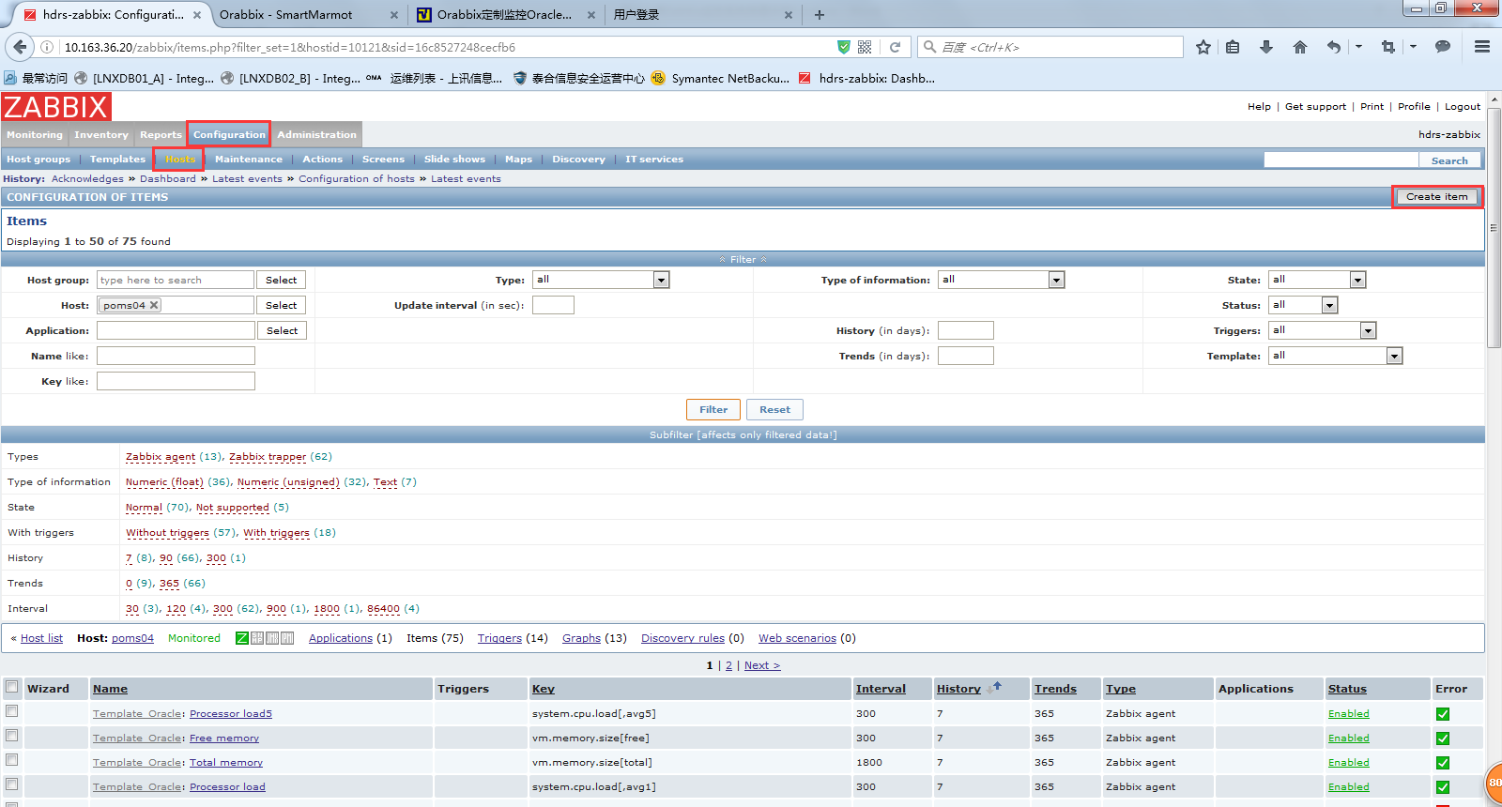

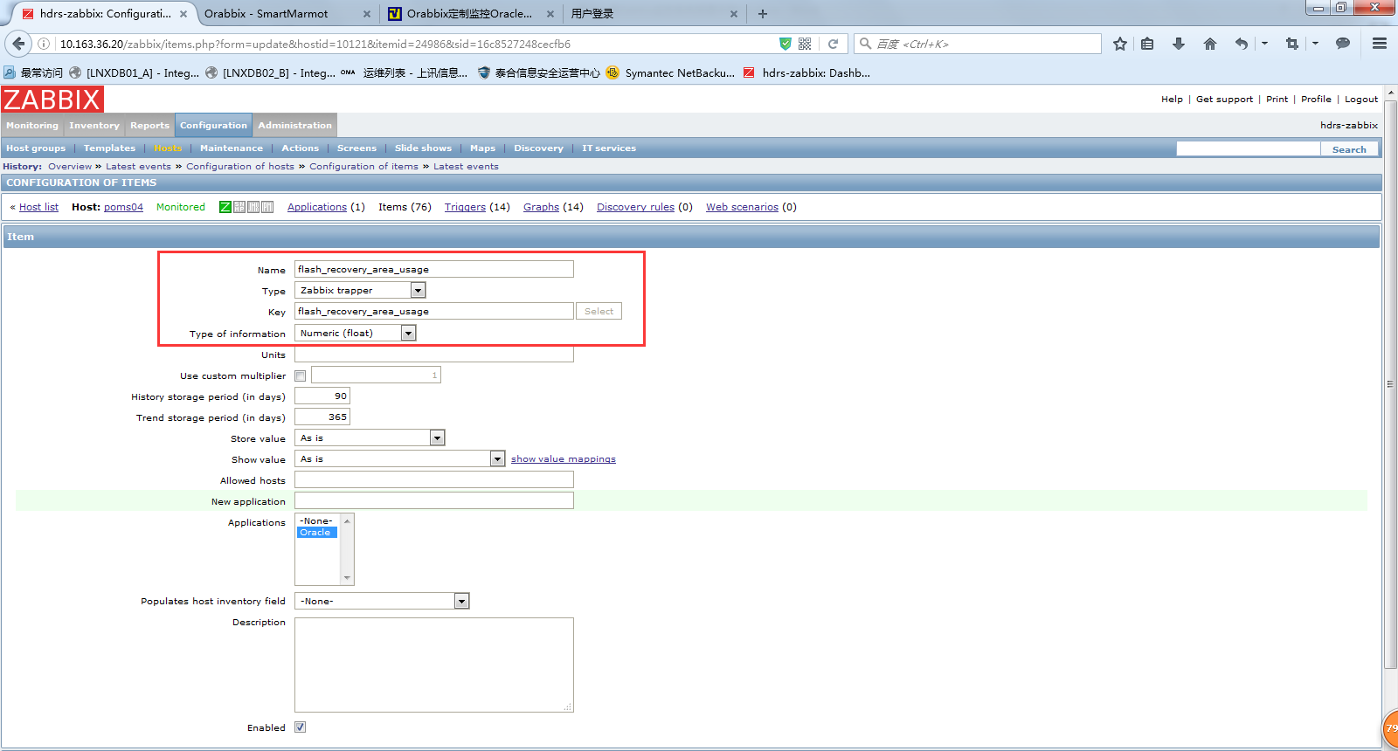

设置图像显示：

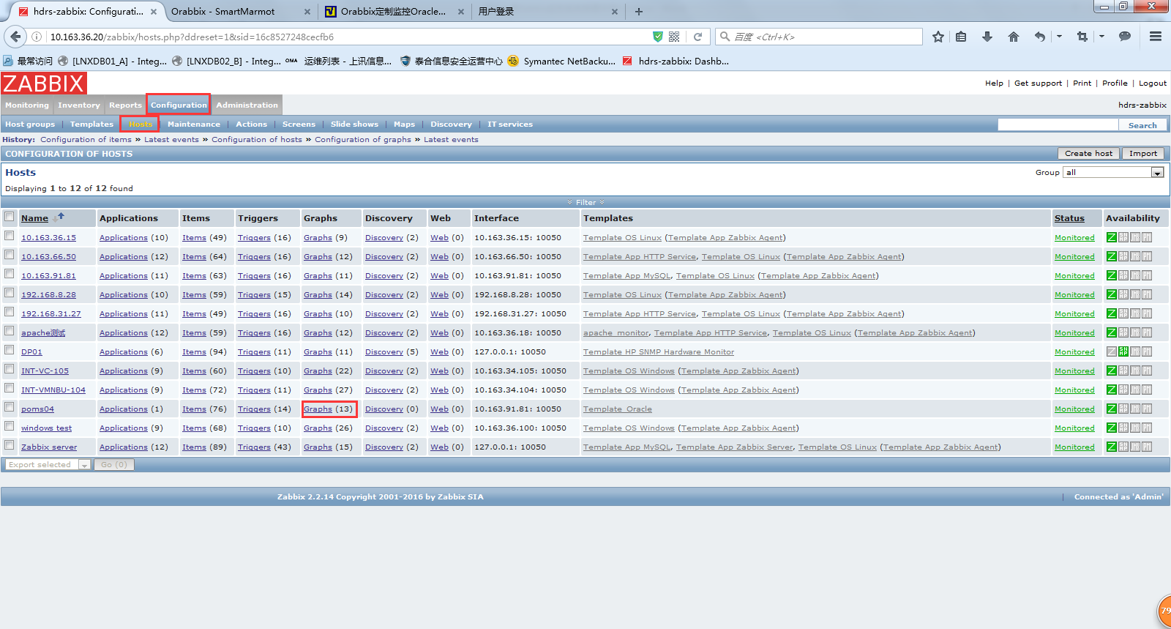

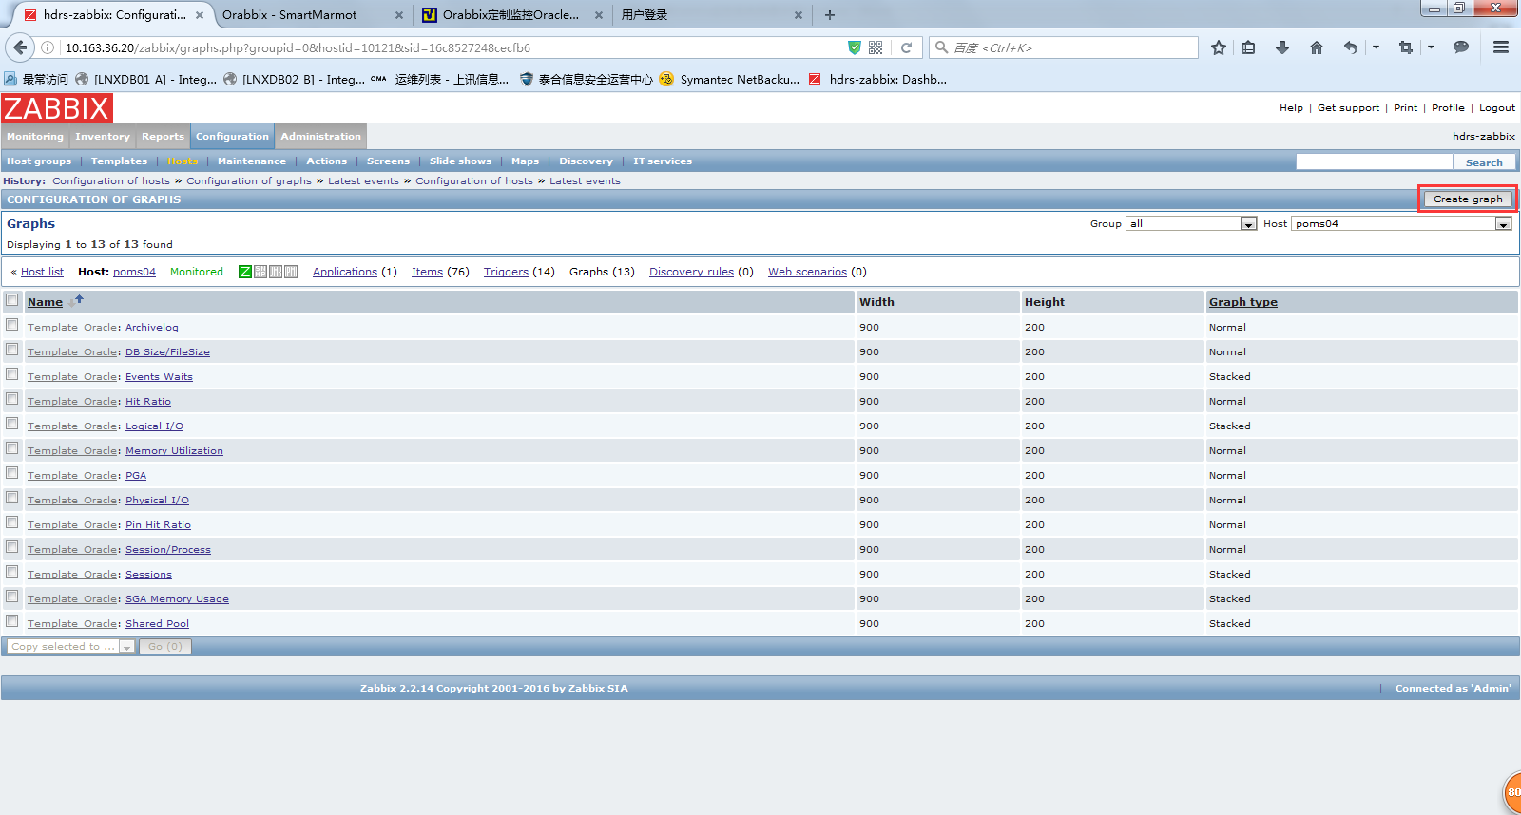

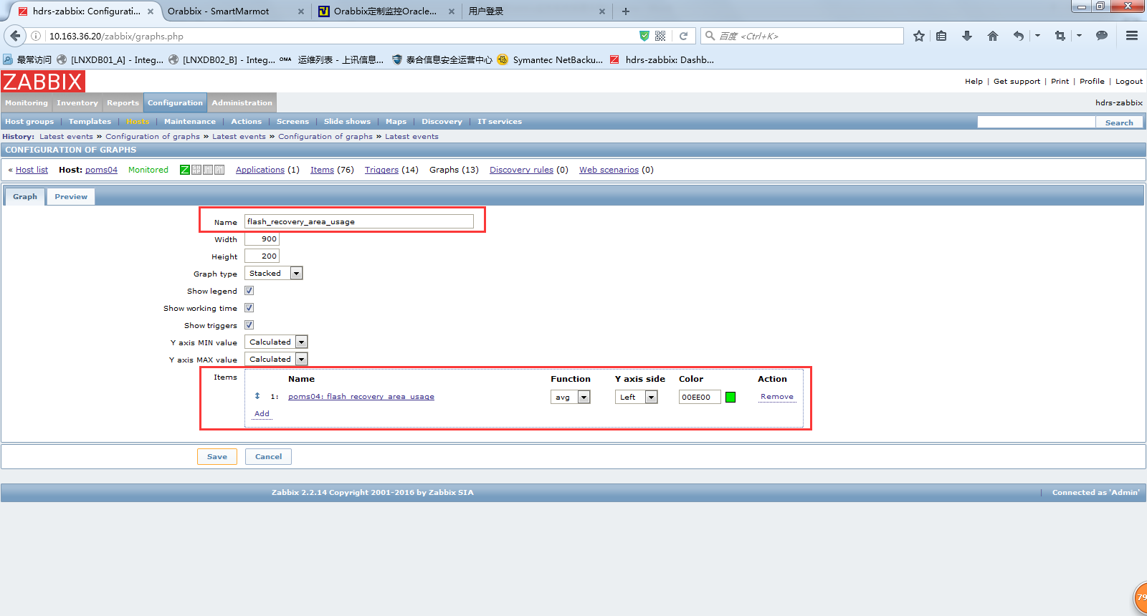

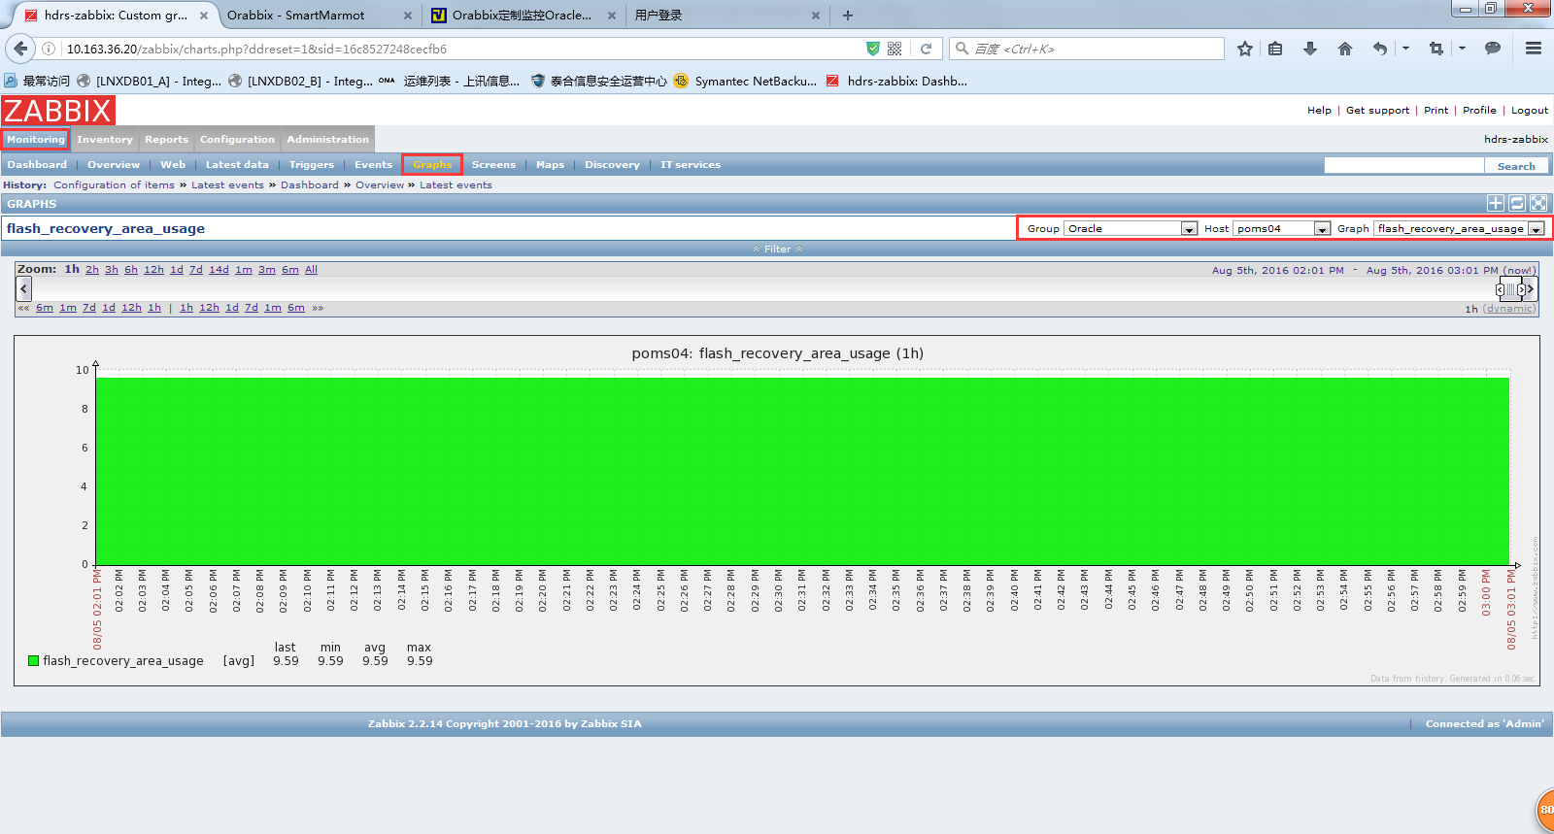

6.8 添加数据库监控

一个orabbix客户端可以连接到多个数据库采集数据，如果要增加数据库，只需要在安装orabbix的客户端进行配置即可，不需要再安装客户端。

增加数据库的监控：

[root@D2-POMS81 ~]# vim /opt/orabbix/conf/config.props

#comma separed list of Zabbix servers

ZabbixServerList=ZabbixServer1

ZabbixServer1.Address=10.163.36.20

ZabbixServer1.Port=10051

#ZabbixServer2.Address=IP_ADDRESS_OF_ZABBIX_SERVER

#ZabbixServer2.Port=PORT_OF_ZABBIX_SERVER

#pidFile

OrabbixDaemon.PidFile=./logs/orabbix.pid

#frequency of item's refresh

OrabbixDaemon.Sleep=300

#MaxThreadNumber should be >= than the number of your databases

OrabbixDaemon.MaxThreadNumber=100

#put here your databases in a comma separated list

DatabaseList=poms04,PISIT23

#Configuration of Connection pool

#if not specified Orabbis is going to use default values (hardcoded)

#Maximum number of active connection inside pool

DatabaseList.MaxActive=10

#The maximum number of milliseconds that the pool will wait

#(when there are no available connections) for a connection to be returned

#before throwing an exception, or <= 0 to wait indefinitely.

DatabaseList.MaxWait=100

DatabaseList.MaxIdle=1

#define here your connection string for each database

poms04.Url=jdbc:oracle:thin:@10.163.91.81:1521:poms04

poms04.User=zabbix

poms04.Password=zabbix

#Those values are optionals if not specified Orabbix is going to use the general values

poms04.MaxActive=10

poms04.MaxWait=100

poms04.MaxIdle=1

poms04.QueryListFile=./conf/query.props

PISIT23.Url=jdbc:oracle:thin:@10.163.91.23:1521:PISIT23

PISIT23.User=zabbix

PISIT23.Password=zabbix

PISIT23.QueryListFile=./conf/pisit23query.props

#DB3.Url=jdbc:oracle:thin:@server3.domain.example.com:<LISTENER_PORT>:DB3

#DB3.User=zabbix

#DB3.Password=zabbix_password

#DB3.QueryListFile=./conf/query.props

修改配置文件后，根据配置文件创建pisit23query.props

[root@D2-POMS81 ~]# cd /opt/orabbix/conf/

[root@D2-POMS81 conf]# cp query.props pisit23query.props

再在被监控数据库中创建用户和授予权限。

|  |
| --- |
| CREATE USER ZABBIX  IDENTIFIED BY zabbix  DEFAULT TABLESPACE USERS  TEMPORARY TABLESPACE TEMP  PROFILE DEFAULT  ACCOUNT UNLOCK;  GRANT CONNECT TO ZABBIX;  GRANT RESOURCE TO ZABBIX;  ALTER USER ZABBIX DEFAULT ROLE ALL;  GRANT SELECT ANY TABLE TO ZABBIX;  GRANT CREATE SESSION TO ZABBIX;  GRANT SELECT ANY DICTIONARY TO ZABBIX;  GRANT UNLIMITED TABLESPACE TO ZABBIX;  GRANT SELECT ANY DICTIONARY TO ZABBIX;  exec dbms_network_acl_admin.create_acl(acl => 'resolve.xml',description => 'resolve acl', principal =>'ZABBIX', is_grant => true, privilege => 'resolve');  exec dbms_network_acl_admin.assign_acl(acl => 'resolve.xml', host =>'*');  commit;  select utl_inaddr.get_host_name('127.0.0.1') from dual; |

SQL> exec dbms_network_acl_admin.create_acl(acl => 'resolve.xml',description => 'resolve acl', principal =>'ZABBIX', is_grant => true, privilege => 'resolve');

PL/SQL procedure successfully completed.

SQL> exec dbms_network_acl_admin.assign_acl(acl => 'resolve.xml', host =>'*');

PL/SQL procedure successfully completed.

SQL> commit;

Commit complete.

SQL> select utl_inaddr.get_host_name('127.0.0.1') from dual;

UTL_INADDR.GET_HOST_NAME('127.0.0.1')

--------------------------------------------------------------------------------

D2-PISIT23

然后在orabbix端重启orabbix：

[root@D2-POMS81 ~]# /etc/init.d/orabbix stop

Stopping Orabbix service:

[root@D2-POMS81 ~]# /etc/init.d/orabbix start

Starting Orabbix service:

然后就可以参考5.5添加主机创建监控了。

6.9 添加数据库DG监控

查询配置文件pisit23query.props包含了DG的监控项：

[root@D2-POMS81 conf]# cat pisit23query.props | grep dg

DataGuardPrimaryQueryList=dg_error,dg_sequence_number

DataGuardStandbyQueryList=dg_sequence_number_stby

returncode||decode(returncode,'1004','-Wrong Connection','1005','-NULL Password','1017','-Wrong Password','1045','-Insufficient Priviledge','0','-Login Accepted','--') "returncode" \

dg_error.Query=SELECT ERROR_CODE, SEVERITY, MESSAGE, TO_CHAR(TIMESTAMP, 'DD-MON-RR HH24:MI:SS') TIMESTAMP FROM V$DATAGUARD_STATUS WHERE CALLOUT='YES' AND TIMESTAMP > SYSDATE-1

dg_error.NoDataFound=none

dg_sequence_number.Query=SELECT MAX (sequence#) FROM v$log_history

#dg_sequence_number_stby.Query=SELECT MAX (sequence#) last_log_applied FROM v$log_history

dg_sequence_number_stby.Query= select max(sequence#) from v$archived_log

修改成以下监控项（注意结尾不要加分号）：

[root@D2-POMS81 conf]# cat pisit23query.props | grep dg

DataGuardPrimaryQueryList=dg_error,dg_sequence_number

DataGuardStandbyQueryList=dg_sequence_number_stby

returncode||decode(returncode,'1004','-Wrong Connection','1005','-NULL Password','1017','-Wrong Password','1045','-Insufficient Priviledge','0','-Login Accepted','--') "returncode" \

#dg_error.Query=SELECT ERROR_CODE, SEVERITY, MESSAGE, TO_CHAR(TIMESTAMP, 'DD-MON-RR HH24:MI:SS') TIMESTAMP FROM V$DATAGUARD_STATUS WHERE CALLOUT='YES' AND TIMESTAMP > SYSDATE-1

dg_error.Query=select error from v$archive_dest where dest_id=2

dg_error.NoDataFound=none

dg_sequence_number.Query=SELECT MAX (sequence#) FROM v$log_history

#dg_sequence_number_stby.Query=SELECT MAX (sequence#) last_log_applied FROM v$log_history

dg_sequence_number_stby.Query= select max(sequence#) from v$archived_log

参考6.7配置对DG的监控：

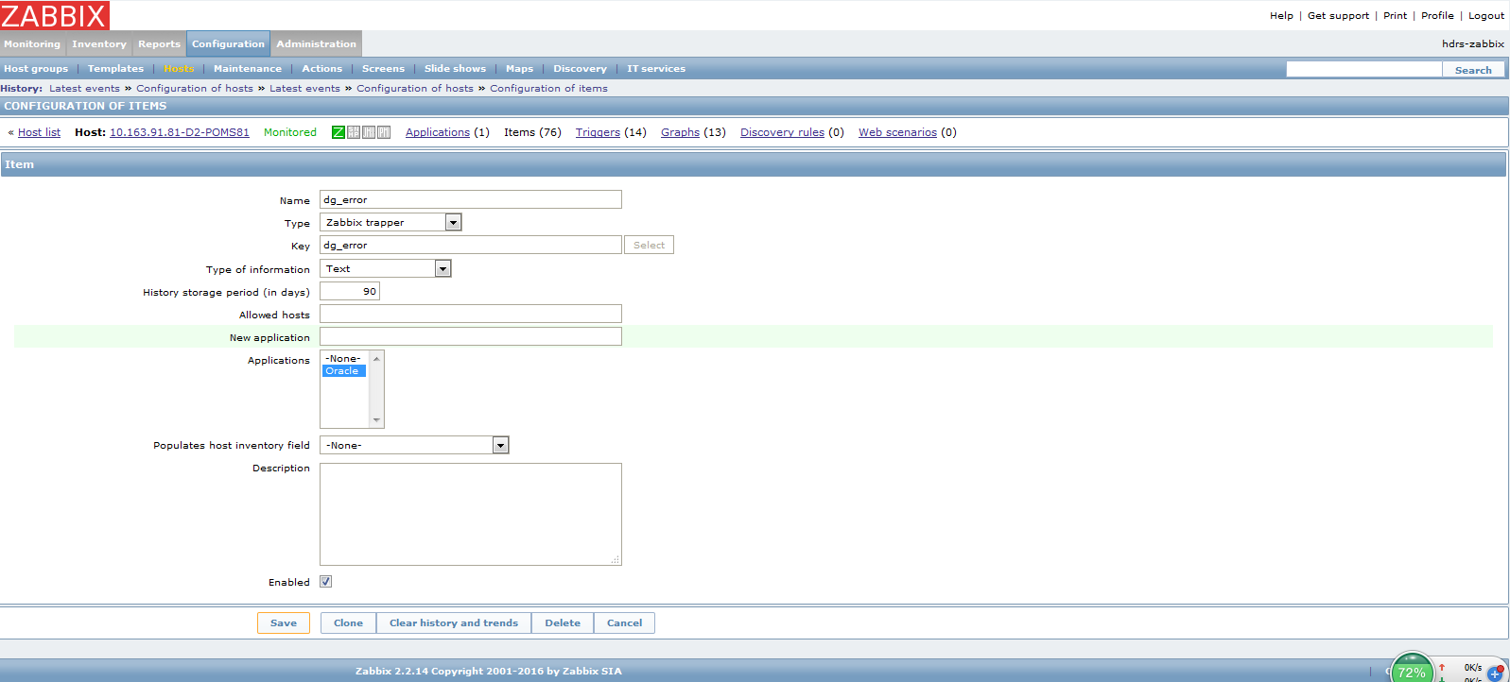

6.10 添加ORA告警的触发器

如果监控的dg_error项产生了ORA告警，则可以通过配置触发器的方式产生告警。

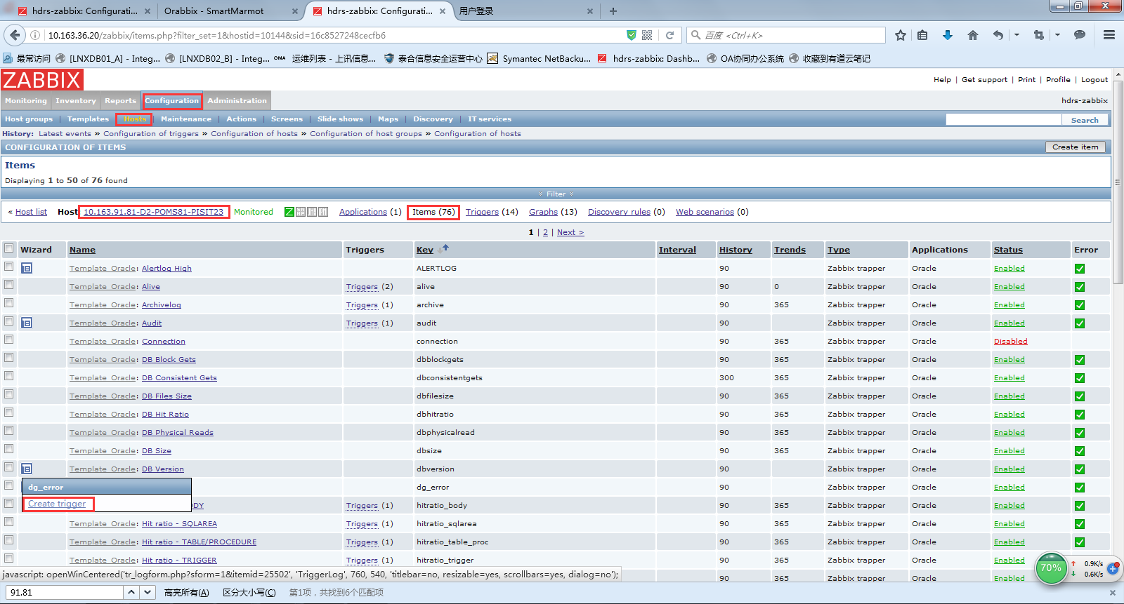

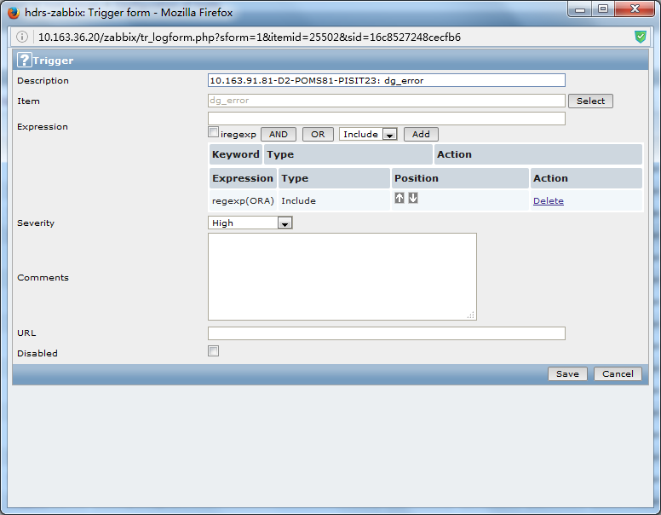

关闭DG，模拟故障，可以看到发出来告警：

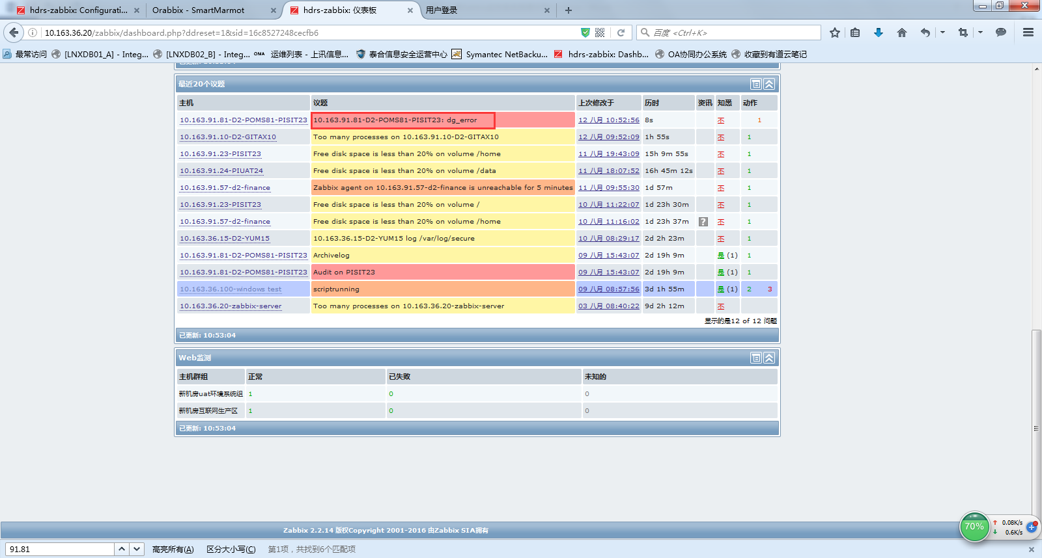

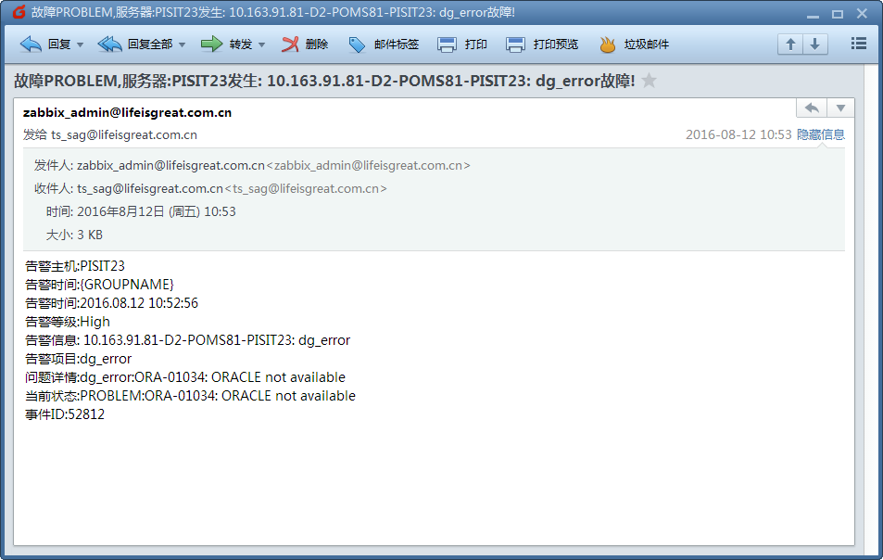

恢复DG，可以看到告警取消：

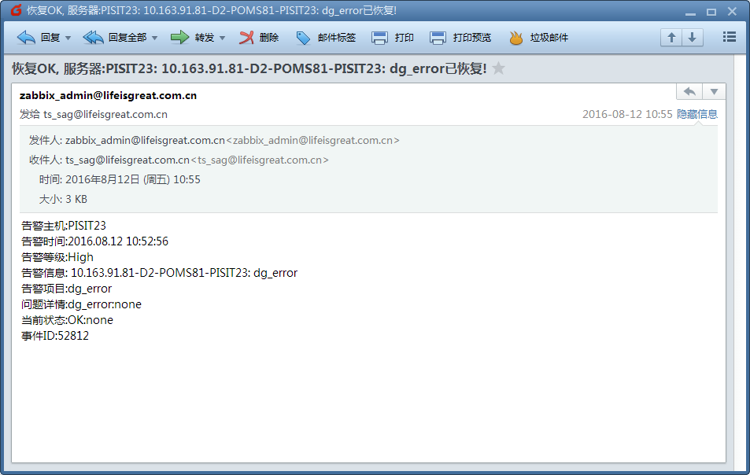

6.11 添加所有的测试数据库

配置文件如下：

|  |
| --- |
| [root@D2-POMS81 conf]# cat config.props  #comma separed list of Zabbix servers  ZabbixServerList=ZabbixServer1  ZabbixServer1.Address=10.163.36.20  ZabbixServer1.Port=10051  #ZabbixServer2.Address=IP_ADDRESS_OF_ZABBIX_SERVER  #ZabbixServer2.Port=PORT_OF_ZABBIX_SERVER  #pidFile  OrabbixDaemon.PidFile=./logs/orabbix.pid  #frequency of item's refresh  OrabbixDaemon.Sleep=300  #MaxThreadNumber should be >= than the number of your databases  OrabbixDaemon.MaxThreadNumber=100  #put here your databases in a comma separated list  DatabaseList=poms04,PISIT23,cistest90201,gitest01916,giuat01918,gipre919,gitest029110,gitest029111,testdb059117,testdb049118,poccard9120,testdb089121,pocuat019124,pocuat029125,imageuat9131,imageuat9132,auwtest019146,jhsit019151,testdb079153,testdb589158,poms049181,websit9183,poms139713,poms149714,poms159715,poms169716,poms179717,poms189718,poms199719  #Configuration of Connection pool  #if not specified Orabbis is going to use default values (hardcoded)  #Maximum number of active connection inside pool  DatabaseList.MaxActive=10  #The maximum number of milliseconds that the pool will wait  #(when there are no available connections) for a connection to be returned  #before throwing an exception, or <= 0 to wait indefinitely.  DatabaseList.MaxWait=100  DatabaseList.MaxIdle=1  #define here your connection string for each database  poms04.Url=jdbc:oracle:thin:@10.163.91.81:1521:poms04  poms04.User=zabbix  poms04.Password=zabbix  #Those values are optionals if not specified Orabbix is going to use the general values  poms04.MaxActive=10  poms04.MaxWait=100  poms04.MaxIdle=1  poms04.QueryListFile=./conf/query.props  PISIT23.Url=jdbc:oracle:thin:@10.163.91.23:1521:pocsit02  PISIT23.User=zabbix  PISIT23.Password=zabbix  PISIT23.QueryListFile=./conf/pisit23query.props  cistest90201.Url=jdbc:oracle:thin:@10.163.90.201:1521:cistest  cistest90201.User=zabbix  cistest90201.Password=zabbix  cistest90201.QueryListFile=./conf/cistest90201query.props  gitest01916.Url=jdbc:oracle:thin:@10.163.91.6:1521:gitest01  gitest01916.User=zabbix  gitest01916.Password=zabbix  gitest01916.QueryListFile=./conf/gitest01916query.props  giuat01918.Url=jdbc:oracle:thin:@10.163.91.8:1521:giuat01  giuat01918.User=zabbix  giuat01918.Password=zabbix  giuat01918.QueryListFile=./conf/giuat01918query.props  gipre919.Url=jdbc:oracle:thin:@10.163.91.9:1521:gipre  gipre919.User=zabbix  gipre919.Password=zabbix  gipre919.QueryListFile=./conf/gipre919query.props  gitest029110.Url=jdbc:oracle:thin:@10.163.91.10:1521:gitest02  gitest029110.User=zabbix  gitest029110.Password=zabbix  gitest029110.QueryListFile=./conf/gitest029110query.props  #DB3.Url=jdbc:oracle:thin:@server3.domain.example.com:<LISTENER_PORT>:DB3  #DB3.User=zabbix  #DB3.Password=zabbix_password  #DB3.QueryListFile=./conf/query.props  gitest029111.Url=jdbc:oracle:thin:@10.163.91.11:1521:gitest02  gitest029111.User=zabbix  gitest029111.Password=zabbix  gitest029111.QueryListFile=./conf/gitest029111query.props  testdb059117.Url=jdbc:oracle:thin:@10.163.91.17:1521:testdb05  testdb059117.User=zabbix  testdb059117.Password=zabbix  testdb059117.QueryListFile=./conf/testdb059117query.props  testdb049118.Url=jdbc:oracle:thin:@10.163.91.18:1521:testdb04  testdb049118.User=zabbix  testdb049118.Password=zabbix  testdb049118.QueryListFile=./conf/testdb049118query.props  poccard9120.Url=jdbc:oracle:thin:@10.163.91.20:1521:poccard  poccard9120.User=zabbix  poccard9120.Password=zabbix  poccard9120.QueryListFile=./conf/poccard9120query.props  testdb089121.Url=jdbc:oracle:thin:@10.163.91.21:1521:testdb08  testdb089121.User=zabbix  testdb089121.Password=zabbix  testdb089121.QueryListFile=./conf/testdb089121query.props  pocuat019124.Url=jdbc:oracle:thin:@10.163.91.24:1521:pocuat01  pocuat019124.User=zabbix  pocuat019124.Password=zabbix  pocuat019124.QueryListFile=./conf/pocuat019124query.props  pocuat029125.Url=jdbc:oracle:thin:@10.163.91.25:1521:pocuat02  pocuat029125.User=zabbix  pocuat029125.Password=zabbix  pocuat029125.QueryListFile=./conf/pocuat029125query.props  imageuat9131.Url=jdbc:oracle:thin:@10.163.91.31:1521:imageuat  imageuat9131.User=zabbix  imageuat9131.Password=zabbix  imageuat9131.QueryListFile=./conf/imageuat9131query.props  imageuat9132.Url=jdbc:oracle:thin:@10.163.91.32:1521:imageuat  imageuat9132.User=zabbix  imageuat9132.Password=zabbix  imageuat9132.QueryListFile=./conf/imageuat9132query.props  auwtest019146.Url=jdbc:oracle:thin:@10.163.91.46:1521:auwtest01  auwtest019146.User=zabbix  auwtest019146.Password=zabbix  auwtest019146.QueryListFile=./conf/auwtest019146query.props  jhsit019151.Url=jdbc:oracle:thin:@10.163.91.51:1521:jhsit01  jhsit019151.User=zabbix  jhsit019151.Password=zabbix  jhsit019151.QueryListFile=./conf/jhsit019151query.props  testdb079153.Url=jdbc:oracle:thin:@10.163.91.53:1521:testdb07  testdb079153.User=zabbix  testdb079153.Password=zabbix  testdb079153.QueryListFile=./conf/testdb079153query.props  testdb589158.Url=jdbc:oracle:thin:@10.163.91.58:1521:testdb58  testdb589158.User=zabbix  testdb589158.Password=zabbix  testdb589158.QueryListFile=./conf/testdb589158query.props  poms049181.Url=jdbc:oracle:thin:@10.163.91.81:1521:poms04  poms049181.User=zabbix  poms049181.Password=zabbix  poms049181.QueryListFile=./conf/poms049181query.props  websit9183.Url=jdbc:oracle:thin:@10.163.91.83:1521:websit  websit9183.User=zabbix  websit9183.Password=zabbix  websit9183.QueryListFile=./conf/websit9183query.props  poms139713.Url=jdbc:oracle:thin:@10.163.97.13:1521:poms13  poms139713.User=zabbix  poms139713.Password=zabbix  poms139713.QueryListFile=./conf/poms139713query.props  poms149714.Url=jdbc:oracle:thin:@10.163.97.14:1521:poms14  poms149714.User=zabbix  poms149714.Password=zabbix  poms149714.QueryListFile=./conf/poms149714query.props  poms159715.Url=jdbc:oracle:thin:@10.163.97.15:1521:poms15  poms159715.User=zabbix  poms159715.Password=zabbix  poms159715.QueryListFile=./conf/poms159715query.props  poms169716.Url=jdbc:oracle:thin:@10.163.97.16:1521:poms16  poms169716.User=zabbix  poms169716.Password=zabbix  poms169716.QueryListFile=./conf/poms169716query.props  poms179717.Url=jdbc:oracle:thin:@10.163.97.17:1521:poms17  poms179717.User=zabbix  poms179717.Password=zabbix  poms179717.QueryListFile=./conf/poms179717query.props  poms189718.Url=jdbc:oracle:thin:@10.163.97.18:1521:poms18  poms189718.User=zabbix  poms189718.Password=zabbix  poms189718.QueryListFile=./conf/poms189718query.props  poms199719.Url=jdbc:oracle:thin:@10.163.97.19:1521:poms19  poms199719.User=zabbix  poms199719.Password=zabbix  poms199719.QueryListFile=./conf/poms199719query.props |

然后在控制台添加对应的主机和模版，具体参考6.5。结果如下：

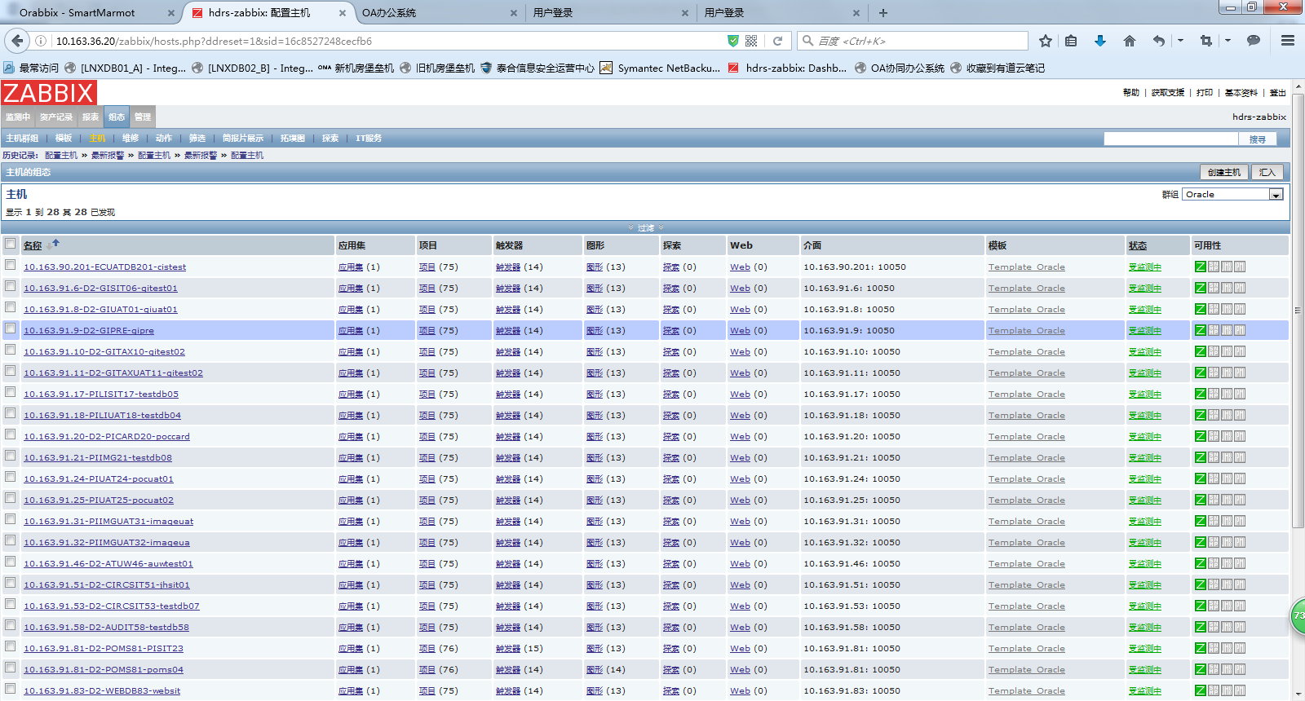

7、Mysql数据库监控

7.1 客户端创建mysql用户

创建一个mysql用户来获取mysql的相关数据：

mysql> grant usage on *.* to 'zabbix'@'localhost' identified by 'zabbix';

Query OK, 0 rows affected (0.00 sec)

mysql> flush privileges;

Query OK, 0 rows affected (0.00 sec)

7.2 客户端创建.my.cnf

在/etc/zabbix/创建.my.cnf，存储mysql的密码信息：

[root@D2-ZABBIX20 ~]# vim /etc/zabbix/.my.cnf

[mysql]

host = localhost

user = zabbix

password = zabbix

socket = /var/lib/mysql/mysql.sock

[mysqladmin]

host = localhost

user = zabbix

password = zabbix

socket = /var/lib/mysql/mysql.sock

7.3 客户端配置userparameter_mysql.conf

配置文件userparameter_mysql.conf用于制定Zabbix Agent如何获取mysql数据，需要将所有的/var/lib/zabbix修改为当前.my.cnf文件的路径/etc/zabbix。设置完成之后保存并重启Zabbix Agent。

[root@D2-ZABBIX20 ~]# sed -i 's@/var/lib/zabbix@/etc/zabbix@g' /etc/zabbix/zabbix_agentd.d/userparameter_mysql.conf

配置完成后重启agent：

[root@D2-ZABBIX20 ~]# /etc/init.d/zabbix-agent restart

Shutting down Zabbix agent: [ OK ]

Starting Zabbix agent: [ OK ]

如果有问题，可以查看日志进行定位解决：

[root@D2-ZABBIX20 ~]# tail -f /var/log/zabbix/zabbix_agentd.log

7.4 服务器端配置主机和模版

添加模版：

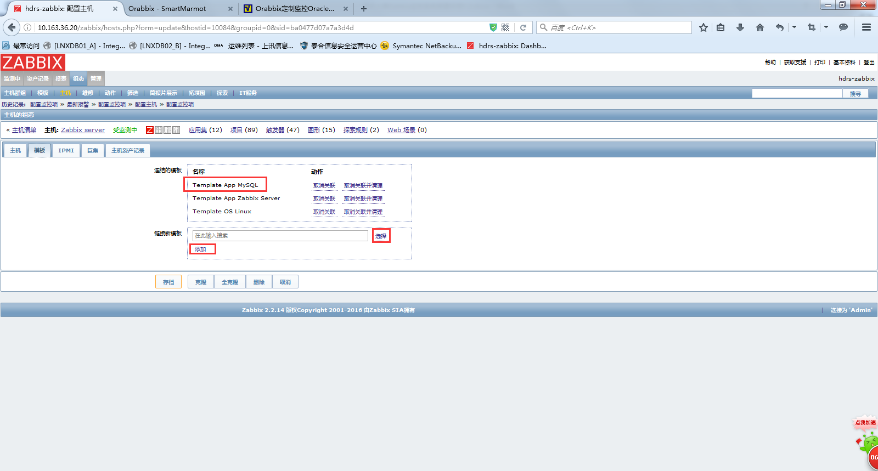

8、添加zabbix外部邮件报警平台

8.1 登录zabbix管理平台，配置外部邮件转发服务器

管理-示警媒介类型-创建媒体类型-创建一个ALARM-EMAIL

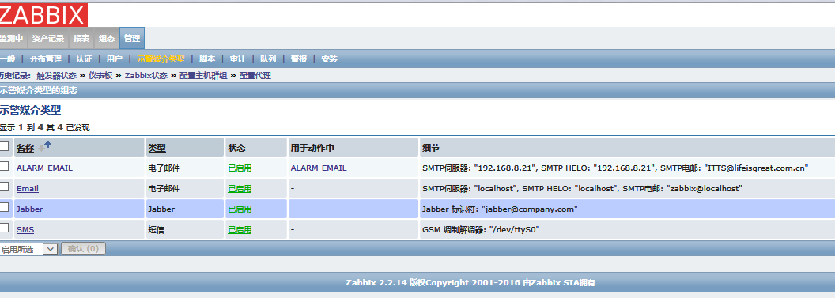

打开ALARM-EMAIL类型,配置外部邮件转发服务器ip地址和邮箱用户，点击-存档

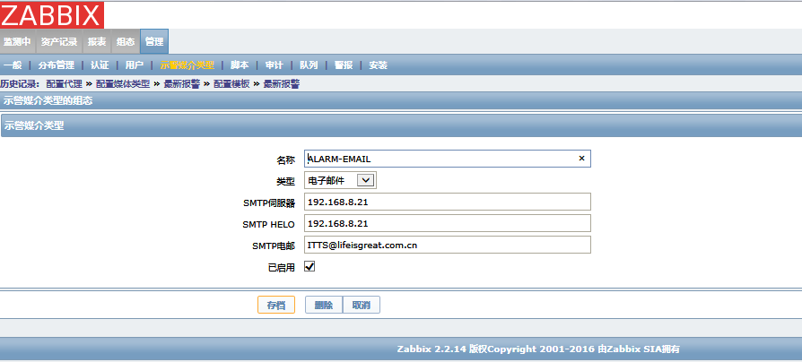

8.2 配置zabbix监控平台用户邮件

管理-用户-Admin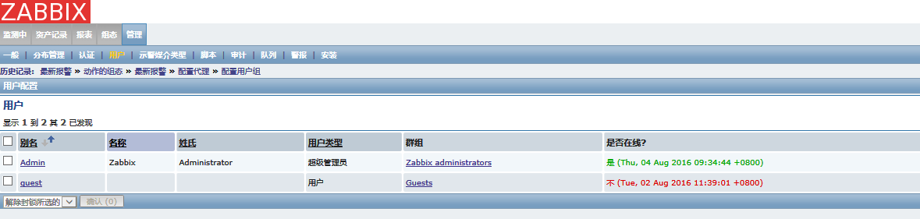

双击打开Admin用户配置-点击-示警媒介-添加

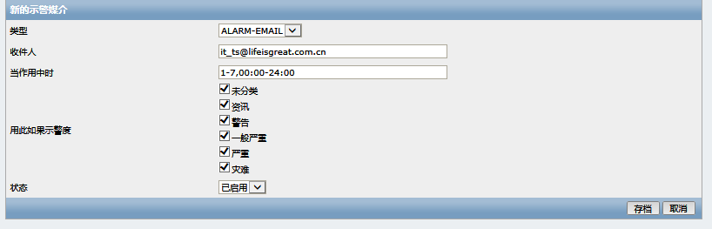

最后-存档

8.3 配置zabbix报警采取的动作

组态-动作

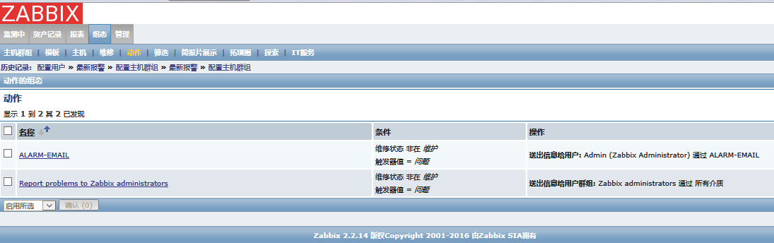

双击打开ALARM-EMAIL-动作-填写下图报警信息

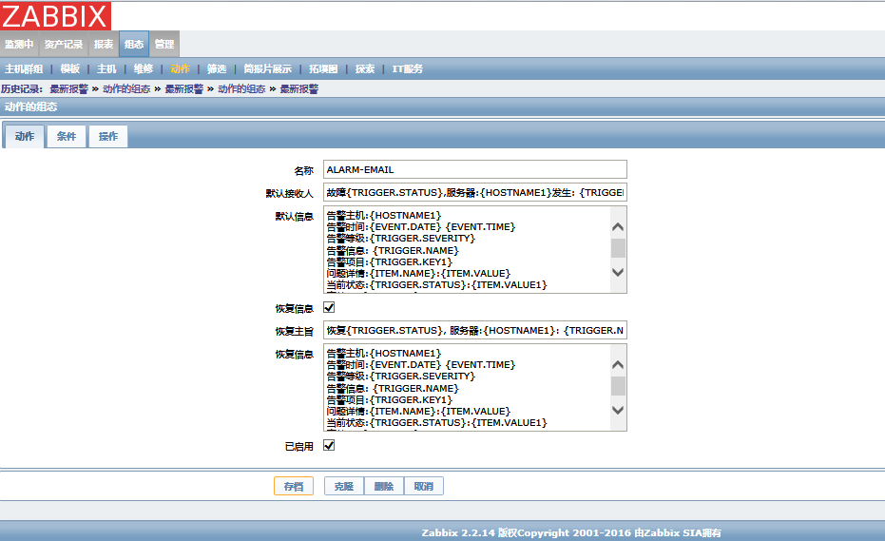

故障{TRIGGER.STATUS},服务器:{HOSTNAME1}发生: {TRIGGER.NAME}故障!

告警主机:{HOSTNAME}

告警时间:{EVENT.DATE} {EVENT.TIME}

主机群组:{TRIGGER.HOSTGROUP.NAME}

告警等级:{TRIGGER.SEVERITY}

告警信息: {TRIGGER.NAME}

告警项目:{TRIGGER.KEY1}

问题详情:{ITEM.NAME}:{ITEM.VALUE}

当前状态:{TRIGGER.STATUS}:{ITEM.VALUE1}

事件ID:{EVENT.ID}

恢复{TRIGGER.STATUS}, 服务器:{HOSTNAME1}: {TRIGGER.NAME}已恢复!

恢复主机:{HOSTNAME}

恢复时间:{DATE} {TIME}

告警时间:{EVENT.DATE} {EVENT.TIME}

主机群组:{TRIGGER.HOSTGROUP.NAME}

告警等级:{TRIGGER.SEVERITY}

告警信息: {TRIGGER.NAME}

告警项目:{TRIGGER.KEY1}

问题详情:{ITEM.NAME}:{ITEM.VALUE}

当前状态:{TRIGGER.STATUS}:{ITEM.VALUE1}

事件ID:{EVENT.ID}

点击-操作-新的

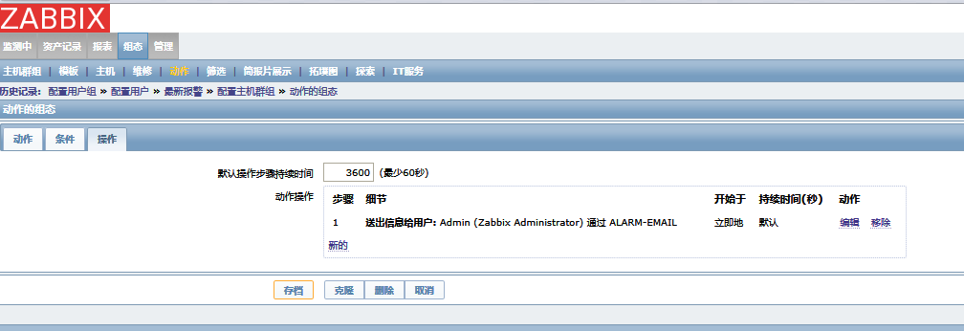

填写信息如下图

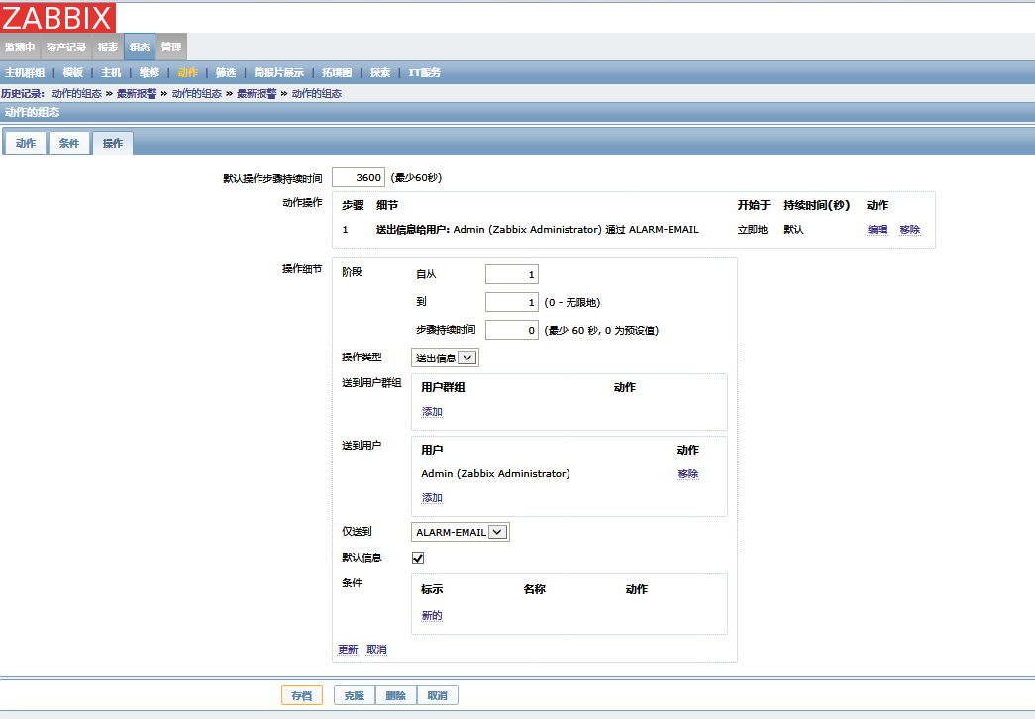点击存档，完成邮件报警的设置

8.4 配置zabbix分组报警采取的动作

　１.　添加　media types

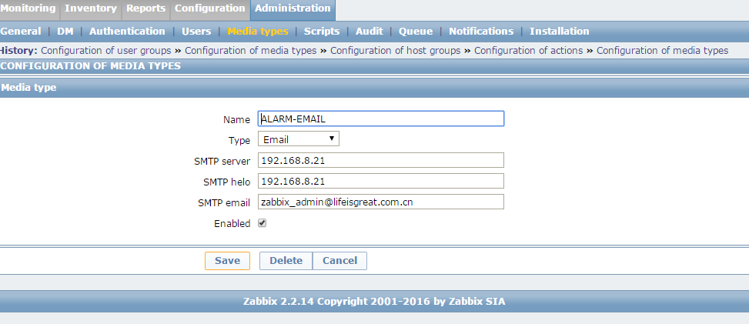

2.添加用户，并配置media

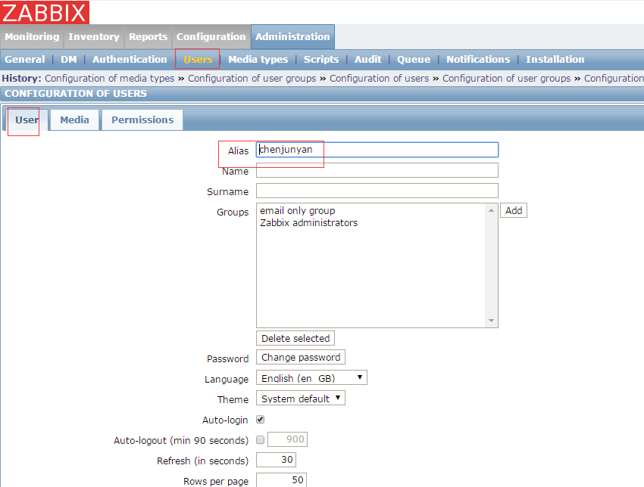

选择之前创建的media type, 输入接收邮件

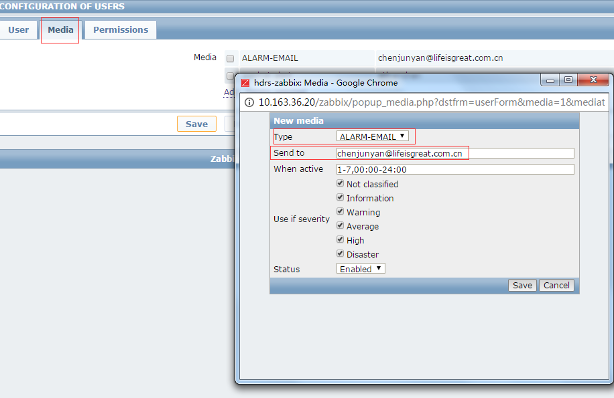

3.创建单独的组，添加用户，用于不同的host group报警邮件接收组

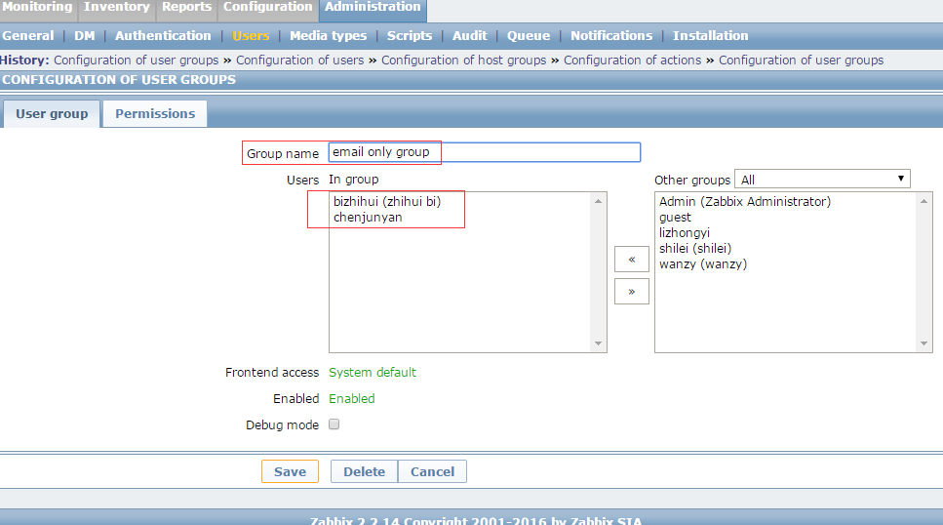

4.配置action,并配置condition 和operation

Action用于邮件报警内容

Condition用于在哪个条件

Operation 用于zabbix将要做的动作

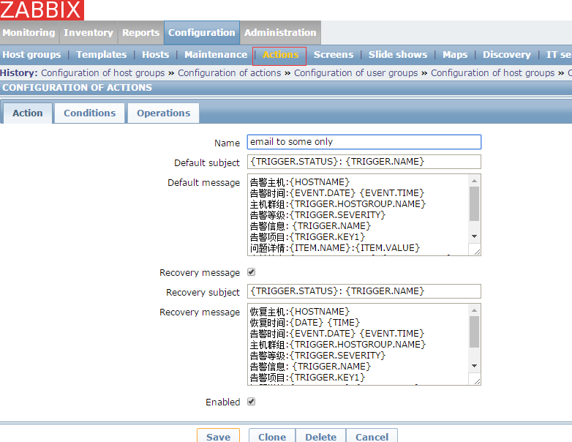

针对host group作一个condition

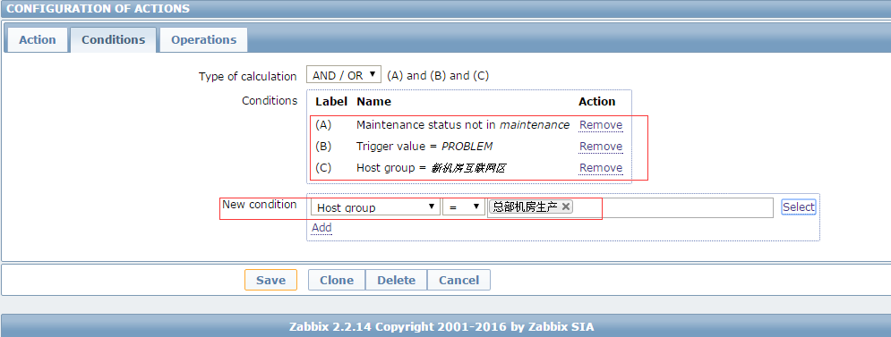

Operation用于发邮件，注意duration时间为６０秒（默认为１小时）

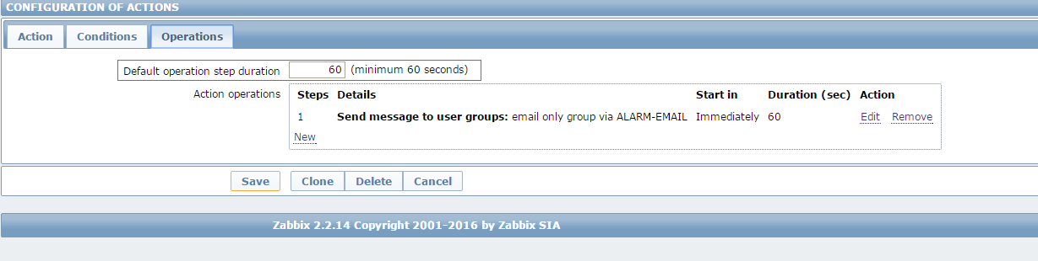

选择step from 1 to 1

选择 要接收邮件的组

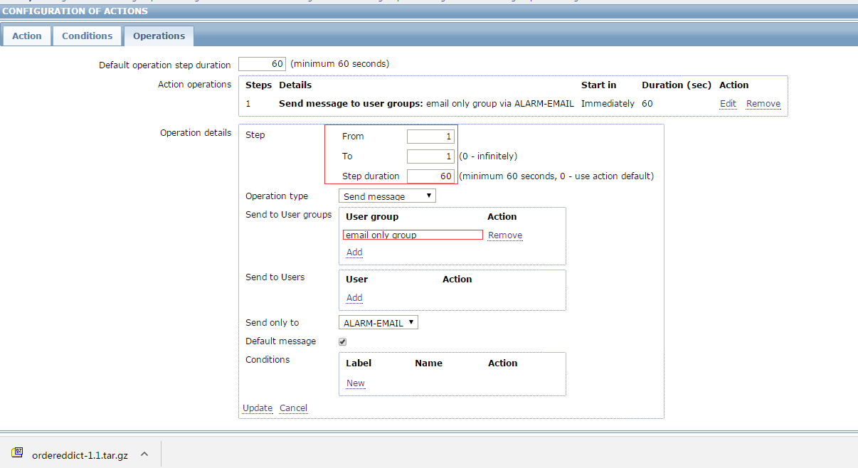

9、添加配置zabbix微信报警

9.1 微信报警实现需要准备这些东西

    一个微信企业号

    企业号已经被部门成员关注

    企业号里有一个可以发消息的应用

    一个授权管理员，可以使用该应用给成员发消息

9.2 微信报警实现需要取到这些信息

    成员账号

    组织部门ID

    应用ID

    CropID

    Secret

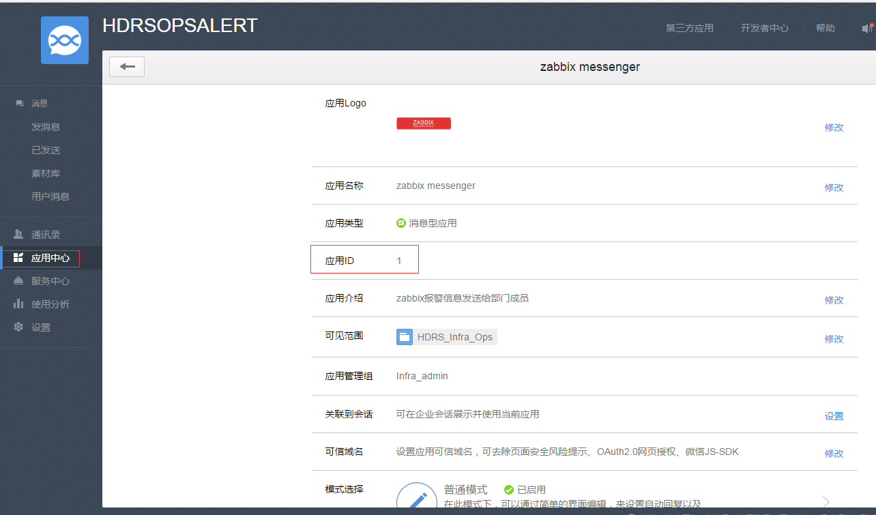

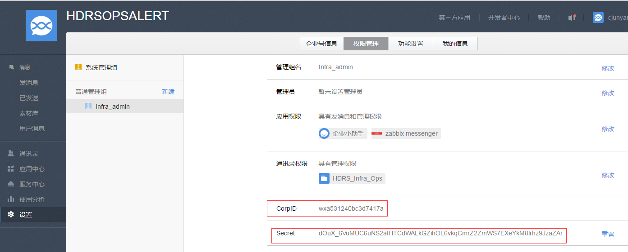

9.3 微信公众号平台的通讯录添加企业成员

把成员信息添加进组织部门，必填项+手机号或者微信号，用户才能通过扫描二维码成功关注企业号。

           注意：这里有两个要用到信息，一个组织部门的ID，一个部门成员的账号（账号是自己手动指定的，不同于微信号）

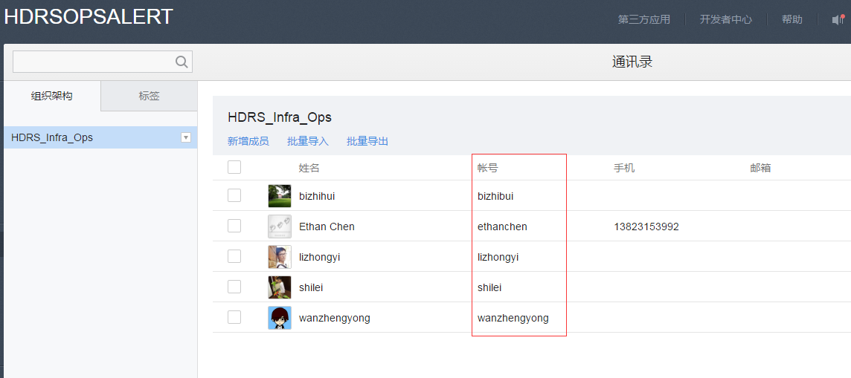

9.4. 在/etc/zabbix/alertscripts目录下添加微信报警shell脚本

[root@D2-ZABBIX20 alertscripts]# cat wechat.sh

#!/bin/bash

##sCRIPT_NAME:weixin.sh###

###send message from weixin for zabbix monitor###

###wuhf###

###V1-2016-10-08###

CorpID='wxa531240bc3d7417a'

Secret='dOuX_6VuMUC6uNS2aIHTCdWALkGZihOL6vkqCmrZ2ZmWS7EXeYkM8lrhz9JzaZAr'

GURL="https://qyapi.weixin.qq.com/cgi-bin/gettoken?corpid=$CorpID&corpsecret=$Secret"

Gtoken=$(/usr/bin/curl -s -G $GURL | awk -F\" '{print $4}')

PURL="https://qyapi.weixin.qq.com/cgi-bin/message/send?access_token=$Gtoken"

function body() {

local int AppID=1

local UserID=$1

local Msg=$(echo "$@" | cut -d" " -f3-)

printf '{\n'

printf '\t"touser": "'"$UserID"\"",\n"

printf '\t"msgtype": "text",\n'

printf '\t"agentid": "'" $AppID "\"",\n"

printf '\t"text": {\n'

printf '\t\t"content": "'"$Msg"\""\n"

printf '\t},\n'

printf '\t"safe":"0"\n'

printf '}\n'

}

/usr/bin/curl --data-ascii "$(body $1 $2 $3)" $PURL

**注意：脚本如果添加了partyID参数，所有部门成员都能收到微信报警，不能实现zabbix按不同的成员组收发不同的邮件**

9.5.　在/etc/zabbix/alertscripts目录下，添加zabbix用户运行脚本的权限

[root@D2-ZABBIX20 alertscripts]# ll

total 16

-rwxr-xr-x 1 zabbix zabbix 1016 Oct 13 15:45 wechat_poms.sh

-rwxr-xr-x 1 zabbix zabbix 1699 Oct 13 14:25 wechat.py

-rwxr-xr-x 1 zabbix zabbix 934 Oct 13 17:54 wechat.sh

drwxr-xr-x 4 zabbix zabbix 4096 Sep 28 17:30 WeiXin-Private-API

9.6.　检查测试脚本是否成功

执行脚本，./weixin.sh  ethanchen   subjectmessage    bodymessage

(ethanchen，这是微信公众平台创建的用户ID，不是微信ID)

(subjectmessage, bodymessage，这是邮件标题和内容)。如下图返回结果为ok ,则表示正常，如果不是ok ,则检查脚本内容和公众平台是否完全按我的步骤操作



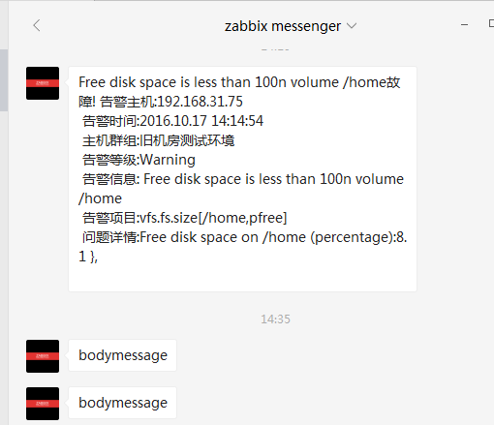

下面就是配置zabbix 管理界面

9.7.　在zabbix创建示警媒介

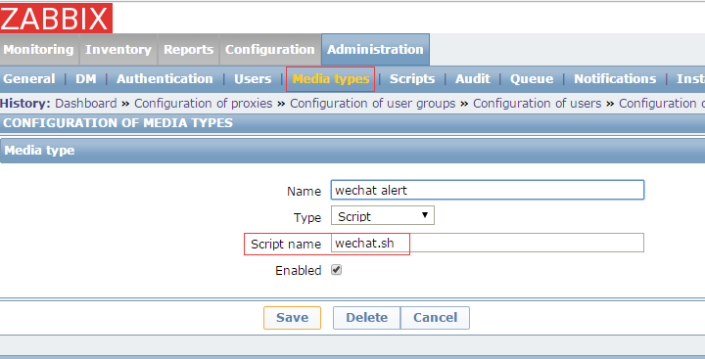

9.8. 在用户的示察媒介中添加示警媒介

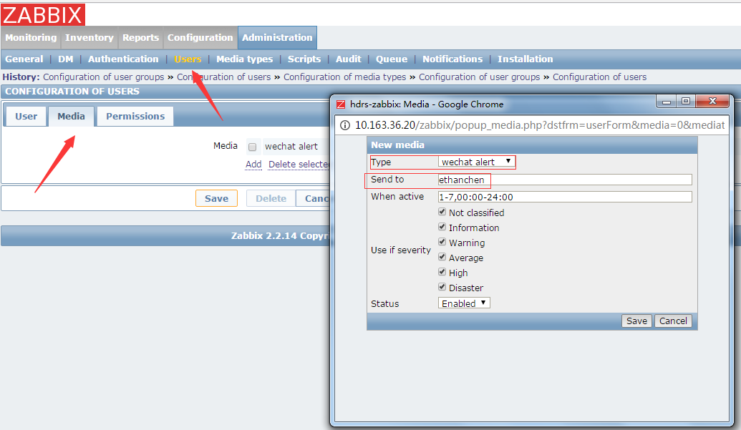

9.9. 创建触发器动作发送内容

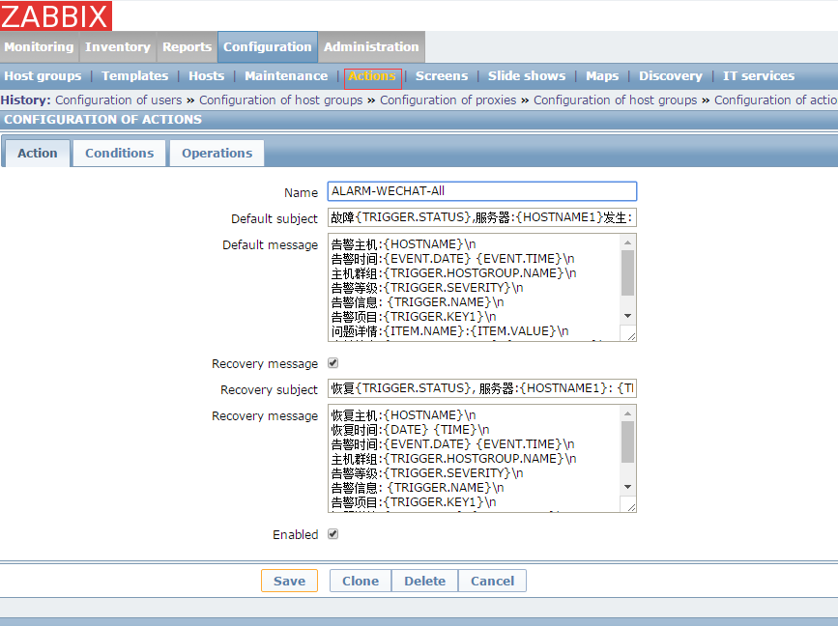

故障{TRIGGER.STATUS},服务器:{HOSTNAME1}发生: {TRIGGER.NAME}故障!

告警主机:{HOSTNAME}\n

告警时间:{EVENT.DATE} {EVENT.TIME}\n

主机群组:{TRIGGER.HOSTGROUP.NAME}\n

告警等级:{TRIGGER.SEVERITY}\n

告警信息: {TRIGGER.NAME}\n

告警项目:{TRIGGER.KEY1}\n

问题详情:{ITEM.NAME}:{ITEM.VALUE}\n

当前状态:{TRIGGER.STATUS}:{ITEM.VALUE1}\n

事件ID:{EVENT.ID}\n

恢复{TRIGGER.STATUS}, 服务器:{HOSTNAME1}: {TRIGGER.NAME}已恢复!

恢复主机:{HOSTNAME}\n

恢复时间:{DATE} {TIME}\n

告警时间:{EVENT.DATE} {EVENT.TIME}\n

主机群组:{TRIGGER.HOSTGROUP.NAME}\n

告警等级:{TRIGGER.SEVERITY}\n

告警信息: {TRIGGER.NAME}\n

告警项目:{TRIGGER.KEY1}\n

问题详情:{ITEM.NAME}:{ITEM.VALUE}\n

当前状态:{TRIGGER.STATUS}:{ITEM.VALUE1}\n

事件ID:{EVENT.ID}\n

9.10. 设置按组分发微信报警和触发器发送方式

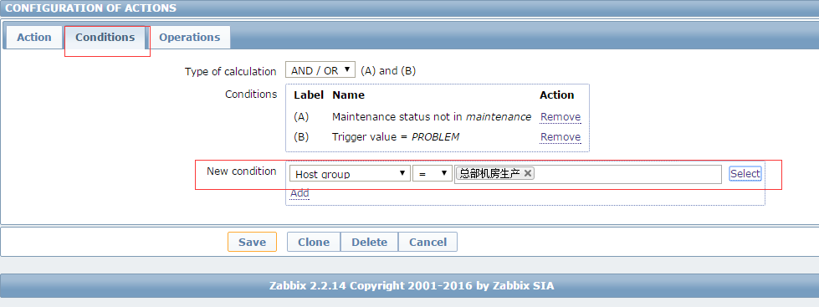

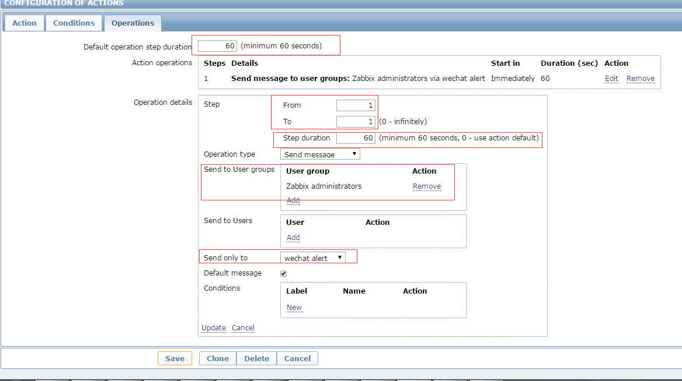

10、添加HP刀片服务器的硬件监控

10.1 登录HP刀箱管理平台，开启SNMP

开启SNMP read community

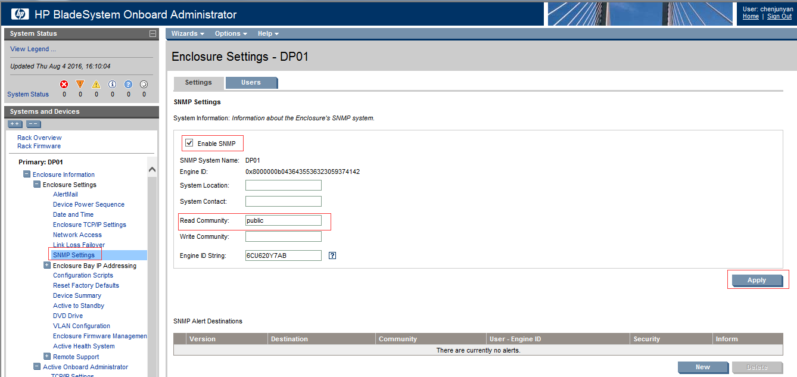

10.2 登录Zabbix管理平台，创建模板Template HP SNMP Hardware Monitor

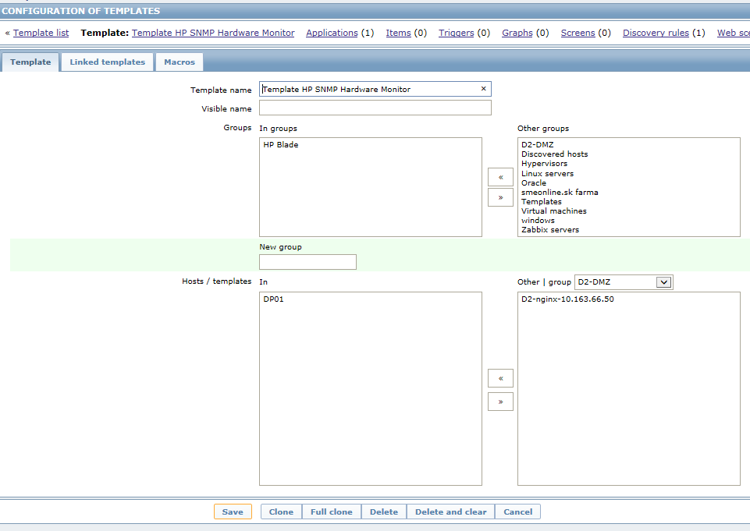

10.3 在创建的模板Template HP SNMP Hardware Monitor创建Create discovery rule

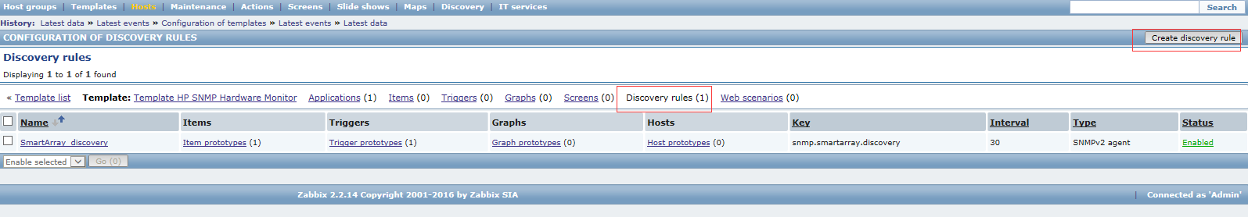

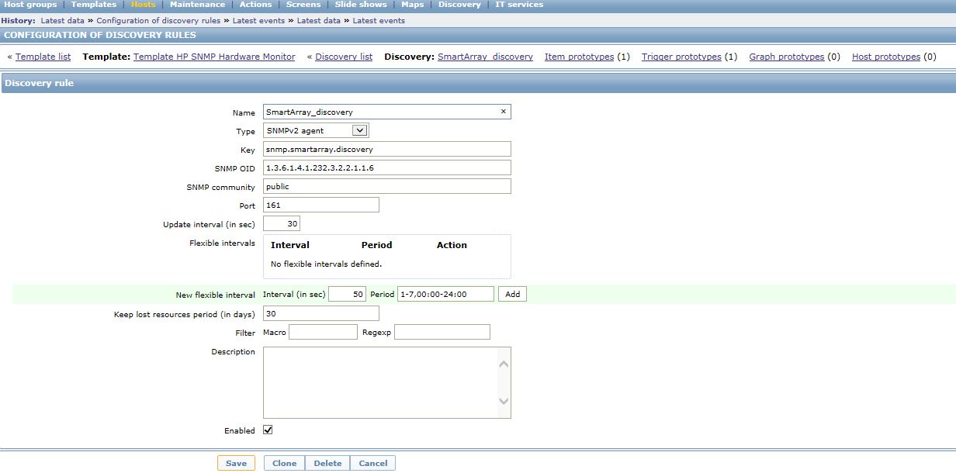

10.4 在discovery rule创建监控项目Create item prototype

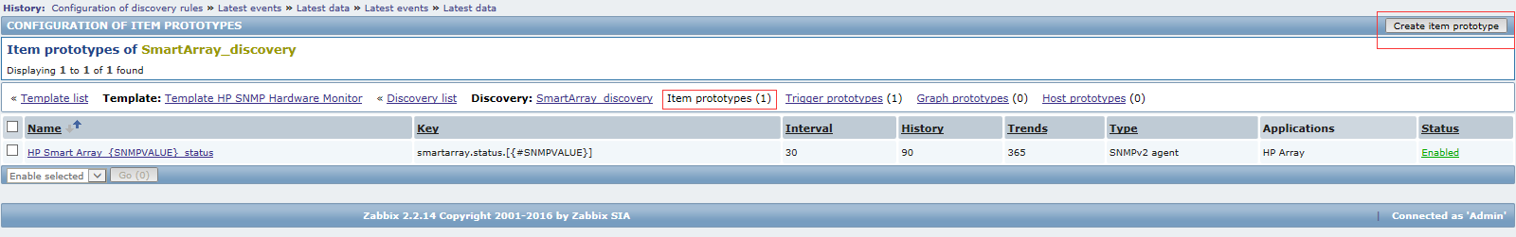

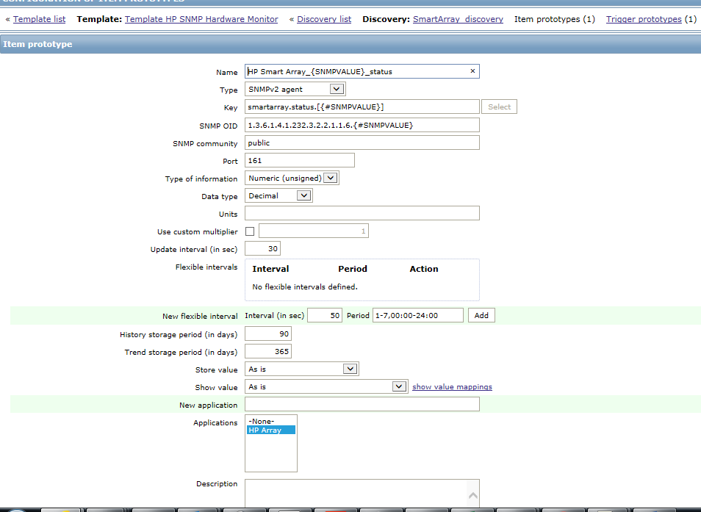

Name:SmartArray_discovery

KEY:smartarray.status.[{#SNMPVALUE}]

SNMP OID:1.3.6.1.4.1.232.3.2.2.1.1.6.{#SNMPVALUE}

SNMP community: public

Port:161

10.5 在监控项目Create item prototype创建触发器Create trigger prototype

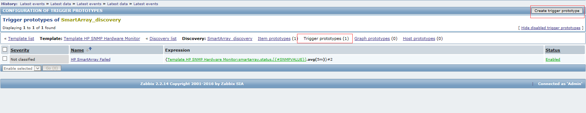

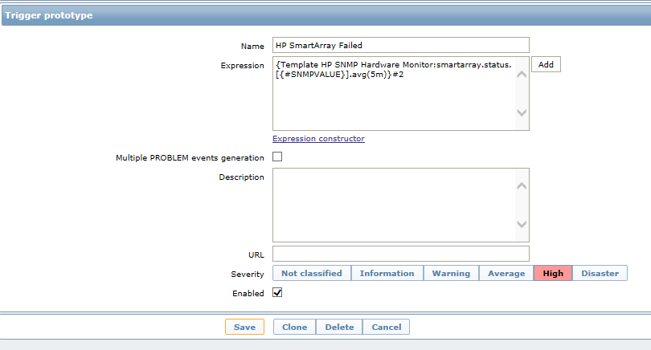

HP服务器硬盘，阵列卡，逻辑磁盘等的状态正常返回值都是2，如果不是2，说明有问题，触发报警

Name:HP SmartArray Failed

Expression:{Template HP SNMP Hardware Monitor:smartarray.status.[{#SNMPVALUE}].avg(5m)}#2

Severity: High

10.6 重复10.3 -10.5创建其他discovery rule, 监控项目和触发项目

监控HP硬盘的状态，逻辑磁盘的状态，风扇的状态，HP各部件的温度

HP SNMP OLD如下：

HP阵列卡状态：1.3.6.1.4.1.232.3.2.2.1.1.6

物理磁盘状态：1.3.6.1.4.1.232.3.2.5.1.1.6

逻辑磁盘状态：1.3.6.1.4.1.232.3.2.3.1.1.4

HP部件温度：1.3.6.1.4.1.232.6.2.6.8.1.4

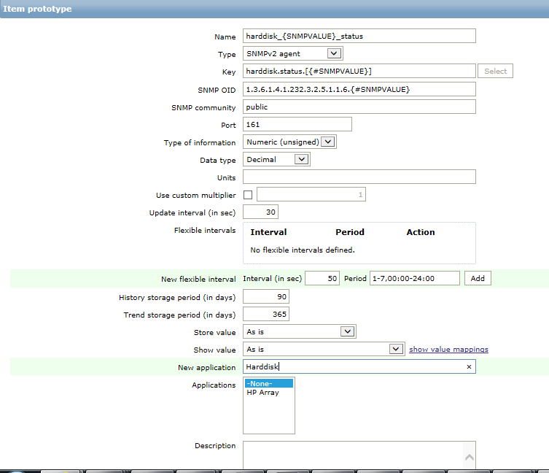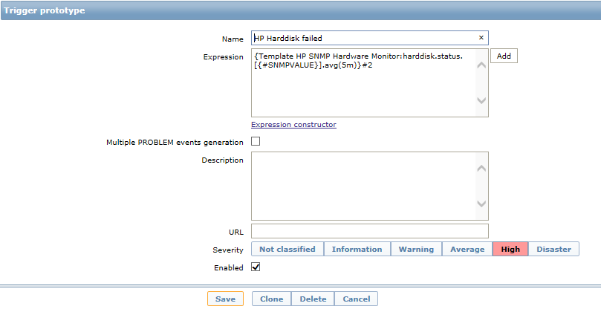

11、脚本运行监控

11.1 Windows BAT 脚本监控

1. 创建BAT脚本，添加返回值

例如脚本监控服务状态，返回值为state

@echo off

sc query Spooler |find/i "STATE"

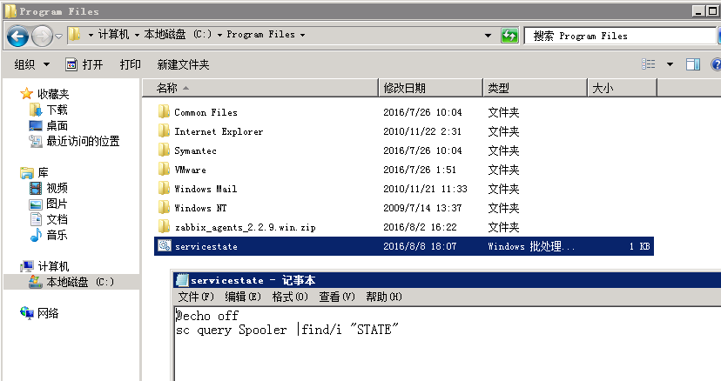

1. 配置zabbix agent的conf文件

UnsafeUserParameters=1

UserParameter=scriptrunning, "C:\Program Files\servicestate.bat"

UserParameter=<key>,<command>

Scriptrunning 为key,与zabbix server 管理界面创建item的key名称一致．

"C:\Program Files\servicestate.bat"　为 command 的路径

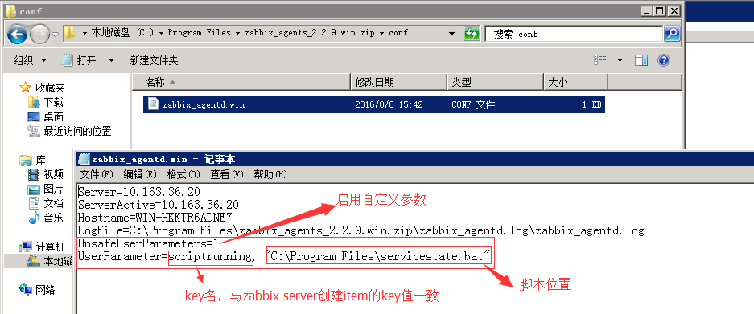

1. 重启zabbix agent 服务
2. 在zabbix server 管理界面相应的host创建item

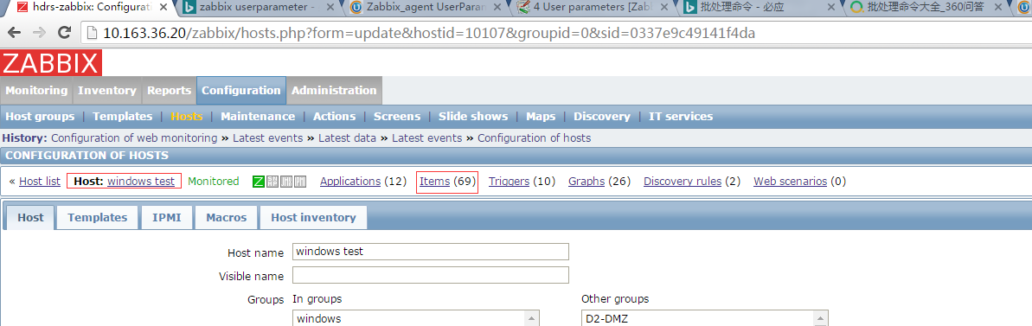

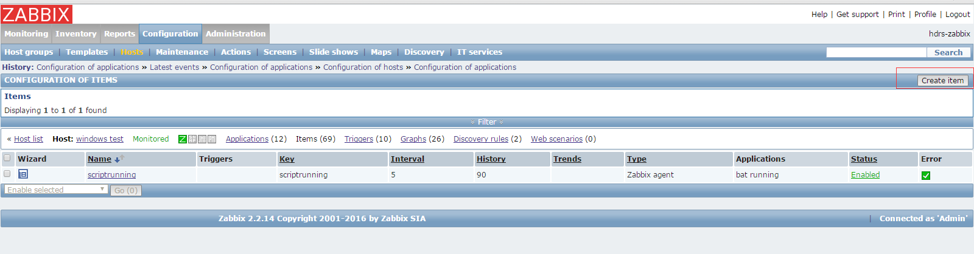

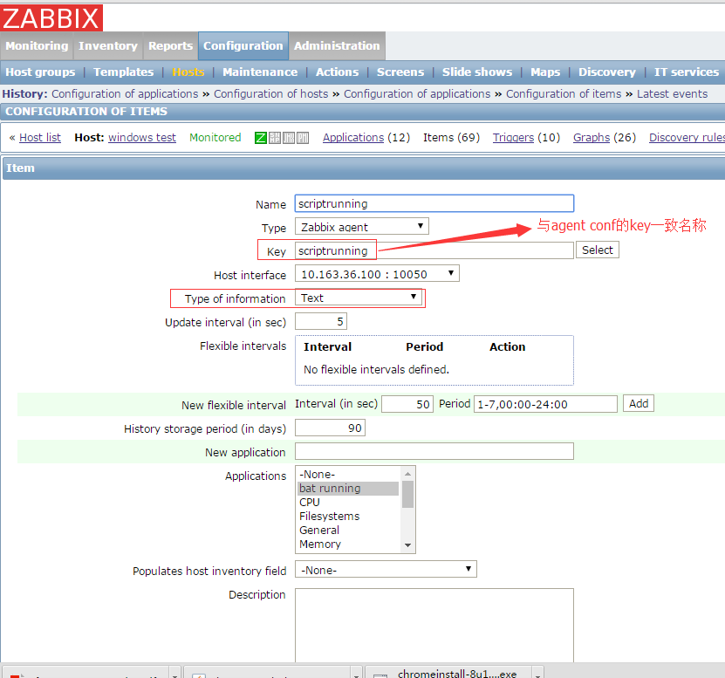

1. 在item创建后，根据wizard创建trigger

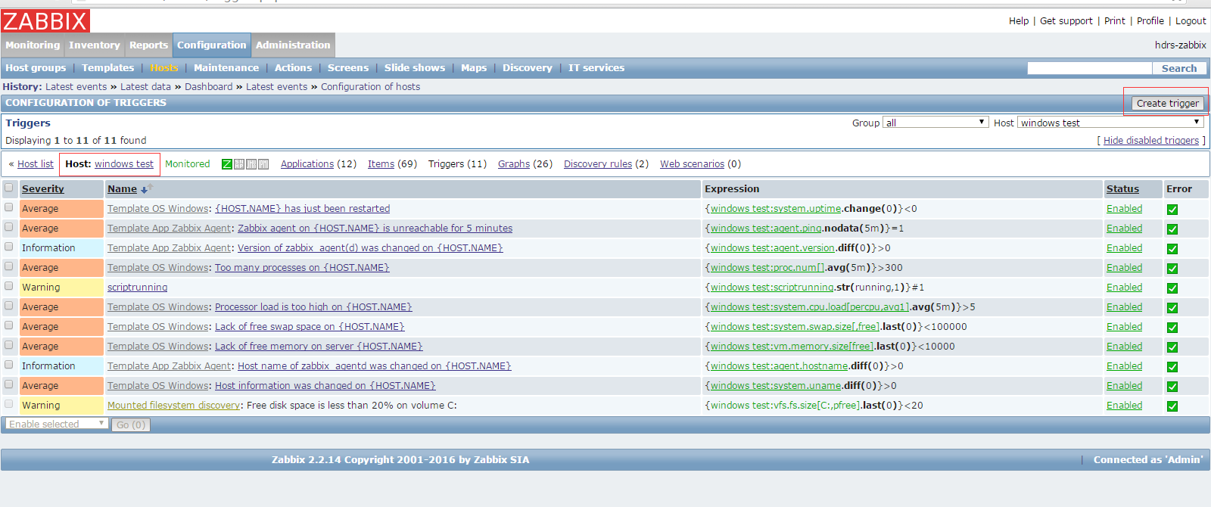

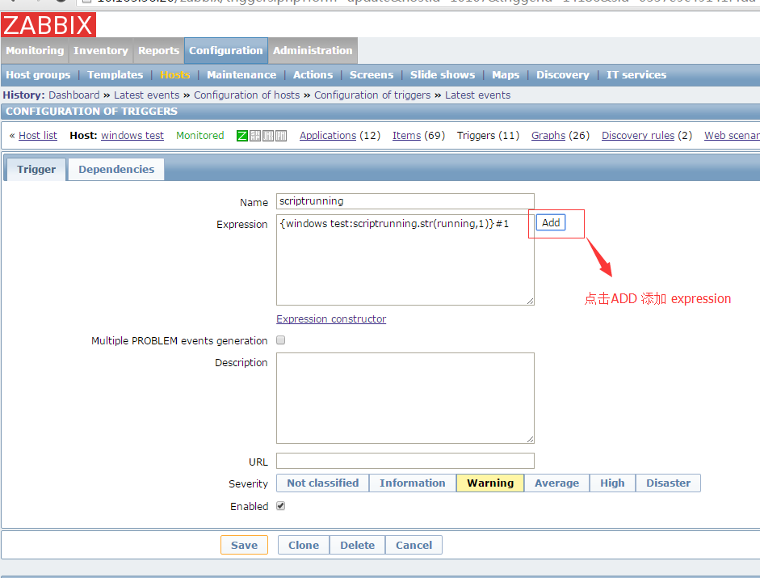

选择相应的function,填写相关的判断值

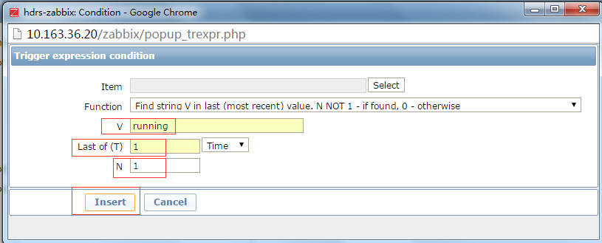

选择相关的报警severity

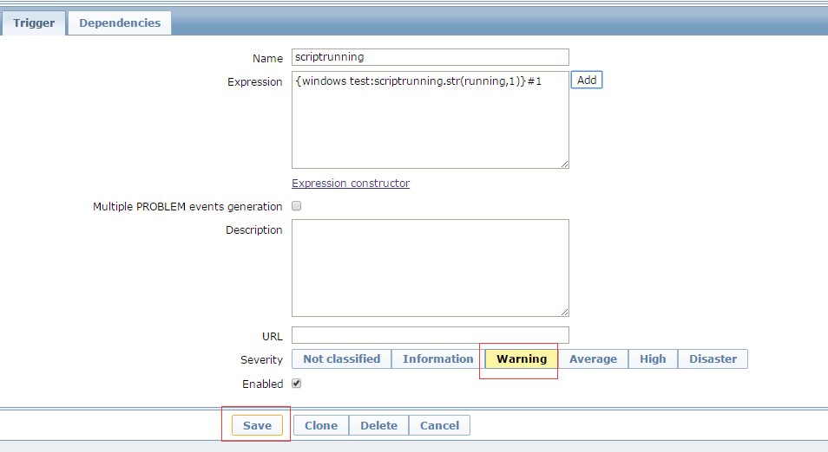

如果返回值不是正常的值，是触发值，就会产生报警

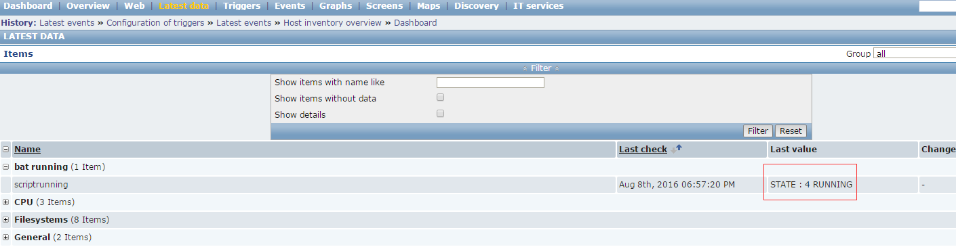

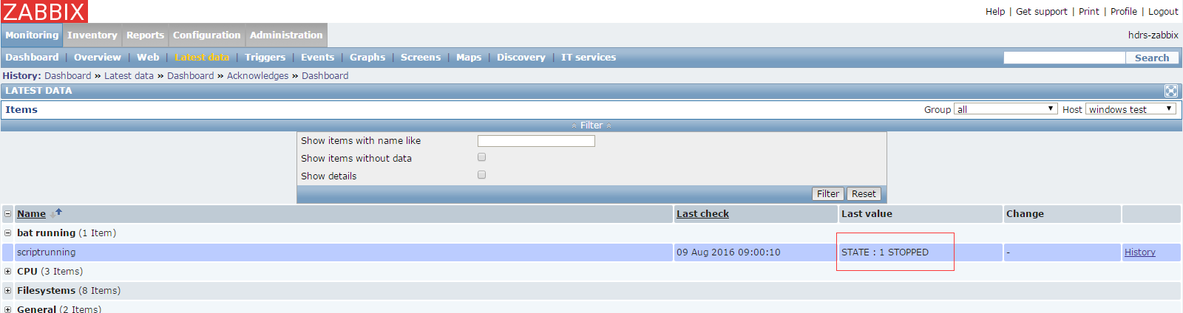

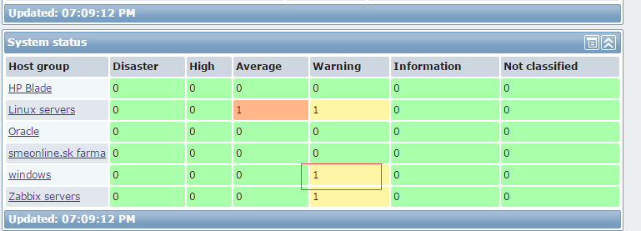

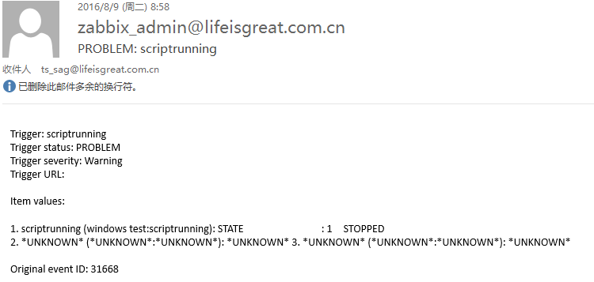

11.2 linux SH脚本监控

1. 创建SH脚本，添加返回值, 步骤与windows bat脚本一样

确保zabbix agent有权限读写脚本

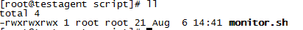

1. 配置zabbix agent的conf文件

UnsafeUserParameters=1

UserParameter=scriptrunning,/usr/local/script/monitor.sh

UserParameter=<key>,<command>

scriptrunning 为key,与zabbix server 管理界面创建item的key名称一致．

/usr/local/script/monitor.sh　为 command 的路径

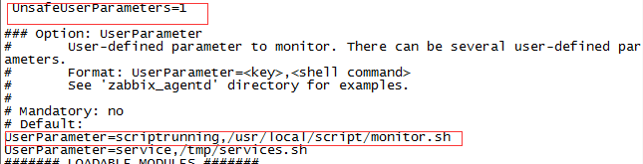

1. 重启zabbix agent 服务
2. 在zabbix server 管理界面相应的host创建item

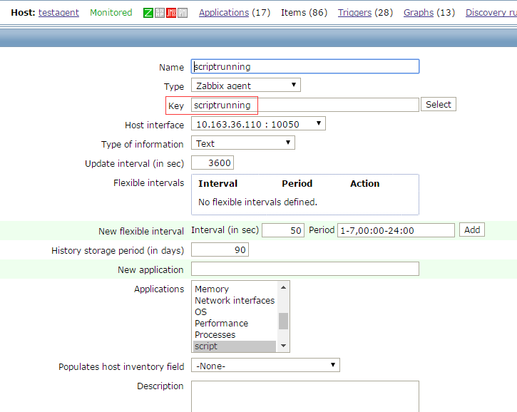

1. Trigger和报警的配置与windows 一样

12、日志监控

12.1 linux 日志监控

1. 创建主机的监控items

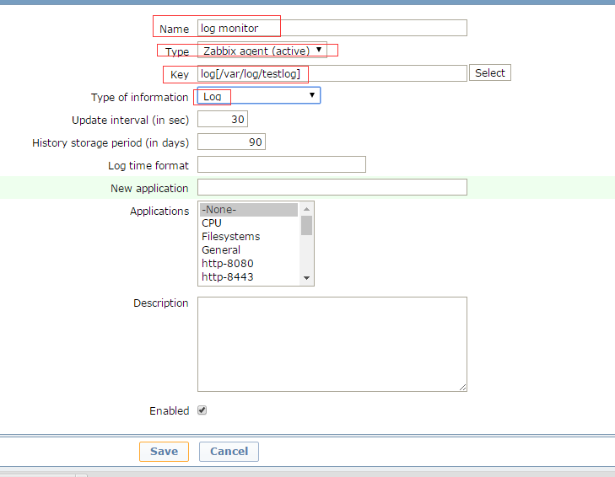

type：一顶要选择zabbix agent active

key：log[文件名个格式：日志文件路径,,,,]

举个例子：

log[/var/log/message]  log[/var/log/secure]等

配置完成之后点save。配置正确的话，可以看到状态是enable的

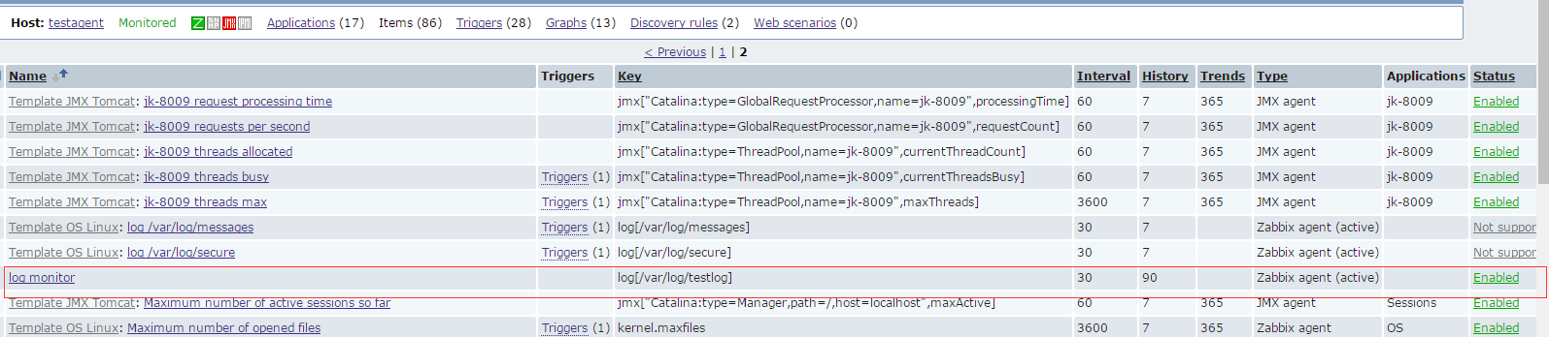

2. 在linux主机创建相应的log 文件(指定相关的log: /var/log/testlog)



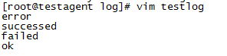

3. 需要指定zabbix agent有读写log的权限





4. monitoring-lastdata就可以看到有日志的数据了

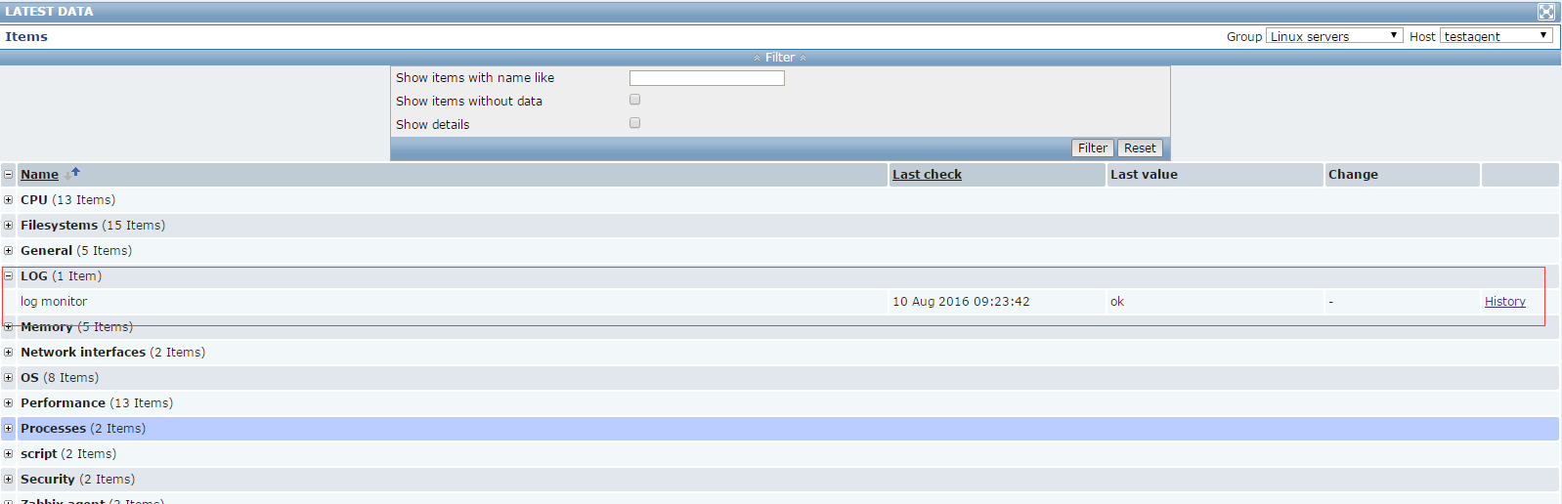

最新的一行日志结果会显示出来



5. 创建trigger,添加报警

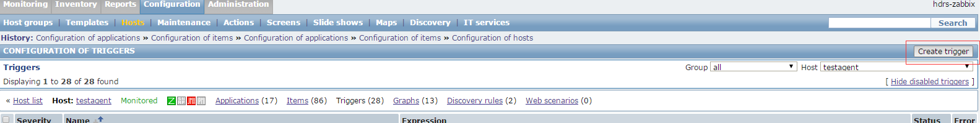

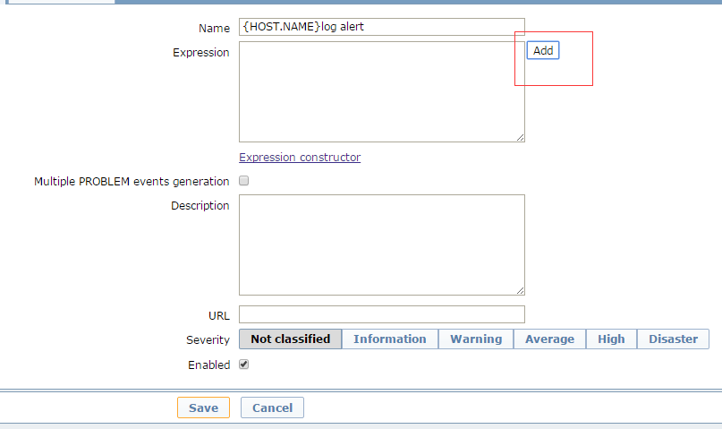

找到相应的item

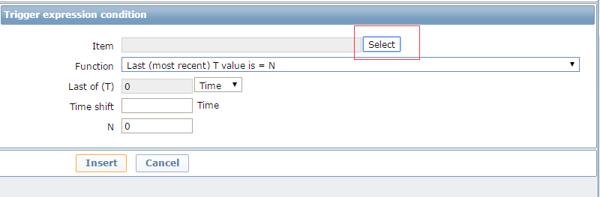

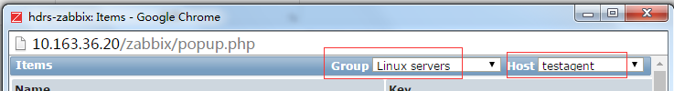

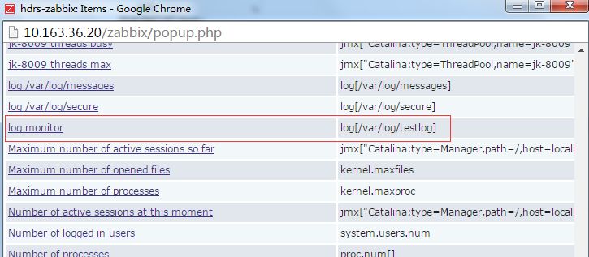

选择function,选择报警的根据条件

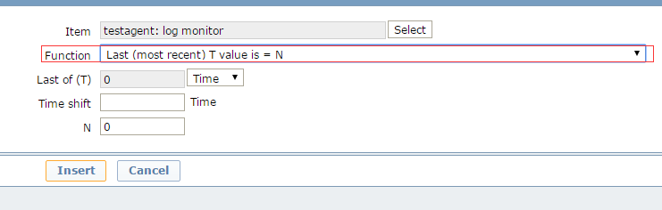

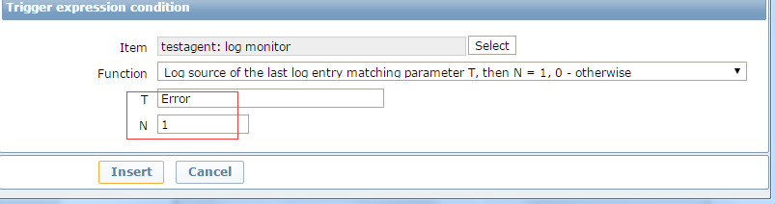

选择报警severity

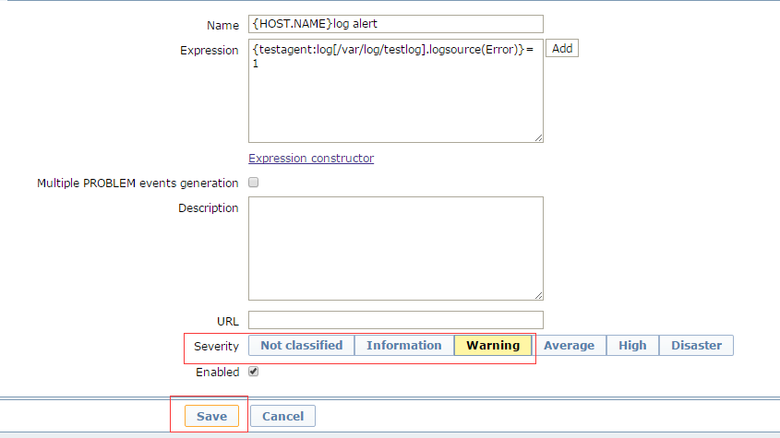

如果返回值不是正常的值，是触发值，就会产生报警

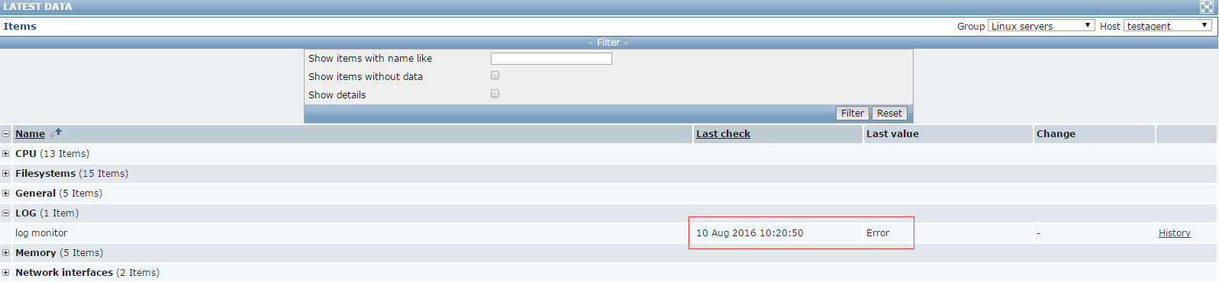

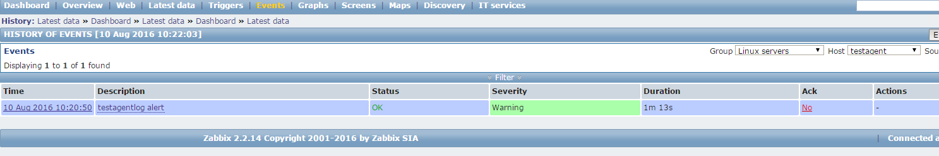

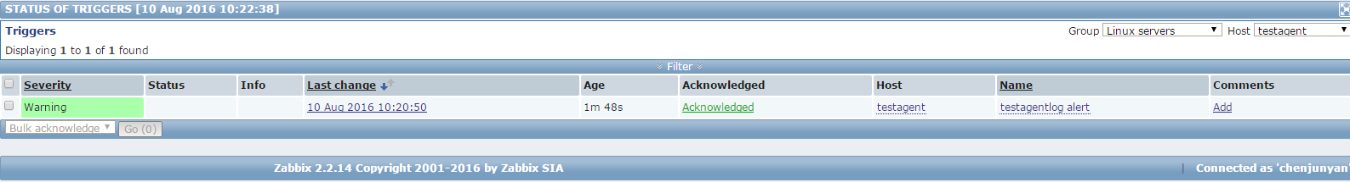

13、web url监控

13.1 创建主机的web scenarios

Zabbix所有Items都必须创建在hosts上，必须选择host后才能创建scenario

Configuration – hosts -web scenarios -creat scenario

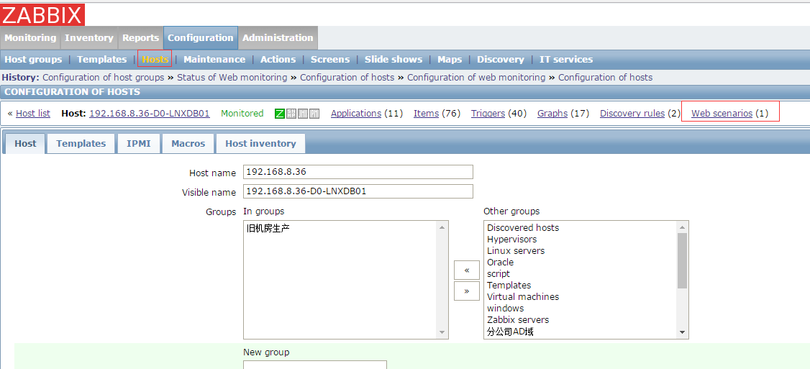

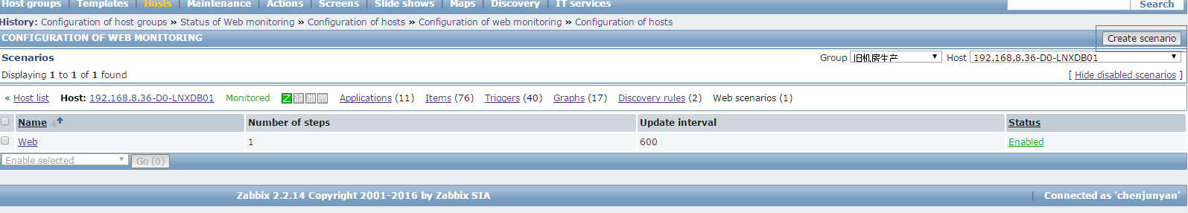

13.2 创建新的web，需入名字，组和测试agent

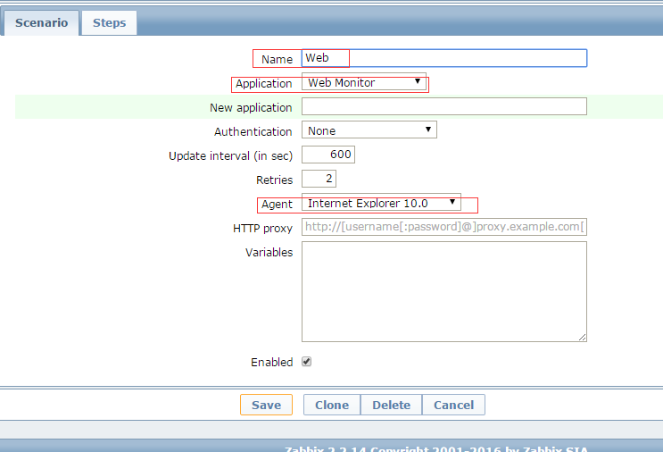

13.3 创建step1来测试无用户认证的web scenarios

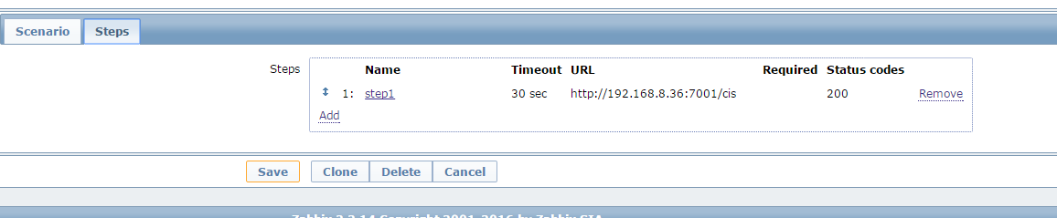

输入url 和返回值（200为正常返回值）

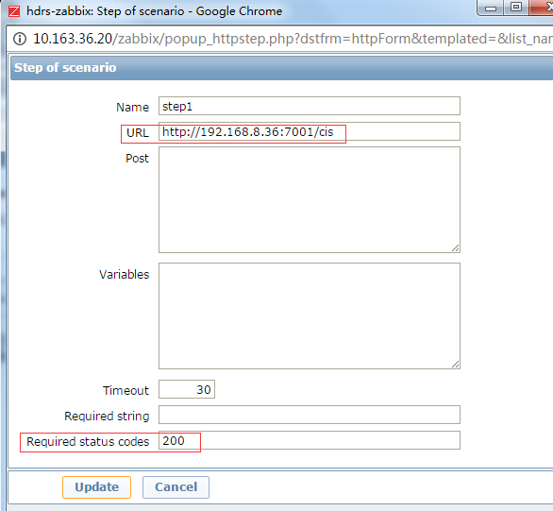

13.4 触发器设置

选择对应host/template,对web创建触发器

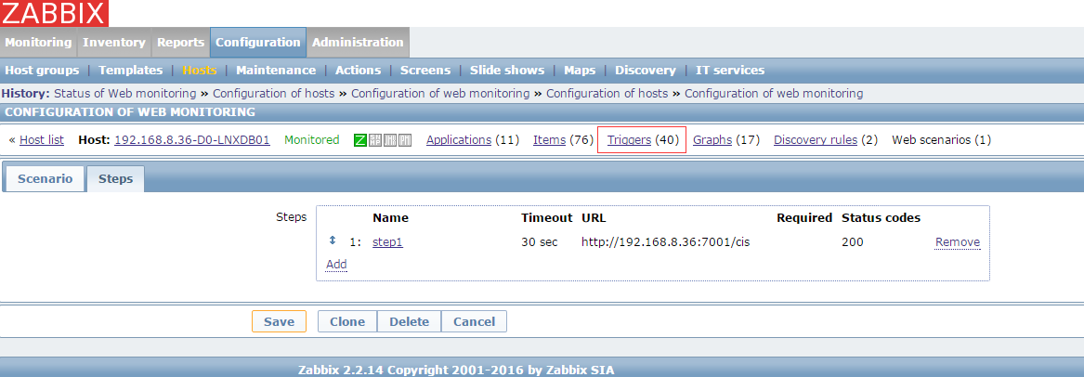

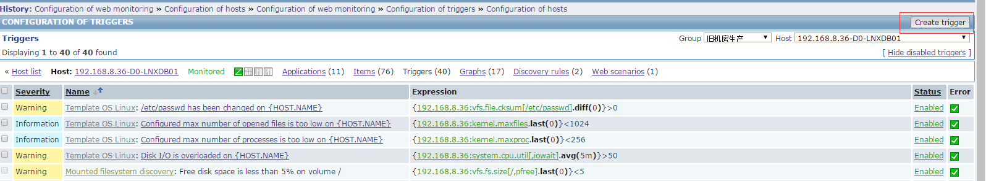

13.5 expression设置

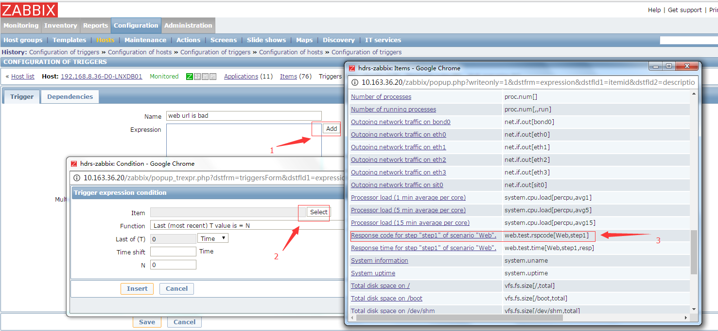

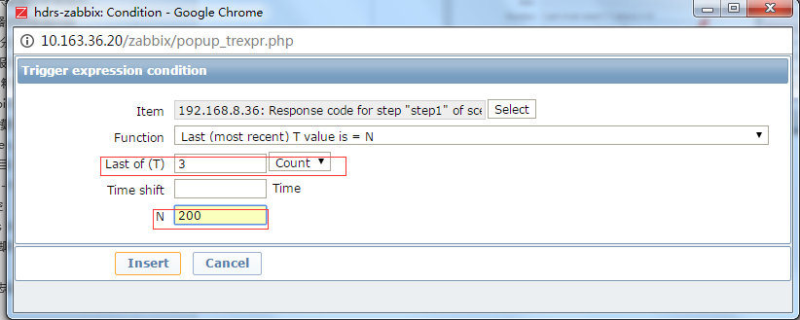

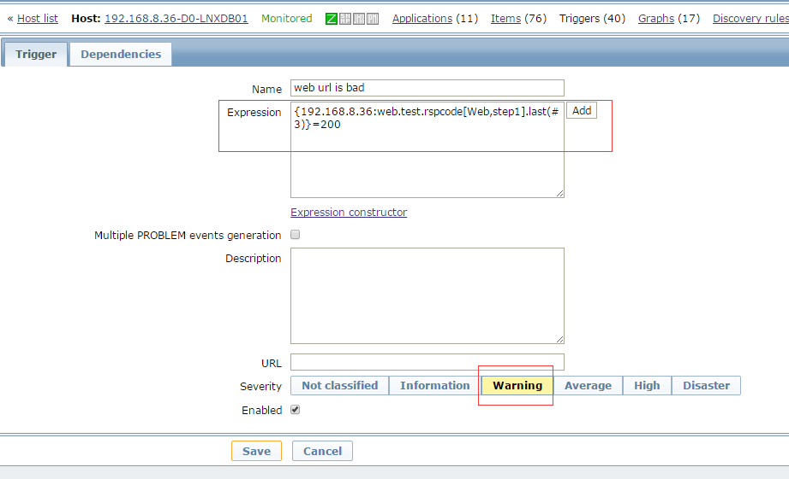

13.6 查看trigger成功enable触发器



13.7 监控web的数据产生

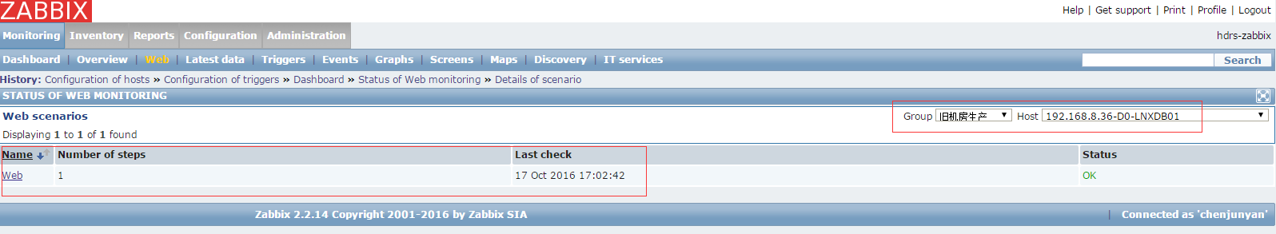

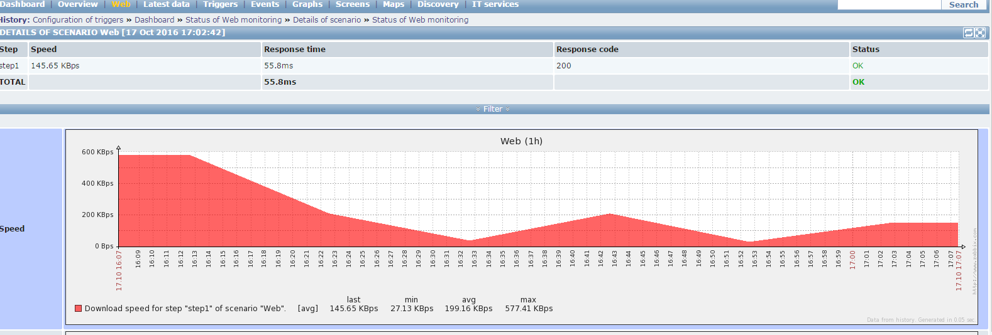

14、zabbix server本身监控

14.1 创建shell 监控脚本

1. Zabbix server 监控脚本，如进程不在，发微信报警到ethanchen, 重启zabbix-server 服务

[root@D2-ZABBIX20 zabbix]# cat zabbixserver_process_monitor.sh

#!/bin/sh

ps -fe|grep zabbix_server |grep -v grep

if [ $? -ne 0 ]

then

echo "start zabbix-server process....."

/etc/zabbix/alertscripts/wechat.sh ethanchen alert zabbix_server_is_stopped_Trigger_Restart

/etc/init.d/zabbix-server start

else

echo "zabbix-server runing....."

fi

#####

[root@D2-ZABBIX20 zabbix]# chmod +x zabbixserver_process_monitor.sh

1. Zabbix agent 监控脚本，如进程不在，发微信报警到ethanchen, 重启zabbix-agent 服务

[root@D2-ZABBIX20 zabbix]# cat zabbixagent_process_monitor.sh

#!/bin/sh

ps -fe|grep zabbix_agentd |grep -v grep

if [ $? -ne 0 ]

then

echo "start zabbix-agent process....."

/etc/zabbix/alertscripts/wechat.sh ethanchen alert zabbix_agent_is_stopped_Trigger_Restart

/etc/init.d/zabbix-agent start

else

echo "zabbix-agent runing....."

fi

#####

[root@D2-ZABBIX20 zabbix]# chmod +x zabbixagent_process_monitor.sh

1. mysql 监控脚本，如进程不在，发微信报警到ethanchen, 重启mysql 服务

[root@D2-ZABBIX20 zabbix]# cat zabbixmysql_process_monitor.sh

#!/bin/sh

ps -fe|grep mysqld |grep -v grep

if [ $? -ne 0 ]

then

echo "start mysqld process....."

/etc/zabbix/alertscripts/wechat.sh ethanchen alert zabbix_mysqld_is_stopped_Trigger_Restart

/etc/init.d/mysqld start

else

echo "mysqld runing....."

fi

[root@D2-ZABBIX20 zabbix]# chmod +x zabbixmysql_process_monitor.sh

14.2 添加crontab自动运行

[root@D2-ZABBIX20 zabbix]# crontab -e

*/10 * * * * ntpdate 10.163.66.5 >/dev/null 2 >&1

0 1 * * * service zabbix-server restart > /dev/null 2>&1

*/1 * * * * /etc/zabbix/zabbixserver_process_monitor.sh >/dev/null 2 >&1

*/1 * * * * /etc/zabbix/zabbixagent_process_monitor.sh >/dev/null 2 >&1

*/1 * * * * /etc/zabbix/zabbixmysql_process_monitor.sh >/dev/null 2 >&1

监控结果

